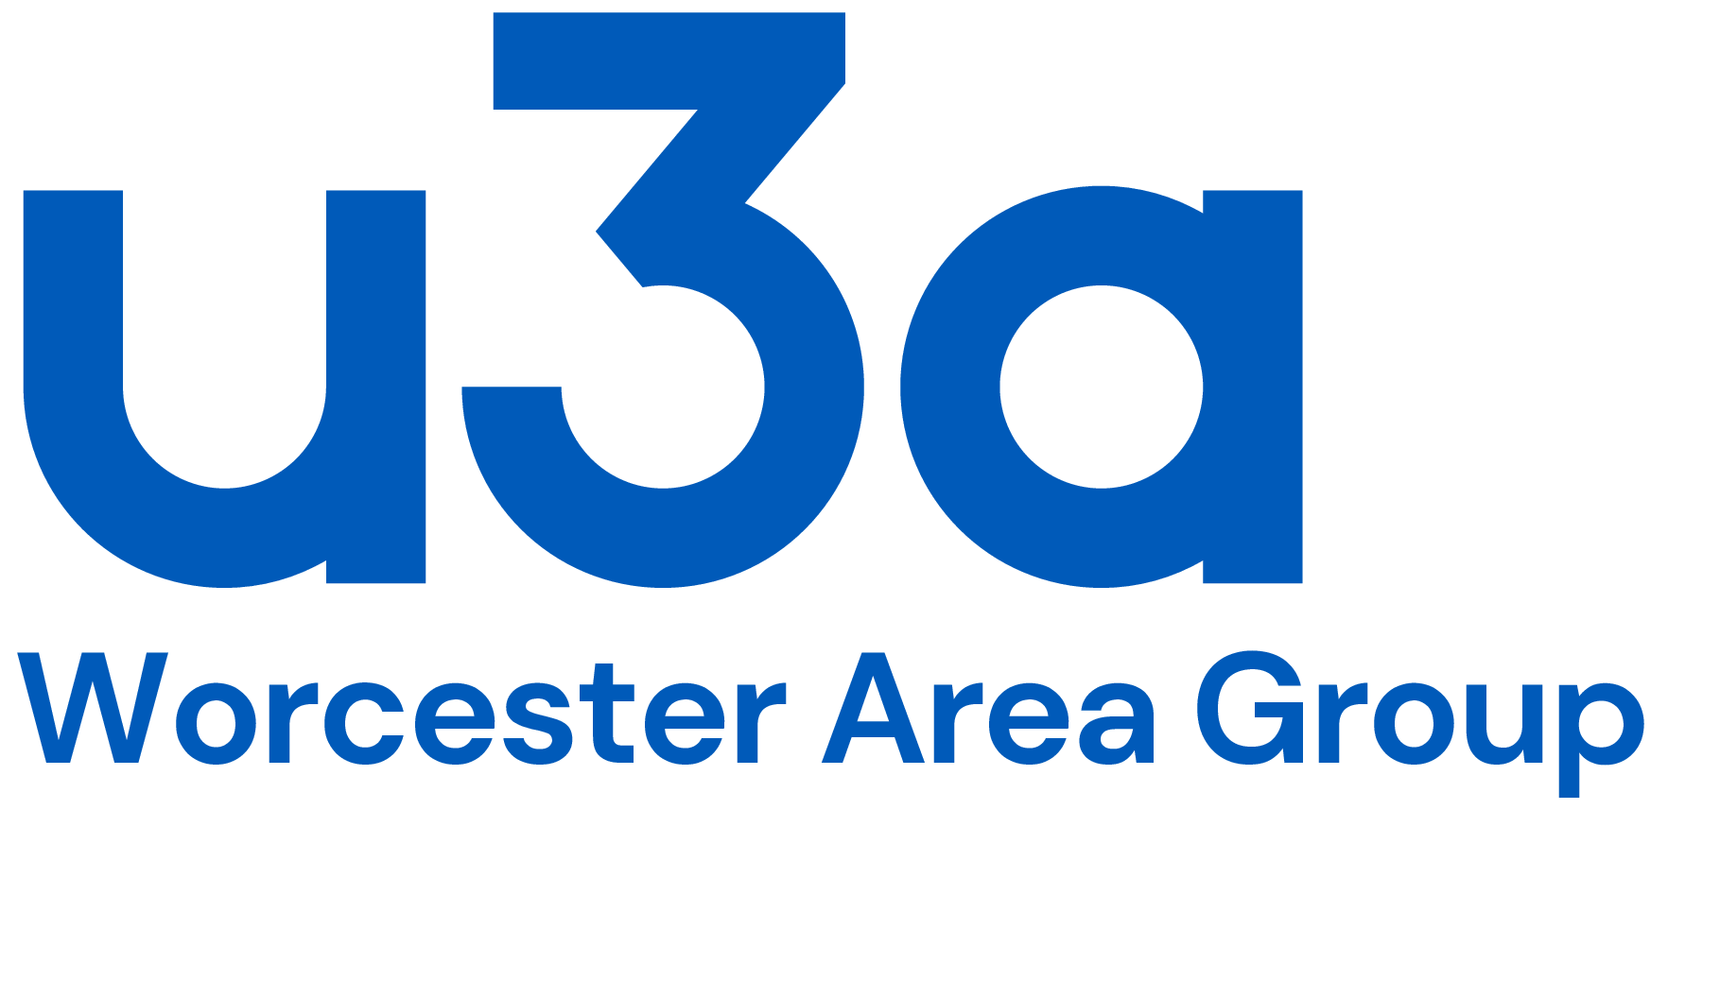
Please use a separate form for each person
Registered Charity No. 702588
Office use only
Date Received
Membership Number

Application for Part Annual Membership
(1 January 2024 – 31 August 2024)

Please complete this form if you wish to pay by bank transfer, cheque, or are paying in person at one of our events. You can also pay by PayPal or credit/debit card via our website www.worcesteru3a.org

Privacy Statement: Your personal details will be held on a secure database and will be used solely for the purposes of administration and the distribution of u3a communications. They will never be supplied to an outside agency or party other than for you to receive Third Age Matters by Direct Mail or to claim Gift Aid from HMRC.

Title and Full Name
Known as  (preferred name) |  | Membership No.  (if an existing member)
Address and postcode
Email address
Telephone No. |  | Mobile No.
Emergency contact name |  | Emergency contact number
Details of your home u3a if applying for Guest membership:
Name of u3a |  | Membership No.
Membership (please tick): £25 Standard*; £34 Additional Hours**; £8 Guest***
*Standard members may join one or more of the many interest groups but not an Additional Hours group

**Applies to Bridge 1 (Duplicate), Bridge 2 (Rubber or Chicago), Bridge Beginners, Pickleball Groups 1-4, Art-Oil Painting, French Year 3 and Film Appreciation group members only
***Already a current member of another u3a (can attend one Standard, non-Additional Hours, group only)
Concessionary membership is also available at 50% of the Standard or Additional Hours subscription. Applications are considered individually. Contact membership@worcesteru3a.org or 07531 000957

Methods of Payment:
PayPal, Credit and Debit card: visit the Join/Renew page on our website www.worcesteru3a.org
Electronic bank transfer:
A/C Name: | Worcester Area Group u3a
A/C Number: | 44009260
Sort Code: | 30-90-89
Your ref: | SUBS your name
Please inform us of the date and time of bank transfer by e-mail membership@worcesteru3a.org, or using this form.
Date and time of transfer:
Cheque: Made payable to Worcester Area Group u3a Send your completed form and cheque to:
Membership Secretary, WAGu3a, 3 Millbrook Close, Worcester WR3 7BJ
membership@worcesteru3a.org Tel No. 07531 000957
Please provide a STAMPED ADDRESSED ENVELOPE if you want a printed Membership Card and/or any other information.
If you are a UK taxpayer, please consider making a Gift Aid declaration. Gift Aid is a government scheme, administered by the HMRC, which enables charities to reclaim the tax you have already paid on your membership subscription and donations.
Gift Aid Declaration – we can claim Gift Aid on £12 of your subscription
If you wish us to do so, you must tick the boxes below and sign the declaration:
- I want to Gift Aid my subscription and any donations I make in the future, or have made in the past 4 years to: Worcester Area Group u3a.
- I am a UK taxpayer and understand that if I pay less Income Tax and/or Capital Gains Tax than the amount of Gift Aid claimed on all my donations in that tax year it is my responsibility to pay any difference.
Please notify Worcester Area Group u3a if you:
- Want to cancel this declaration
- Change your name or home address
- No longer pay sufficient tax on your income and/or capital gains.
If you pay Income Tax at the higher or additional rate and want to receive the additional tax relief due to you, you must include all your Gift Aid donations on your Self-Assessment tax return or ask HM Revenue and Customs to adjust your tax code.
Signature
Date
For other enquiries, contact membership@worcesteru3a.org Tel No. 07531 000957

