Issue 74 January 2024
Warsop & Distict
HAPPY NEW YEAR
Notes from the Chairman
Hi
Happy New Year to you all.
The Christmas party at the December meeting was a very pleasant couple of hours. The raffle was very well supported and the food went down well. Thank you to the committee members who put a lot of time and effort into organizing the event.

I would also like to thank all the members that have been on the refreshment and meeters and greeters rota throughout the year. Without members helping in these areas the monthly meetings would not be the same.

At the monthly meetings. Can I ask members to be aware of other members with disabilities whose life may be made easier by sitting where they choose is suitable for them.

There is a change to the speaker this month. It is the same speaker, but the talk is now ‘the History Show part 2’ we were entertained by part 1 in July 2022 which proved to be very entertaining. The published talk on the Wild West is not possible.

Jim Shervey
Chair (phone-07484784849)

The deadline for including articles/information in the next newsletter is Friday 9th Feb Send contributions to Chris Shervey.

Rota for refreshments and greeting.
Please be there around 9.30am, any problems please let me know, thanks Ann
January 15th
Refreshments – Ann Holland, Ann Ayodele
Meet & Greet – Yvonne Brown, Sandra Bradley
February 19th
Refreshments – Karen Breed, Pat England
Meet & Greet – Ray White, Ann Barnes
March 18th
Refreshments – Janice Thorlby, Anne Poultney
Meet & Greet – Brenda Pearce, Chris Wilson

Christmas Party and Crafts pictures
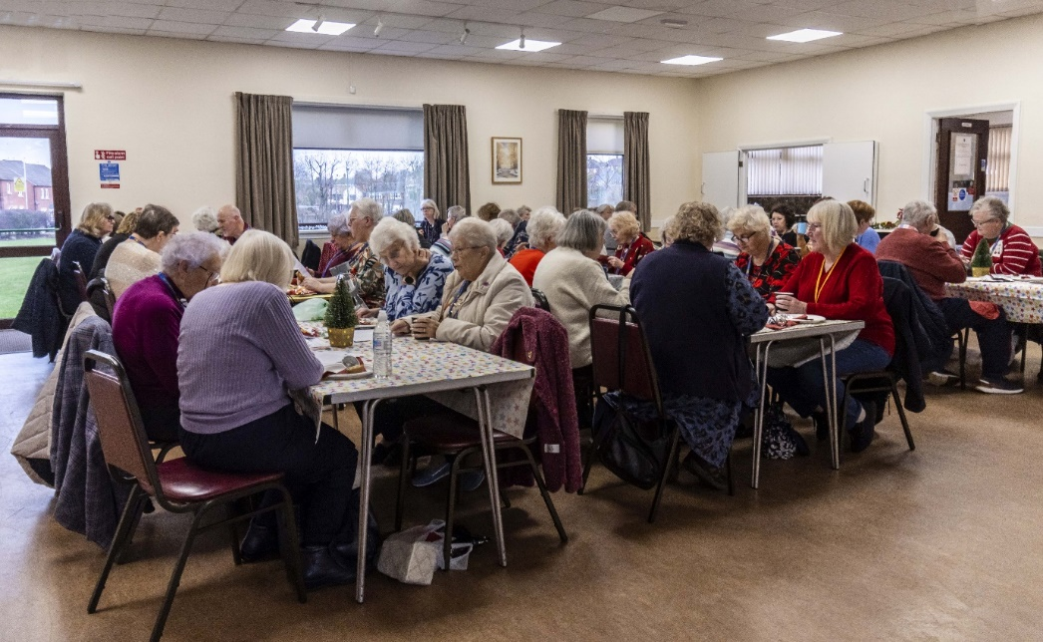

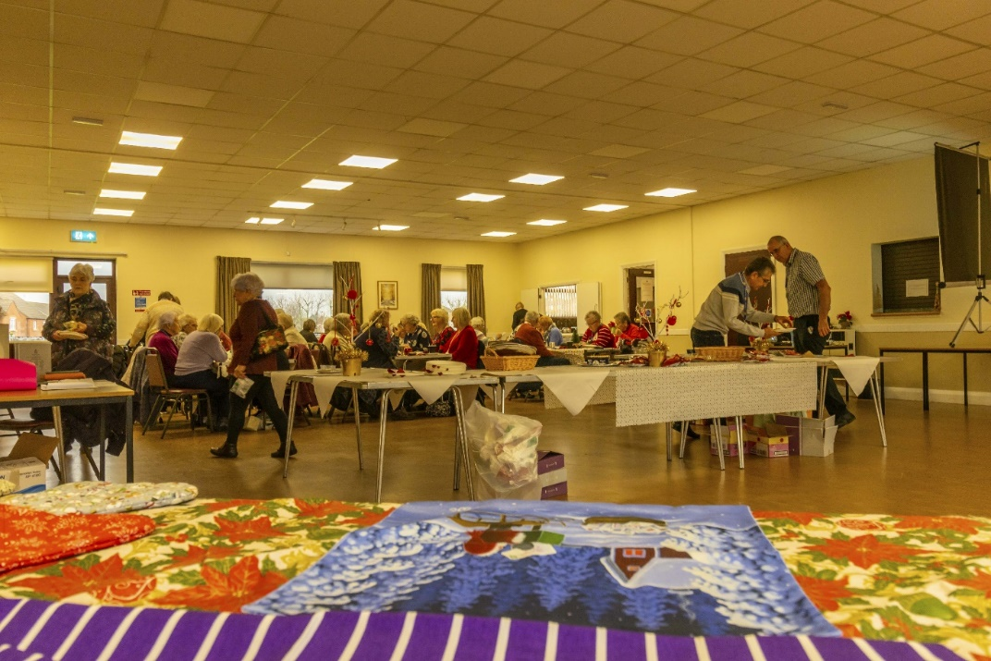

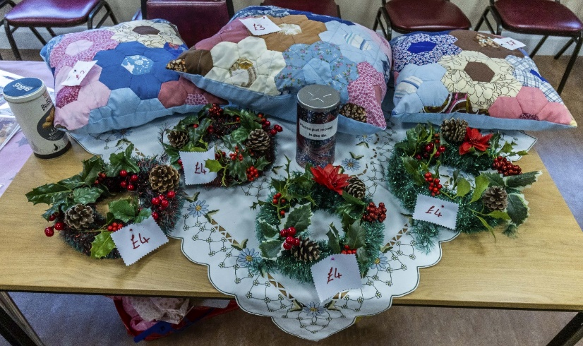

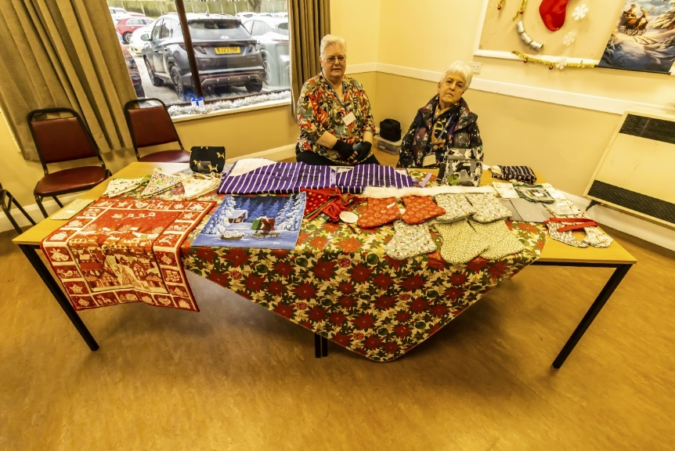
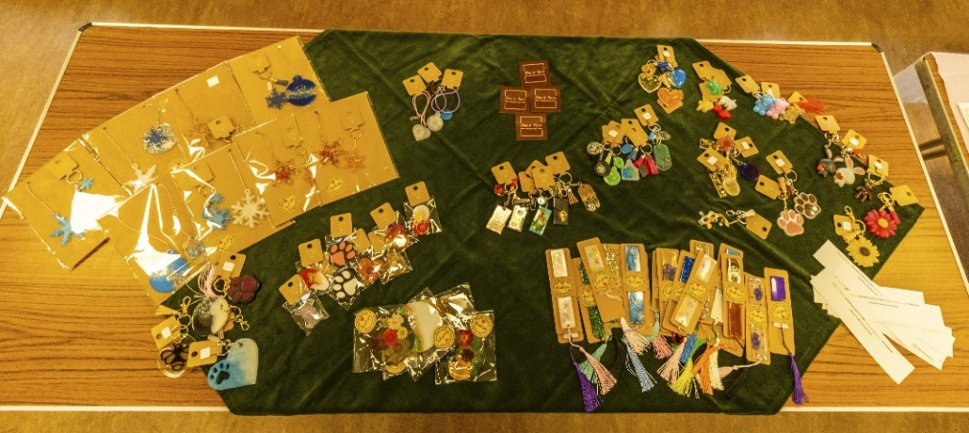

ITEMS OF INTEREST
Membership renewals 2024
Hi. It is time to be thinking about when you are going to renew your membership.
You will be pleased to hear that we are able to keep the cost of membership at £20.00, Or £16.00 with proof of membership where the TAT levy has been paid at another u3a.

You will be able to renew your membership at the February, March or April meetings. If you can’t make the meetings let me know and we can make arrangements to renew. The current membership year ends at the end of March, so anyone who has not renewed after the April meeting will be taken off the circulation lists (this does not prevent you rejoining at a later date).

Mel Mitchell
Quiz Night
The next quiz night will take place on Thursday 22nd February. 7.00pm at the Plough Inn.
Supper will be at 7.15pm. As usual the supper will be baked potatoes and trimmings or pie & peas.
Tickets are £6 and can be booked at the next main meeting on 15th January, or contact me for tickets.
Ann Ayodele

Raffle. The December Raffle raised £128.
RAFFLE PRIZES NEEDED PLEASE ESPECIALLY ONES SUITABLE FOR MEN.

Books and Jigsaws 50p. We made £9 at the November meeting. There were NO jigsaws or books at the Dec meeting.

Cups Please will as many of you as
possible bring your own mug for your tea or coffee. This is not only more environmentally friendly but also would save us a lot of money as the paper disposable cups we use are surprisingly expensive. Ann.
Robin Hood Lottery
Warsop and District U3A is a cause registered with the Robin Hood Lottery.
To buy a ticket you can now register on line at www.robinhoodlottery.co.uk and set up regular payments. If you buy a ticket every week for a year Warsop U3A will receive £26.
Remember the more members that have a go (specifying Warsop & District U3A) the more money we get for our funds.

Group News
Theatre Group
Our first meeting of the year will be on Friday 2nd February at 2pm in The Plough. We'll be deciding which shows we'd like to see next. All are welcome and if you have details of forthcoming productions in local theatres, please bring the details. Thank you, Jen.

Welfare
The committee like to let members know that we are thinking of them if they are ill or suffering a bereavement.
If you know anyone who has missed a couple of meetings due to illness, or who has lost a loved one, please let me know. Jen

The Friendship Group
The next meeting will be on Friday 2nd February.

Discussion Group
The discussion group meets on the 4th Monday of each month. We meet at the forest Lodge Edwinstowe 10.30 till 12 noon. Regards Mary Morris

International Dining
We thought with the time of year we would do a lunch time meal outing.

Venue: Greendale Oak, Cuckney
Date: Tuesday 6th February 2024
Time 12.30pm for 1.00pm
We have provisionally booked 20 places and will be taking bookings at the meeting (January 15th 2024) together with your choice of meal as we have to pre-book. A copy of the menu will be on view at the meeting.

We are using the Lunch Time Menu only which costs £12.50 per person for a main meal or two for £20.00.
We require a £5.00 deposit when booking to secure your place. (Non-refundable)

Regards
Brenda & Chris

Silver Screeners

Savoy cinema Worksop. For the over 50’s. Every Wednesday at 11.30. Tickets £4.50, include a drink and free raffle.
Upcoming Movies in January:
Wednesday 10th Jan - And Then Come the Nightjars
Adapted for the screen from Bea Roberts’ multi-award-winning stage play, And Then Come the Nightjars tells the story of an unlikely friendship between a Devon farmer and the vet who is assigned to cull his precious herd. A heart-warming story of friendship and survival set against the backdrop of the 2001 Foot and Mouth outbreak.
Wednesday 17th Jan - Wonka
Based on the extraordinary character at the centre of Charlie and the Chocolate Factory, Roald Dahl’s most iconic children's book and one of the best-selling children's books of all time, "Wonka" tells the wondrous story of how the world's greatest inventor, magician and chocolate-maker became the beloved Willy Wonka we know today.

Bridge Club
The Dukeries u3a Bridge Group meet on the Second and Fourth Tuesday of each month at the Jubilee Hall (NG22 9AP) from 1 – 4PM. The cost of each session is currently £3.
All U3a members are welcome to attend.

Strollers
"Strollers - 24th January 2024 - Sherwood Forest. Meet at the Carrs car park at 10.00 am for car share to Edwinstowe.
Leader Pam Hick."

TIMETABLE FOR 2024

Jan 24th | Sherwood Forest
Feb 28th | Vicar Water
Mar 27th | Poulter Park
Apr 24th | Rufford Rufford
May 22nd | Thoresby
June 26th | Cresswell Crags
Walking Group
For our first walk of the year we will be staying local and the route will depend on permissible paths due to the rain we have had in recent weeks.
As usual we will leave The Carrs car park at 10.00. a.m. prompt (Thursday 18th January)

Brenda & Pam
WALKING GROUP - 3RD THURSDAY OF THE MONTH 2024
Date | Walk Leader | Walk | Distance
18th January | Brenda Pearce | Carrs - Local Walk | 3.5 miles
15th February | Pam Hick | Sherwood RSPB
21st March | Val Buckinger | Edwinstowe
18th April | Brenda Pearce | Glapwell to Hardwick Circular
16th May | Gerald Weston | Mansfield Woodhouse
20th June | Val Buckinger | Clumber Lake | 4 miles
18th July | Jen Long | Gleadthorpe | 4 miles
15th August |  | TBC
19th September |  | TBC
17th October | Brenda Pearce | Ault Hucknall | 3.5 or 5 miles
21st November |  | TBC
 |  | Walks can be subject to change

Photography Group
The Photography group is continuing to operate online, with the ‘Themed’ challenges.
The ‘Theme’ for the last challenge was ‘Anything beginning with either C or D’
A Big THANKS to Jen Thomson, Jim & Chris Shervey who also entered the challenge this month.
Joyce O’Neill – C= Cups, CD and Choir (Vienna)
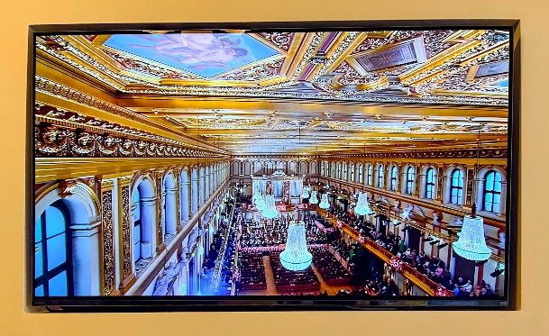
Jen Thomson – C = Crufts
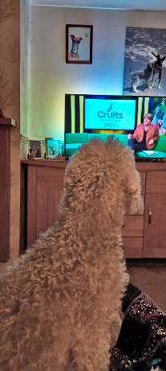
Jim & Chris Shervey – C = Stalking Cat, D = Dawn sky

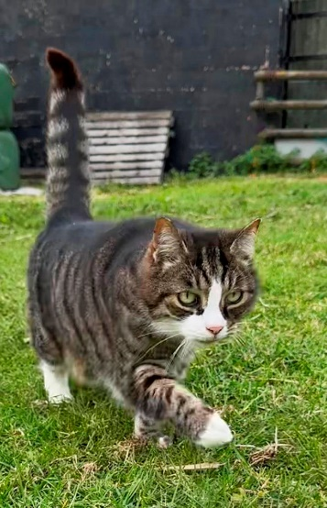

Bob Thomson – C = Clumber church
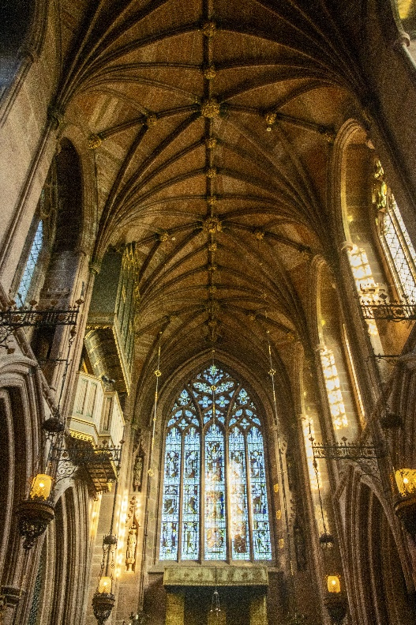
D = Damselfly, Dancing around the Maypole
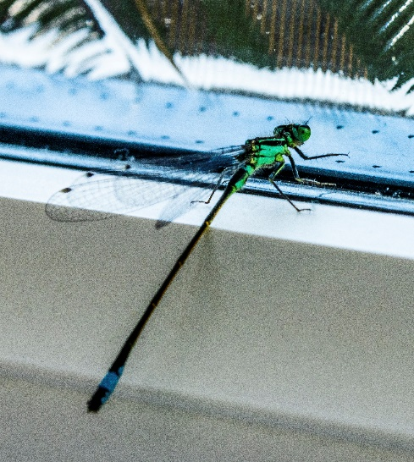
Joanne Wheatley- C= Christmas Clock , Chain
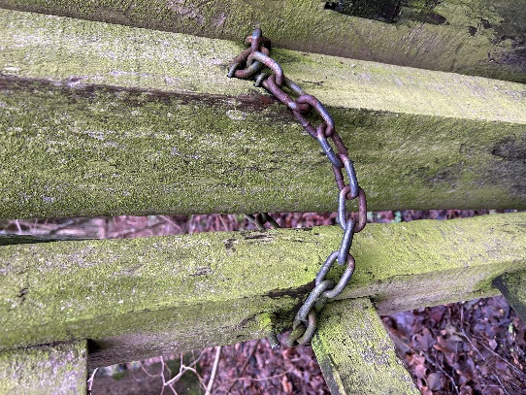
The next online ‘Themed’ challenge is ‘Anything that starts with either E or F’, once again this challenge is open to ALL u3a members.

Craft Group
The craft group meets the first Monday of the month 10am – 12noon at THE SHED
(behind the Dr’s surgery) Wood Street, Warsop. NG20 0AX.
We always have a fun time, with refreshments. The only thing you need to bring is a basic sewing kit and a willingness to have a go at anything. All materials are available for a very small donation to the person who brings them, if anything more specialised is required you will be given the opportunity to purchase any item needed yourself, or you can borrow from other group members.
The next meeting is at THE SHED (behind the Dr’s surgery) Wood Street, Warsop. NG20 0AX, on Monday 5th February 2024 at 10am.
This is the itinerary for the coming year.
5th February 2024 – Felt Lavender Bags
4th March 2024 – Twiggy Easter Trees
TBC April 2024 – Toiletry bags made from face flannels
TBC May 2024 – Stone Painting
3rd June 2024 – Button Pictures/collages
5th August 2024 – Garden ornaments
Sept, Oct, Nov TBC
December 2024 – Christmas cards/calendars
We’re looking forward to welcoming new members.
Zena

History Group
Hello everyone, Happy New Year!
Barbara, Sue and I are excited about our planned calendar of talks and visits for 2024 and hope you will be too.
We kick off on Tuesday 16th January, 10am at St Theresa’s church hall when we welcome Denis Hill who will be telling us all about Major Hayman Rooke, an antiquarian, whose observations and research contributed to our understanding of local history. He was responsible for the identification of the site of a Roman Villa on the north field of Mansfield Woodhouse.
We look forward to seeing you there. Everyone welcome.
Barbara,Sue & Tamar

2024 - Proposed Calendar of Events for Warsop & District U3A History Group
16th Jan | Hayman Rooke - Denis Hill | St Theresa’s Church Hall 10am
20th Feb | Four Kings. Chris Shervey | St Theresa’s Church Hall 10am
19th Mar | Visit to Hardwick Hall -
16th Apr | Mining Communities  Denis Hill | St Theresa’s Church Hall 10am
21st May | The Story of Boots  Chris Weir | St Theresa’s Church Hall 10am
18th Jun | Visit to Richard 3rd Museum Leicester or Lincoln Castle and Cathedral.
16th July | Early History of Mansfield  Denis Hill | St Theresa’s Church Hall 10am
20th Aug | In house presentation  Eminent Local Sporting Personalities  Roger Holland | St Theresa’s Church Hall 10am
17th Sept | Historic Mansfield Trail  Denis Hill | Meet in Mansfield Town Square 10am
15th Oct | Nottinghamshire’s Dark Side  Chris Weir | St Theresa’s Church Hall 10am
19th Nov | Medieval Buildings & the English Civil War  James Wright TBA | St Theresa’s Church Hall 10am
17th Dec | No meeting as very close to Christmas

Natural History, Science and Technology.
We had a very interesting talk on our Immune System, it is amazing how the antigens and antibodies know how to attack the bad bacteria. We saw some amazing photos of bacteria and one of bacteria actually being consumed by an antigen. Joyce made a complex subject understandable and interesting.

2024
Thursday 11th Jan | Anti- gen and Anti- bodies  Your Immune System
Thursday 8th Feb | Habitats around us
Thursday 14th March | Bats
Thursday 18th April | Visit to Veolia 2.00pm | Note this is not our usual meeting date
Thursday 9th May | To be decided
Thursday 13th June | Paramedic with ambulance | Because of parking the ambulance this meeting will be held at Oakroyd NG20 0EP
Thursday 11th July | St Johns | CPR and use of DEFRIBULATOR

Speakers for the main meetings

2024
January 15th History show part 2. The industrial
revolution and beyond ending in the 1960's. Steve Allen

February 19th A Family History(Title to be confirmed) Peter Slater

March 18th ‘Mind Your Motoring Manners 1928’ Paula Cornwell

April 15th Knickers a Brief History Janet Stain

May 20th Social time

June 17th (Title to be confirmed) Mel Mitchell

July 15th More Funny Turns! Dave Moylan

August 19th Medieval superstitions and science. Gareth Howell

September 16th Annual General Meeting

Group | Leaders Name | Tel
NATURAL HISTORY SCIENCE AND TECHNOLOGY | Chris Shervey
WALKING GROUP | Brenda Pearce  Pam Hick
STROLLERS | Sue Cox  Pat Magness
HISTORY GROUP | Barbara Spybey
CRAFTS | Zena Inger
GARDENING | Linda Crossley
PHOTOGRAPHY | Rob Thomson
FRIENDSHIP GROUP | Betty Trinder
INTERNATIONAL DINING GROUP | Chris Wilson  Brenda Pearce
THEATRE GROUP | Jennifer Thomson
SOCIAL EVENTS ORGANISER
DISCUSSION GROUP | Mary Morris
REFRESHMENTS | Ann Ayodele
COULD GROUP LEADERS PLEASE COLLECT THEIR BADGES WHEN COLLECTING THEIR LANYARDS. (Then members at the meeting can identify who they may need/want to talk to)

INTEREST GROUP TIMETABLE
 | MONDAY | TUESDAY | WEDNESDAY | THURSDAY | FRIDAY
1st | 10am – 12pm  CRAFTS GROUP  The Adam Eastwood Building. Warsop |  |  |  | 2pm  FRIENDSHIP GROUP  The Plough Warsop
2nd |  | 10am  GARDENING GROUP  Venue agreed by members |  | 2pm  NATURAL HISTORY  SCIENCE AND  TECHNOLOGY  Plough Warsop
3rd | MAIN MEETING 10.15  Oaklands Centre  Warsop | 10am– 12pm  HISTORY GROUP  Catholic Church Warsop |  | 10am  WALKING GROUP  Carrs Car Park | 11.am  PHOTOGRAPHY  Venue to be agreed by the members.
4th | 10.30 -12.30  DICUSSION GROUP  Forest Lodge  Edwinstowe |  | 10.am  STROLLERS  Carrs Car Park
INTERNATIONAL DINING -Location and time as announced.
THEATRE GROUP - Location and time as announced.
PHOTOGRAPHY GROUP-Please see Newsletter for the online challenge.

January quiz What comes next?
1 QWERTY ?
2 Wilding Todd Fisher ?
3 Nixon Ford Carter?
4 Hartnell Troughton Pertwee ?
5 Dragon Snake Horse ?
6 England Brazil West Germany ?
7 Pugh Pugh Barney ?
8 Edward II Edward III Richard II?
9 Gemini Cancer Leo ?
10 Brown Cameron May ?
11 Revolver Abbey Road Rubber Soul ?
12 The Philosophers Stone Chamber of secrets Prisoner of Azkaban ?
13 Val Singleton John Noakes Peter Purves ?
14 A League of their own Sleepless in Seattle Philidelpia?
15 Richard Whitely Des Lynam Des O Conner ?
16 McDonald Baldwin Chamberlin?
17 Waterloo Dancing Queen Mamma Mia ?
18 George IV William IV Victoria ?
19 Lust Envy Gluttony ?
20 John Surtees Jackie Stewart James Hunt ?
21 Genesis Exodus Leviticus ?
22 Kelvin Fletcher Bill Bailey Rose Ayling Ellis ?
23 Captain Major Colonel ?
24 Viscount Earl Marquess ?
25 All things bright and beautiful
All creatures great and small
All things wise and wonderful ?

January quick quiz?
- Russian goldsmith famous for Easter eggs?
- Islands off the coast of Argentina?
- Type of deer found in UK?
- Member of Catholic conspiracy to blow up Houses of Parliament ? ( Surname F )
- Italian Dictator 1883-1945?
- Famous Chess Grand Master ? ( Surname F )
- A long narrow sea inlet lying between mountains ?
- Former French Royal palace ?
- St ------- of Assisi?
- A breed of black and white dairy cattle?

January riddles
What has ahead and a tail but no body?

I am an odd number, take away a letter and I become even. What number am I?

What begins with E and only contains one letter?

January --- curious county customs
Goathland Plough Stot N Yorkshire.
Originally took place on Plough Monday – the first Monday after Twelfth Night. With a group of Long Sword dancers dancing through the village. The tradition has been happening for 150yrs and originally the dancers asked for alms and threated a furrow being ploughed in the garden of anyone who refused to pay.
These days it occurs on the Saturday after Plough Monday. The Long Sword dancers dance through the village and it all culminates with the Stot Rosh – a roast dinner and a Barn Dance.

Up-Helly-Aa Lerwick Shetland Islands
This takes place on the last Tuesday in January, when a “Viking” army proceed through the town with their longship. Flaming torches are then thrown onto the boat. It marks the end of the winter festival of Yule. Up-Helly -Aa translates as end of the holy days. There is also a Up-Helly-Aa festival at Scalloway on Shetland 11 days before the one in Lerwick.

Answers to Christmas Quiz The answers begin with the letter opposite the question.
S You will find 7 of these in "The 12 Days of Christmas" ? SWANS
E A traditional Christmas drink? EGG NOG
A Reindeer Headgear! ? ANTLERS
S The song "Floating in the Air" is from The ? SNOWMAN
O From which carol are these words Yea Lord We Greet Thee" ? O COME ALL YE FAITHFUL
N Another name for Christmas? NOEL
S What did the Magi follow ? STAR

G Who visited Mary? GABRIEL
R A Christmas bird? ROBIN
E Christian name of Scrooge? EBENEZER
E Mother of John the Baptist (cousin of Mary) ELIZABETH
T In the carol how many ships came sailing in? THREE
I Where is Christmas Island? INDIAN OCEAN
N Mary and Joseph travelled from here? NAZERETH
G A present given to Baby Jesus? GOLD
S The fountain in the carol Good King Wenceslas? ST AGNES

T Composer of the ballet The Nutcracker? TAICHKOVSKY
O In which carol are these words " How still we see thee lie" ? O LITTLE TOWN OF BETHLEHEM

A The time leading up to Christmas? ADVENT
L Shining everywhere at Christmas ? LIGHTS
L A Christmas song by Wham? LAST CHRISTMAS( Made number 1 In Dec 2023 !
North Notts Neighbourhood Group
This means that you as a member of Warsop & District can ask to join an interest group in another U3A that is also in the NNNG, as long as the group is not oversubscribed at the time of your request you can join the group without joining the host u3a
The u3as in the NNNG are Mansfield, Sherwood, Dukeries, Rainworth, Forest Town, Ashfield, Sutton in Ashfield, Hucknall, Worksop and Warsop.

Data Protection Rules
Warsop & District U3A is committed to treating all people equally.
Anyone wishing to see the Privacy and Data Protection policies may view them on the Warsop & District U3A website, alternatively please ask Rob.

Website & Facebook
The Warsop & District u3a website can be found at the address below. If any of the group leaders/facilitators would like to advertise/ promote any of their future activities or change the information shown, please contact Bob Thomson.

Facebook
Warsop & District U3A has a Facebook Group. It is a private group which can be seen by the public but only members can see who’s in the group and what they post.
What this means is that you have to be invited to join the group or have your request to join accepted. Also you need to be on Facebook which some of you may not be. As a member of the group you will be able to put your own posts on the page, please keep them relevant to the U3A and what it stands for. We would ask that you don't put anything on that is in anyway party political or anything that may be offensive to others who may be of a different creed or religion. Hopefully everyone will join, use the page and find it useful.
One of the things that puts people ‘off’ Facebook, is the ‘bad press’ some of the Social sites get. You can join Facebook, choose only to join the Warsop Facebook page and not be involved in any other site, or Friends requests (usually from people that you have never heard of!) The choice is entirely yours.
To request to join the Warsop u3a Facebook page, contact Bob Thomson, email addresses as per the Website.

Committee Members | Role
Jim Shervey | Chairperson
Mel Mitchell | Deputy Chairperson
Irene Clay | Business Secretary
Linda Crossley | Treasurer
Mel Mitchell | Membership Secretary
Jim Shervey | Speaker Seeker
Jennifer Thomson | Groups co-ordinator
Chris Shervey | Newsletter editor
Vacant | Social Events
Jennifer Thomson | Welfare Officer
Rob Thomson | Website & Facebook manager
Ann Ayodele | Refreshments rota/Quiz
June Whittle | Raffle
Betty Trinder | Social events assistant
Carolyn Brankin | Co-opted member
Pat Magness | Co-opted member

