Issue 76 March 2024
Warsop & Distict

Notes from the Chairman
Hi
There are a few things to mention before you get immersed in the rest of the newsletter.
Don’t forget it is time to renew your membership if you have not done so already.

Also ‘Fish + Chips with Fun’ is taking place in April, check the international dining section for more details.

The speaker this month is Paula Cornwell with a presentation titled ‘Mind Your Motoring Manners 1928’, I understand she is in period costume for the presentation. Should be good I have had good reports about Paula’s talks.

There are a couple of events being planned for the future, firstly the North Notts Neighbourhood group (NNNG) are planning a ‘Picnic in the Forest’ on Wednesday 26th June, 11.00-3.00pm taking place at the Sherwood Forest visitors centre, Edwinstowe. A free event, apart from parking, where you bring the picnic and the NNNG will provide the entertainment. More detail to follow next month as plans get finalised. Make a note for your diary.

Then a few weeks later in early August (possibly Saturday 3rd) we, Warsop u3a, are hoping to hold a BBQ, the planning is in the very early stages with dates and menus still being discussed. Keep the date in mind more details to follow in the upcoming newsletters.

Jim Shervey
Chair

The deadline for including articles/information in the next newsletter is Friday 5th April Send contributions to Chris Shervey.

Rota for refreshments and greeting.
I am only showing two months as I am waiting for a full list of volunteers from the new membership forms. Please consider volunteering when you complete your form.
Those on the rota please be there around 9.30am. Any problems let me know, thank you Ann.
March 18th
Refreshments :- Janice Thorlby and Anne Poultney
Meet and Greet:- Brenda Pearce and Chris Wilson
April 15th
Refreshments:- Audrey Gilbert and Zena Inger
Meet and Greet:- Jill Greer and Barbara Hartshorn

ITEMS OF INTEREST
Membership renewals 2024
Hi. It is time to be thinking about when you are going to renew your membership.
You will be pleased to hear that we are able to keep the cost of membership at £20.00, Or £16.00 with proof of membership where the TAT levy has been paid at another u3a.

You will be able to renew your membership at the March or April meetings. If you can’t make the meetings let me know and we can make arrangements to renew. The current membership year ends at the end of March, so anyone who has not renewed after the April meeting will be taken off the circulation lists (this does not prevent you rejoining at a later date).
Carolyn Brankin
Robin Hood Lottery
Warsop and District U3A is a cause registered with the Robin Hood Lottery.
To buy a ticket you can now register on line at www.robinhoodlottery.co.uk and set up regular payments. If you buy a ticket every week for a year Warsop U3A will receive £26.
Remember the more members that have a go (specifying Warsop & District U3A) the more money we get for our funds.

Books and Jigsaws 50p. We made £10.50 at the Feb meeting. The books are sorted into genres making it easier to find a book you like.

Cups Please will as many of you as
possible bring your own mug for your tea or coffee. This is not only more environmentally friendly but also would save us a lot of money as the paper disposable cups we use are surprisingly expensive. Ann.

Raffle. The February Raffle raised £66
RAFFLE PRIZES NEEDED PLEASE ESPECIALLY ONES SUITABLE FOR MEN.

A member of our u3a has a pair of good as new walking boots for sale, size 5. The price of the boots is a donation to our u3a. See Chris S

Group News
For your information the COFFEE LOFT on the High Street will let you use their upstairs room for free as long as you buy a coffee. Talking of Coffee, some members have suggested it may be nice to have a group that meets up for coffee/tea/cake and a chat. If you are interested in this idea, please see Jen at the main meeting.

Theatre Group
Several members of the group are going to see "Evita" later this month. I shall be handing out their tickets and finalising travel arrangements at the March meeting.
I shall also be collecting for "Hound of the Baskervilles" at the next monthly meeting. This is on at the Palace Theatre, Newark, on the 30th April. Tickets are £26.50 and Colin Baker, of Dr Who, will be starring. All are welcome.
Our next planned outings are to the Majestic Theatre, Retford to see Oklahoma on 21st July, £20.50, and to Newark again on 19th November to see the Nutcracker Ballet, £26. Anyone wishing to pay in advance for these shows may do so.
Any non members of the group need to know that any booking fees are divided equally between those going and I charge £0.10 printing costs per ticket.
Finally, Knappley W.I. have been in touch to promote a Masque Players production of "Calendar Girls" at the Palace Theatre, Mansfield, from 17-20th April. All details available from the Palace Box Office.
Jen.

Welfare

Get well wishes have been sent to a member who has been suffering for several months, following a fall.
Please remember to let me know of anyone suffering from health problems or bereavement, so we can let them know that their u3a friends are thinking of them. Jen

The Friendship Group

The Friendship Group met on Friday, 1st March at The Plough for another enjoyable social afternoon. The next meeting will be on Friday, 5th April at 2.00 p.m. at The Plough.
Betty

International Dining

On Tuesday 6th Feb the group visited the Greendale Oak at Cuckney for lunch. The change of time to dining at mid day appeared popular and a good many members packed the dining room. Where we were served a hot and delicious meal. The menu was varied and enjoyed by all.
Thank you to Chris and Brenda for arranging the outing.
FISH & CHIPS with FUN
As the lunchtime meal at The Greendale was such a success we thought another social get together in the day time might prove popular. You can also bring a guest to this event.

Date: Wednesday 10th April 2024
Time: 12.15 - 14.15 ( please do not arrive before 12.00 as we will be setting up the room)
Venue: St Teresa’s Church Hall Warsop
Price: £10 (cash only non refundable)

Note: Can you please bring with you a Knife, Fork & Mug. (Because we don’t won’t to be Cinders doing the washing up)

We will be taking bookings at the March meeting prior to the start.

Chris & Brenda

Discussion Group
The discussion group will run as usual at 10.30 0n the 25th March, Forest Lodge Edwinstowe. Look forward to seeing you there. Mary Morris

Bridge Club
The Dukeries u3a Bridge Group meet on the Second and Fourth Tuesday of each month at the Jubilee Hall (NG22 9AP) from 1 – 4PM. The cost of each session is currently £3.
All U3a members are welcome to attend.

Silver Screeners

Savoy cinema Worksop. For the over 50’s. Every Wednesday at 11.30. Tickets £4.50, include a drink and free raffle.
Upcoming Movie – Grey Matter (12A). Wednesday 20th March
Teenager Chloe has never been close with her Nan Peg but when she gets diagnosed with Alzheimer’s and moves into the family home, Chloe’s forced to become her stay-at-home carer overnight. Chloe reluctantly joins a local support group where she meets Sam who helps her realise how much things are soon about to change for her Nan. Chloe confronts Peg-what does she really want to do before she forgets? Chloe comes up with a list and decides to make Peg’s summer unforgettable.

Stephanie Beacham stars in this heartwarming British drama playing the award-worthy role of Peg who gets diagnosed with Alzheimer's. The film has already made waves on the international film circuit, receiving critical acclaim at its world premiere at the Female Eye Film Festival in Toronto and winning the Best Foreign Debut award. It had its US premiere at Naples International Film Festival to sold out screenings and rave reviews and premiered at London Film Week in the UK. The film is in partnership with charity BRACE Dementia Research who funds small scale pilot projects looking at new and promising ways of understanding and tackling dementia.

Strollers
At the end of Feb we had a pleasant walk around around Vicar Water, followed by a coffee and chat in the Rumbles Café. Please meet at the Carrs car park at 10.00 am for car share to Poulter Park on the 27th.
Best wishes
Pat

STROLLERS TIMETABLE FOR 2024
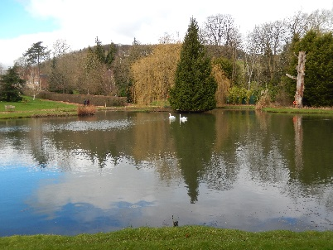
Mar 27th | Poulter Park
Apr 24th | Rufford Rufford
May 22nd | Thoresby
June 26th | Cresswell Crags

Garden Group

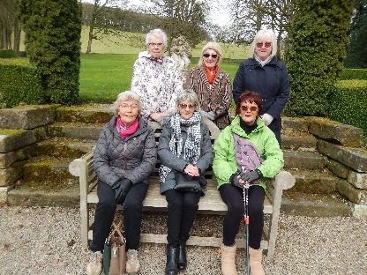
It was decided by a few members of the Garden Group to make a visit to Hopton Hall in Derbyshire to see the snowdrops. It was a lovely day and we had an enjoyable walk round the woods and gardens. Unfortunately the snowdrops were not at their best, if they had been at their height of flowering it would have been a lovely display but the hellebores, primula and few other flowers were out, so not too disappointed.

Walking Group
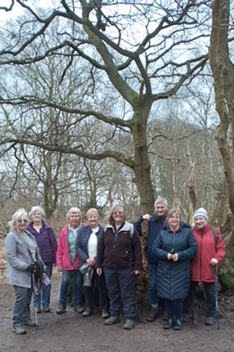
On a glorious Thursday morning in February, during half term, we started our walk from the RSPB car park at Sherwood Forest. Out of the 10 walkers, 5 were new to our group. Heading into he forest it was a time of getting to know each other. We explored new paths both in the forest and on the heathland. In all we walked just under 5 miles and on the way back decided to enjoy a drink in the RSPB café.

Our next walk around Edwinstowe will be led by Val which is on Thursday 21st March. Meet at the Carrs at 10am or join us at the RSPB car park at 10.15 at Edwinstowe.
Pam & Brenda

WALKING GROUP - 3RD THURSDAY OF THE MONTH 2024
Date | Walk Leader | Walk | Distance
21st March | Val Buckinger | Edwinstowe
18th April | Brenda Pearce | Glapwell to Hardwick Circular
16th May | Gerald Weston | Mansfield Woodhouse
20th June | Val Buckinger | Clumber Lake | 4 miles
18th July | Jen Long | Gleadthorpe | 4 miles
15th August |  | TBC
19th September |  | TBC
17th October | Brenda Pearce | Ault Hucknall | 3.5 or 5 miles
21st November |  | TBC
 |  | Walks can be subject to change

Natural History, Science and Technology.
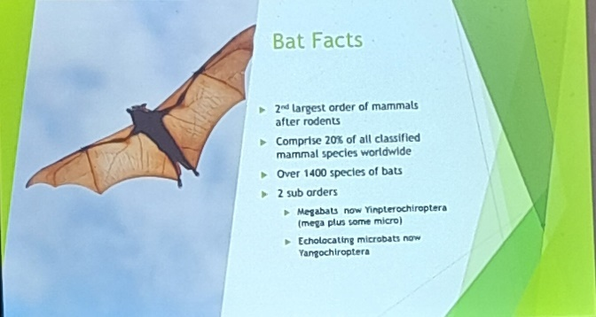
Today Sylvia gave us a talk on bats. Bats seem to get a bad press, but Sylvia showed what useful animals they really are. We looked at the many varieties of bats from the tiny Bumble Bee bat to the large fruit bats often called flying foxes. Ideas of Vampire bats drinking loads of blood was dispelled, apparently they lick the animal until small blobs of blood appear( like when we have a graze) and only take about a teaspoonful. I was particularly interested in their Echolocation- they omit a sound which” hits” eg an insect then the sound returns to the bat and it knows the location of that insect-dinner. Sylvia also entertained us with stories of her time rescuing bats from various locations and her bat hospital. Thank you very much for an interesting and informative talk.

2024
Thursday 18th April | Visit to Veolia 2.00pm | Note this is not our usual meeting date
Thursday 9th May | Habitats around Us
Thursday 13th June | Paramedic with ambulance | Because of parking the ambulance this meeting will be held at Oakroyd NG20 0EP
Thursday 11th July | St Johns | CPR and use of DEFRIBULATOR
Thursday 8th Aug | To be decided
Thursday 12th Sept | To be decided
Thursday 10th Oct | To be decided
Thursday 14th Nov | Birds in your garden
December | No Meeting

Photography Group
Last month the Photography groups ‘Face to Face’ meeting was at the Harley Galley, Welbeck Estate. It was an interesting venue with photography challenges in avoiding reflections, light glare and shadows!
The online ‘Themed’ challenge was ‘Anything that begins with either G or H’
We also welcome back to the group Yvonne Pannifer.
Joyce O’Neil – His & Hers, Hieroglyphs & Hotel.

Betty Trinder – Glass,Grapes & Hall

Joanne Wheatley – Glow, Graveyard, Gonks

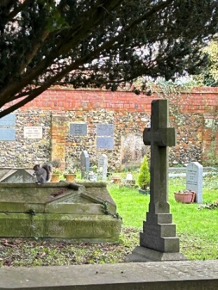

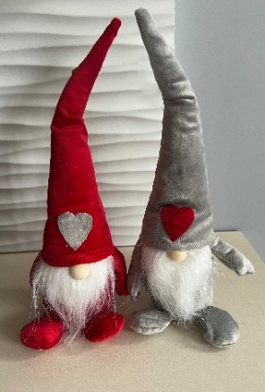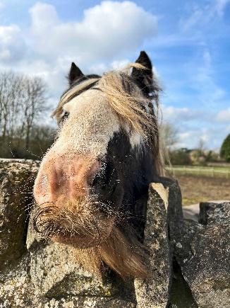

Yvonne Pannifer – Geometric disturbance, Glow & Green.
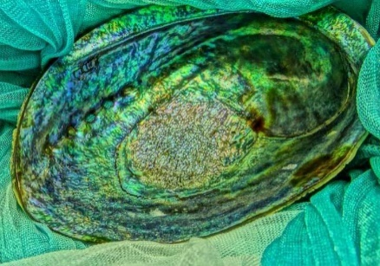
Bob Thomson – Glass, Harley Gallery, Goblin & Hogwarts.
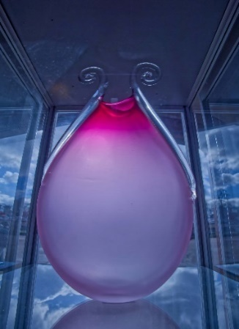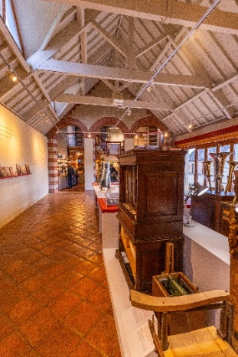

The next ‘Face to Face’ meeting will be at 11am Friday 15th March 24 with a visit to the Military Museum at Thorsby Park, meeting in the Courtyard.

The next ‘Themed’ challenge is ‘Anything that starts with either I or J’

Once again ALL u3a members are invited to take part in the online challenges!

Craft Group

The group had a cheerful morning making twiggy easter trees, it was great to see so many different ideas of decoration. Chris Shervey “found” the twigs, potted them up in Polyfilla and spraypainted them with white paint…it was then up to us to add the colour and flair! Gill even used real mini eggs!!

If you would like to join us the only thing you need to bring is a basic sewing kit and a willingness to have a go at anything. All materials are available for a very small donation to the person who brings them, if anything more specialised is required you will be given the opportunity to purchase any item needed yourself, or you can borrow from other group members.

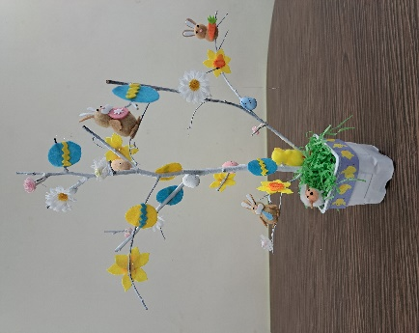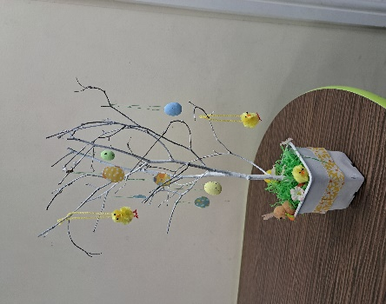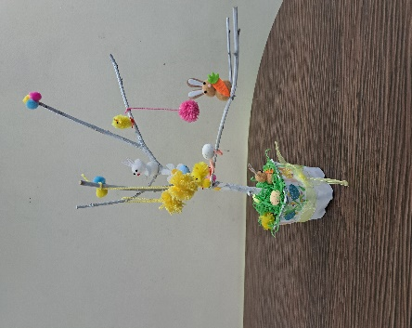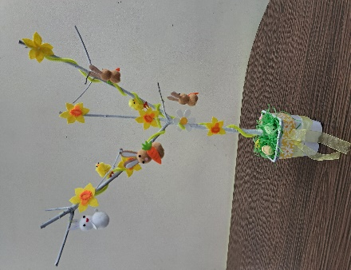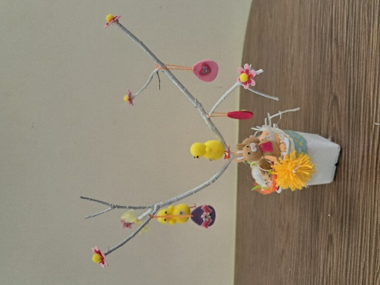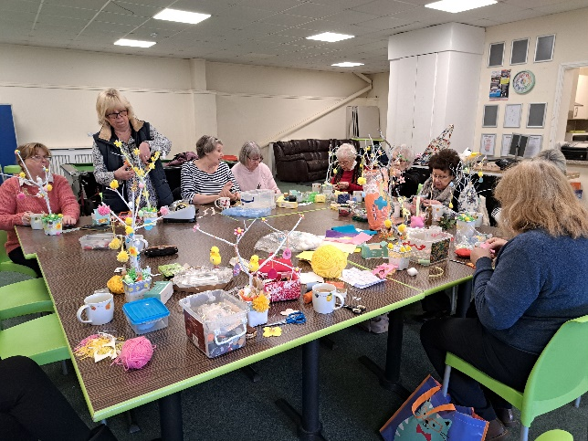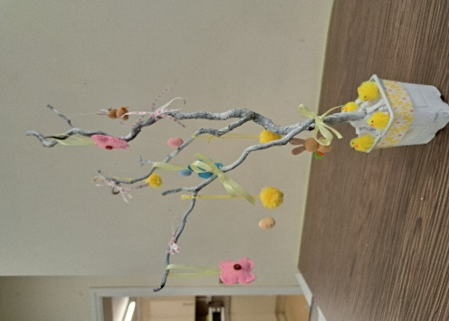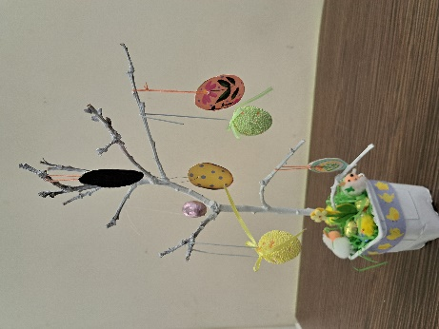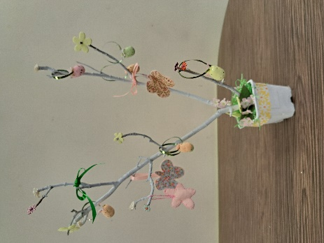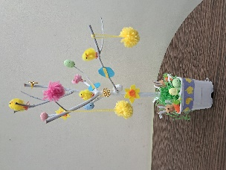
The craft group meets the first Monday of the month 10am – 12noon at THE SHED (behind the Dr’s surgery) Wood Street, Warsop. NG20 0AX.
This year’s itinerary.
8th April 2024 – Paper Beads
13th May 2024 – Pebble Painting
3rd June 2024 – Button Pictures/collages
5th August 2024 – Garden ornaments
2nd Sept, 7th Oct, 4th Nov - TBC
December 2024 – Christmas cards/calendars or wreaths

Zena

History Group
Our last meeting was on Tuesday 20th February when one of our members, Chris Shervey, gave a very interesting and informative talk entitled ‘Four Kings’.
This included William 1, John , James 1 and Charles 1. All these kings had one thing in common: their actions during their reign marked a turning point in our history. It provoked us into thinking how would things be different today if Harold had won the Battle of Hastings and the then ruling class had not been wiped out and replaced by Norman overlords? Would we have the same rights today had the Magna Carta not become a necessity due to John’s behaviour as king? What would things be like if the Gunpowder Plot had been successful and James 1 and most of the landowning gentry that ruled in Stuart times had been blown up? Also, how would our lives be different if we had remained as a Republic and not restored Charles 1 as king?
Our thanks go to Chris for all her hard work in putting this presentation together for us.
Our next meeting is on Tuesday 19th March at 10am at St. Teresa’s Church Hall Warsop when we will be having another in house presentation. Barbara Spybey will be taking us on a virtual tour of Hardwick Hall and telling the story of an amazing woman: Bess of Hardwick.
We look forward to seeing you there. All welcome.
Barbara and Tamar

2024 - Proposed Calendar of Events for Warsop & District U3A History Group
19th Mar | Hardwick Hall | St Teresa’s Church Hall 10am
16th Apr | Mining Communities  Denis Hill | St Teresa’s Church Hall 10am
21st May | The Story of Boots  Chris Weir | St Teresa’s Church Hall 10am
18th Jun | Visit to Richard 3rd Museum Leicester or Lincoln Castle and Cathedral.
16th July | Early History of Mansfield  Denis Hill | St Teresa’s Church Hall 10am
20th Aug | In house presentation  Eminent Local Sporting Personalities  Roger Holland | St Teresa’s Church Hall 10am
17th Sept | Historic Mansfield Trail  Denis Hill | Meet in Mansfield Town Square 10am
15th Oct | Nottinghamshire’s Dark Side  Chris Weir | St Teresa’s Church Hall 10am
19th Nov | Medieval Buildings & the English Civil War  James Wright TBA | St Teresa’s Church Hall 10am
17th Dec | No meeting as very close to Christmas

Speakers for the main meetings

2024

March 18th ‘Mind Your Motoring Manners 1928’ Paula Cornwell

April 15th Knickers a Brief History Janet Stain

May 20th Social time

June 17th Before They Were Famous Mel Mitchell

July 15th More Funny Turns! Dave Moylan

August 19th Medieval superstitions and science. Gareth Howell

September 16th Annual General Meeting

Group | Leaders Name | Tel
NATURAL HISTORY SCIENCE AND TECHNOLOGY | Chris Shervey
WALKING GROUP | Brenda Pearce  Pam Hick
STROLLERS | Sue Cox  Pat Magness
HISTORY GROUP | Barbara Spybey
CRAFTS | Zena Inger
GARDENING | Linda Crossley
PHOTOGRAPHY | Rob Thomson
FRIENDSHIP GROUP | Betty Trinder
INTERNATIONAL DINING GROUP | Chris Wilson  Brenda Pearce
THEATRE GROUP | Jennifer Thomson
SOCIAL EVENTS ORGANISER
DISCUSSION GROUP | Mary Morris
REFRESHMENTS | Ann Ayodele
COULD GROUP LEADERS PLEASE COLLECT THEIR BADGES WHEN COLLECTING THEIR LANYARDS. (Then members at the meeting can identify who they may need/want to talk to)

INTEREST GROUP TIMETABLE
 | MONDAY | TUESDAY | WEDNESDAY | THURSDAY | FRIDAY
1st | 10am – 12pm  CRAFTS GROUP  The Adam Eastwood Building. Warsop |  |  |  | 2pm  FRIENDSHIP GROUP  The Plough Warsop
2nd |  | 10am  GARDENING GROUP  Venue agreed by members |  | 2pm  NATURAL HISTORY  SCIENCE AND  TECHNOLOGY  Plough Warsop
3rd | MAIN MEETING 10.15  Oaklands Centre  Warsop | 10am– 12pm  HISTORY GROUP  Catholic Church Warsop |  | 10am  WALKING GROUP  Carrs Car Park | 11.am  PHOTOGRAPHY  Venue to be agreed by the members.
4th | 10.30 -12.30  DICUSSION GROUP  Forest Lodge  Edwinstowe |  | 10.am  STROLLERS  Carrs Car Park
INTERNATIONAL DINING -Location and time as announced.
THEATRE GROUP - Location and time as announced.
PHOTOGRAPHY GROUP-Please see Newsletter for the online challenge.

MARCH RIDDLES
1 What is the most expensive fish?

2 What goes, up but never comes down?

3 A cowboy rode into town on Friday, he stayed 3 days and left on Friday. How is
this possible?

March quick quiz All the answers start with I except for one.

1Which Island off the coast of Scotland is also known as St Colomba’s island?
2 Which sport has 6 per side and is played on an ice rink?
3 Name a long necked wading bird?
4 USA State dominated by the Rockie Mountains?
5 Highly infectious skin disease?
6 Modern name of Constantinople?
7 Italian city home of the annual Palio (horse race through the streets)?
8 Large breed of hunting dog?
9 A shade of blue?
10 Ancient Peruvian civilisation?

March quiz SPELL CHECK Which is the correct spelling of these words?

1 Microprocessor Microprocesor

2 Hallucinate Halucinate

3 Afirmative Affirmative

4 Antirrhinum Antirhinum

5 Behaviorism Behaviourism

6 Calendar Calander

7 Audience Audience

8 Belligerent Beligerent

9 Binoculars Binoculers

10 Doppelganger Dopellganger

11 Catermaran Catarmaran

12 Emphazise Emphasise

13 Flautist Flutist

14 Hypocondriac Hypochondriac

15 Idiosyncrasy Indiocyncrasy

16 Kumquat Komquat

17 Flourescent Flurescent

18 Misdemeanour Misdemenour

19 Doberman Dobermann

20 Volunteer Volunter

21 Scandalize Scandalise

22 Percolater Percolator

23 Neolithic Neolitthic

24 Pekingese Pekingnese

25 Judicial Judical

Well I didn’t know that!
The longest English word is PNEUMONOULTRAMICROSCOPICSILICOVOLCANOCONIOSIS
Which is a lung disease caused by silica dust.

The longest word in the world is a Sanskrit word with 195 letters.

The longest Welsh word is of course is
LLANFAIRPWLLGWYNGYLLGOGERYCHWYRNDROBWLLLLANTYSILIOGOGOCH
Which translates has Mary’s Church in the hollow of the White Hazel near a rapid whirlpool and the Church of St Tysillio near the red cave.

Answers Feb quiz Songs Each one contains a Season Part of the day or a Day of the week.E.g. Angel of the MORNING by PP Arnold

1 Fantastic DAY Haircut 100
2 SUMMER in the city The Lovin Spoonful
3 SUNDAY girl Blondie
4 Tonights the NIGHT Rod Stewart
5 What a difference a DAY makes Jamie Cullum
6 NIGHTS in white satin The Moody Blues
7 Touch me in the MORNING Diana Ross
8 NIGHTS on Broadway The Bee Gees
9 In the SUMMER TIME Mungo Jerry
10 Boogie NIGHTS Heatwave
11 DAY by DAY from Godspell
12 GOODNIGHT girl Wet Wet Wet
13 I don’t like MONDAYS Boomtown Rats
14 GOODMORNING starshine from Hair
15 Ruby TUESDAY Rolling Stones
16 I could have danced all NIGHT from My Fair Lady
17 SATURDAY NIGHTS Elton John
18 FRIDAY on my mind The Easy Beats
19 Pleasant valley SUNDAY The Monkees
20 Beautiful SUNDAY Daniel Boone

Answers Feb quick quiz All answers except one start with a H except one.

1Tradtional Scottish dish. HAGGIS
2 Set of marks used by an assay office. HALLMARKS
3 Famous orchestra in Manchester. HALLE
4 Old fashioned keyboard instrument. HARPSICHORD
5 Animal, makes it’s nest in cornfields. HARVEST MOUSE
6 Inflammation of the liver caused by a virus. HEPATITUS
7 Ornamental network of threads used for cuffs and collars. LACE
8 Female British sculptor 1903-1975 (last name H) BARBARA HEPWORTH
9 Japanese city where an A bomb was dropped. HIROSHIMA
10 British film director specialising in thrillers. (last name H) HITCHCOCK
Answers Feb riddles

1 What has a neck but no head? BOTTLE

2 What is more useful when broken? EGG

3 I am easy to lift but hard to throw, what am I? FEATHER

North Notts Neighbourhood Group
This means that you as a member of Warsop & District can ask to join an interest group in another U3A that is also in the NNNG, as long as the group is not oversubscribed at the time of your request you can join the group without joining the host u3a
The u3as in the NNNG are Mansfield, Sherwood, Dukeries, Rainworth, Forest Town, Ashfield, Sutton in Ashfield, Hucknall, Worksop and Warsop.

Data Protection Rules
Warsop & District U3A is committed to treating all people equally.
Anyone wishing to see the Privacy and Data Protection policies may view them on the Warsop & District U3A website, alternatively please ask Rob.

Website & Facebook
The Warsop & District u3a website can be found at the address below. If any of the group leaders/facilitators would like to advertise/ promote any of their future activities or change the information shown, please contact Bob Thomson.

Facebook
Warsop & District U3A has a Facebook Group. It is a private group which can be seen by the public but only members can see who’s in the group and what they post.
What this means is that you have to be invited to join the group or have your request to join accepted. Also you need to be on Facebook which some of you may not be. As a member of the group you will be able to put your own posts on the page, please keep them relevant to the U3A and what it stands for. We would ask that you don't put anything on that is in anyway party political or anything that may be offensive to others who may be of a different creed or religion. Hopefully everyone will join, use the page and find it useful.
One of the things that puts people ‘off’ Facebook, is the ‘bad press’ some of the Social sites get. You can join Facebook, choose only to join the Warsop Facebook page and not be involved in any other site, or Friends requests (usually from people that you have never heard of!) The choice is entirely yours.
To request to join the Warsop u3a Facebook page, contact Bob Thomson, email addresses as per the Website.

Committee Members | Role
Jim Shervey | Chairperson
Mel Mitchell | Deputy Chairperson
Irene Clay | Business Secretary
Linda Crossley | Treasurer
Carolyn Brankin | Membership Secretary
Jim Shervey | Speaker Seeker
Jennifer Thomson | Groups co-ordinator
Chris Shervey | Newsletter editor
Vacant | Social Events
Jennifer Thomson | Welfare Officer
Rob Thomson | Website & Facebook manager
Ann Ayodele | Refreshments rota /Quiz
June Whittle | Raffle
Betty Trinder | Social events assistant
Pat Magness | Co-opted member

