Issue 70 September 2023
Warsop & Distict
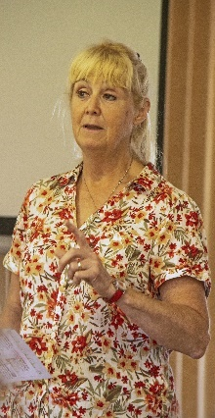
Notes from the Chairman
At our August meeting Leslie, from Veolia, gave us a very informative talk about what and how we recycle. Even though I had heard a talk from Leslie some years ago it seemed I was still getting it wrong in some areas.

As you are aware our September meeting is Annual General Meeting, don’t let that put you off, we are hoping to have some fun and raise a few pounds with the silent auction that is taking place around the AGM. All proceeds go to Warsop u3a.

Sorry I have to go there again. We are short of committee members or people to help with some of the roles the committee has so far undertaken, but don’t necessarily have to be done by committee members. If you think you might be able to help speak to any member of the committee for further information.

It is with disappointment that I have to report that the Barn Dance scheduled for October has been cancelled. See social events section for more detail.

Looking forward to seeing as many of you as possible at the AGM on Monday. Also there should be a bit of fun around the silent auction as well.
Jim Shervey
Chair

The deadline for including articles/information in the next newsletter is Friday 6th October Send contributions to Chris Shervey.
Rota for refreshments and greeting.
Please be there around 9.30 am. Any problems please let me know: 07460760870, thanks Ann.
Date | Refreshments 1 | Refreshments 2 | Meet & Greet 1 | Meet & Greet 2
September 18th | Sonia Attwood-Vlaming | Janet Harford | Brenda Pearce | Chris Wilson
October 16th | Audrey Gilbert | Zena Inger | Jillian Greer | Barbara Hartshorn

ITEMS OF INTEREST
Don’t forget it is the Silent Auction on Monday at the AGM. Please bring your 50p’s and £1’s along all proceeds go to our funds and pay towards speakers and membership fees. (A Silent Auction is when the items are placed on a table, if you wish to bid you write your bid and name on the paper with the item. To bid higher you simply write a higher price and your name on the paper).

Dukeries u3a Annual Quiz Night, Quiz Friday 24 November 2023
Jubilee Hall, Wellow Road, Ollerton, NG22 9AP
Doors Open 6.30pm Quiz starts 7.00pm Supper 7.45 pm

Supper - Chicken and vegetable casserole with mash, bread roll, tea and coffee
Vegetarian and gluten free options available.
U3a members £10 per person Non-members £11 per person

Just bring your own drinks and glasses, and a pen!

Up to four players per team. New member? We will place you with other teams!
All welcome! Prizes for the winning team!

How to pay for this ticket-only event

Bank transfer The Dukeries Third Age Group 60-17-28 account 90045998
Please reference with “Quiz23 and your name”
In cash or by cheque at the Member’s Meeting on Monday 18 September

Please enter your names, and food order, with
Leslye or Kevin, Events Team at the monthly meeting.
Or, send details of names and food orders by email to Leslye. (Details on Dukeries Website).

It’s a good social evening, (it’s not Mastermind) so anyone can join in the fun!!

Group Folders- At each main meeting the group folders are out for members to see what each group has been doing and they also give you an insight if you think you may wish to join that group. The first page of each folder is the sign up sheet if you would like to join or just wish for more information. If anyone has an idea for a group they would like to start let me know. Chris.

Robin Hood Lottery
Warsop and District U3A is a cause registered with the Robin Hood Lottery.
To buy a ticket you can now register on line at www.robinhoodlottery.co.uk and set up regular payments. If you buy a ticket every week for a year Warsop U3A will receive £26.
Remember the more members that have a go (specifying Warsop & District U3A) the more money we get for our funds.

Bottle Tops
Could you please keep collecting plastic tops from bottles of milk to raise money for the JOHN EASTWOOD HOSPICE. Bring to the main meetings. Thank you Barbara Hartshorn.
Cups Please will as many of you as possible bring your own mug for your tea or coffee. This is not only more environmentally friendly but also would save us a lot of money as the paper disposable cups we use are surprisingly expensive. Ann.

Raffle. £61made at Aug meeting. RAFFLE PRIZES NEEDED PLEASE ESPECIALLY ONES SUITABLE FOR MEN.

Books and Jigsaws 50p. £8.95made at Aug meeting. WE HAVE HAD LOTS OF NEW BOOKS AND JIGSAWS GIVEN SO PLEASE HAVE A LOOK. The books are sorted into genres e.g. Crime Non- Fiction Historical etc so it is easier to find a book you like.

Group News

Theatre Group
This Photo by Unknown Author is licensed under CC BY-NC-ND
No report this month.

Welfare
Don't forget to notify me if you know of any members who have been unable to attend meetings for 2 or 3 months due to illness. Thanks, Jen.

Social Events
I won't be at the general meeting in September, we're going away for a week.
However, Betty will be standing in for me, so anyone who has booked for The Last Night of the Proms may pay their balance. There will be one more opportunity to pay for this at the October meeting. The full cost for this event is £30 each. It's at The Hostess on Saturday 11th November, doors open 6.30pm. Don't forget your flags!
Barn Dance
Unfortunately it was decided at the recent committee meeting to cancel the Barn Dance scheduled for October. There are only 25 people wanting to attend which would potentially lead to a large financial loss, as 25 is well below the number costings were calculated on.
Thanks, Jen.
The Friendship Group

Six members of the Friendship Group met at The Plough in Warsop on the 1st September to enjoy a pleasant afternoon playing cards. The next meeting will be on the 6th October at 2.00 p.m. at The Plough.
Betty

Bowls
The Lawn Bowls season is in full swing. Our u3a members are invited to join Welbeck Bowling Club who have a very nice club house in a lovely setting on the Welbeck estate. Anyone who would like a trial go at bowls can contact Linda Crossley to make arrangements.

Dukeries u3a has a bowls club/group with access to the bowling green at Ollerton, if anybody is interested. It is not lawn bowls, but crown green bowls. A whole different ball game! If you are interested ask me for contact details. Chris Shervey

International Dining
The next evening excursion for the International Dining group will probably be in the new year. But don’t worry there was talk of a lunchtime visit for the group. Watch this space.

Walking Group
The walk for August was Maun Valley Trail to Parliament Oak. The tree so named as in 1212 King John held a Parliament under the tree when it was part of Sherwood Forest.
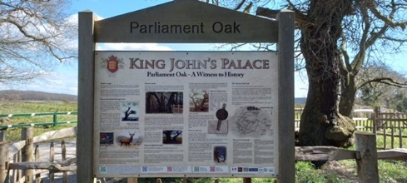
We did however do a number of detours firstly to the Spa Ponds and secondly to the man made lakes at Sherwood Fishery which was a first for some on the walk.
Autumn is definitely on its way as the hedgerows were laden with blackberries hence we did a bit of hedgerow foraging. Looks like blackberry and apple pie will be on the menu!!

September - Thursday 21st Poulter Country Park
October - Thursday 19th Gleadthorpe.

We will be putting together a programme of walks for 2024. If you have any suggestions or a favourite walk which you are willing to lead please let us know.

Regards Brenda & Pam

Garden Group

The garden group went to Dobbies Garden Centre and then to Arrow Farm for lunch, their original destination being changed because of the dreadful weather on Tuesday.

Discussion Group
This Photo by Unknown Author is licensed under CC BY-SA
The first meeting of the Discussion group will take place on Monday 25th September 10.30 -12.30 at the Forest Lodge in Edwinstowe. The price is £2.50 per session. There is plenty of parking. Also there is the opportunity to stay for lunch if you wish to do so.

Silver Screeners

Savoy cinema Worksop. For the over 50’s. Every Wednesday at 11.30. £4.15, includes a drink and free raffle.

MY BIG FAT GREEK WEDDING 3. 20th September
From writer and director Nia Vardalos, the worldwide phenomenon returns for a fun filled global adventure in MY BIG FAT GREEK WEDDING 3, releasing on 8th September 2023.

After a death in the family, the Portokalos family travel to a reunion in Greece for a heartwarming and hilarious trip full of love, twists and turns.

Photography Group
The Aug 23 ‘Face to Face’ meeting to Hardwick Old Hall was cancelled to predicted adverse weather, but the online ‘Themed’ challenge continues.
This months challenge was ‘Anything that begins with either Y or Z’

Joyce O’Neill – Y = Yellow Car / Yellow Flowers

Joanne Wheatley – Y = Yellow Leaves Z = Zonkey

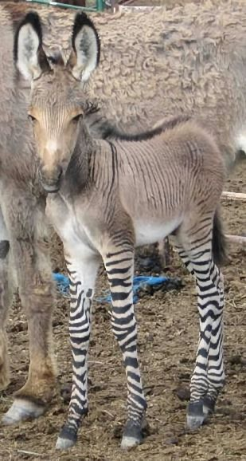

Betty Trinder – Y = Yarn
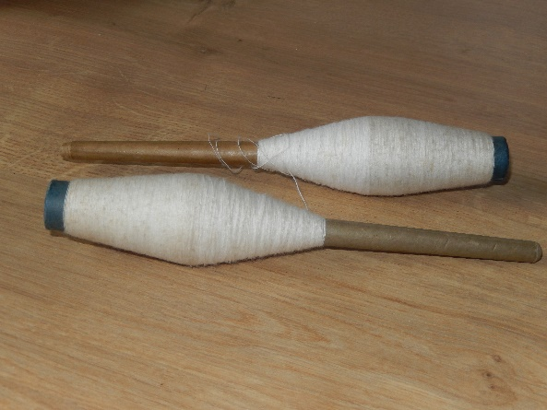
Jim & Chris Shervey – Y = Yatch at Yarmouth IOW & on the Solent

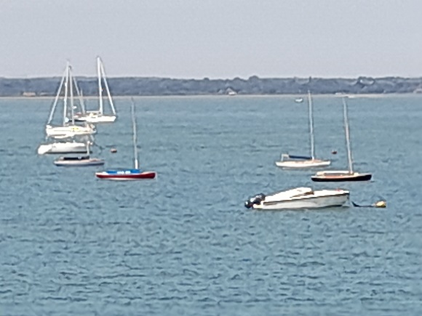

Bob Thomson – Y = Yeoman of the Guard Z = Zebra

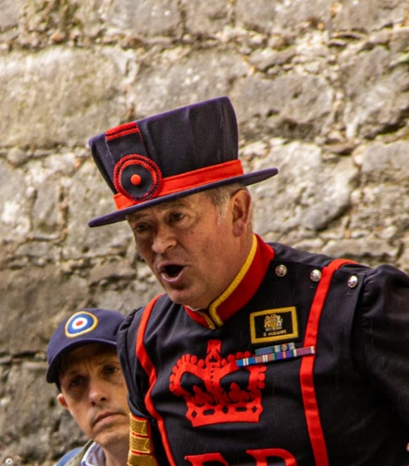
As usual a BIG thanks to Jim & Chris Shervey for joining in!

The next online ‘Themed’ challenge is ‘ Signs of Autumn or Reflections’.

As usual this challenge is open to ALL u3a members.

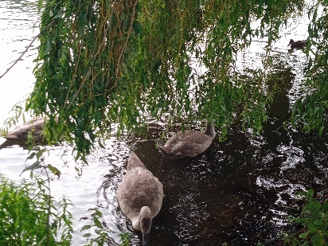
Strollers
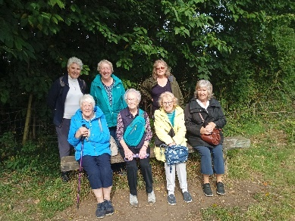
A group of 8 members met at the Carrs car park. After a damp start, we strolled by the river following the path to the bridge at Stonebridge Lane, by which time the sun had come out and we spent a short while sitting by the river. We then proceeded into Warsop to the coffee shop (of course) and spent a very pleasant hour in the sun in the rear patio garden before returning to the Carrs.
Our next stroll is on 27th September, meeting at the Carrs car park at 10.00 am for car share to Thoresby Park.
Why not join us, everyone welcome.
Pat and Sue
Bridge Club
The Dukeries u3a Bridge Group meet on the Second and Fourth Tuesday of each month at the Jubilee Hall (NG22 9AP) from 1 – 4PM. The cost of each session is currently £3.
All U3a members are welcome to attend.

Craft Group
Only five members came to this months meeting due to holidays and sickness. Anne Poultney kindly brought her stock of craft things and we each decided on a different thing to make.

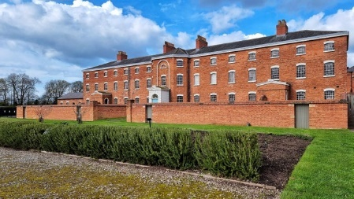
History Group
The history group visited Southwell Workhouse in August. The visit was well attended and enjoyed by members of the group. We were blessed with a beautiful, dry day for our visit.
We were met by David, a National Trust volunteer, who gave us an introductory talk about the history of the workhouse before we split into groups to tour the workhouse and the infirmary.
Southwell Workhouse, also known as Greet House, was built in 1823 and used as a ‘blueprint’ for other workhouses in the country. It was the suggestion of Reverend John Thomas Becher, a social reformer and clergyman who lived in Southwell. He, along with others, devised the ‘workhouse test,’ the rule that no relief should be given to the able-bodied without them entering the workhouse. Southwell Workhouse served 49 parishes. His workhouse system was an economic measure which reduced tax as well as a moral crusade to teach the poor to ask for help only as a l
ast resort - as many believed at that time that part of the ‘poverty’ problem was due to idleness.
Paupers, children, vagrants and the sick went to the workhouse. Families were split up; men, women and children were separated whilst there. The building was in use to house homeless families up to the 1970s.

Our next meeting on Tuesday 19th September is a visit to Bakewell Old House Museum. Following lunch in the town there is the option of a heritage walk, self-guided trail or free time to explore the town. We will be meeting at the Carrs.
Barbara, Sue and Tamar

Warsop & District U3A History Group Calendar of Events

2023
19th September 2023 | Visit to Bakewell Old House Museum and Town Heritage Trail | Meet at 9.45am at The Carrs Warsop
17th October 2023 | Presentation - Secret Passages and Hidden Tunnels  By James Wright | St Theresa’s Church Hall 10am
21st November 2023 | Presentation – Curious Occupations?  Denis Hill | St Theresa’s Church Hall 10am
December | No meeting as very close to Christmas

2024 - Proposed Calendar of Events for Warsop & District U3A History Group
16th Jan | Hayman Rooke - Denis Hill | St Theresa’s Church Hall 10am
20th Feb | Four Kings. Chris Shervey | St Theresa’s Church Hall 10am
19th Mar | Visit to Hardwick Hall -
16th Apr | Mining Communities  Denis Hill | St Theresa’s Church Hall 10am
21st May | The Story of Boots  Chris Weir | St Theresa’s Church Hall 10am
18th Jun | Visit to Richard 3rd Museum Leicester or Lincoln Castle and Cathedral.
16th July | Early History of Mansfield  Denis Hill | St Theresa’s Church Hall 10am
20th Aug | In house presentation  Eminent Local Sporting Personalities  Roger Holland | St Theresa’s Church Hall 10am
17th Sept | Historic Mansfield Trail  Denis Hill | Meet in Mansfield Town Square 10am
15th Oct | Nottinghamshire’s Dark Side  Chris Weir | St Theresa’s Church Hall 10am
19th Nov | Medieval Buildings & the English Civil War  James Wright TBA | St Theresa’s Church Hall 10am
17th Dec | No meeting as very close to Christmas

Natural History, Science and Technology
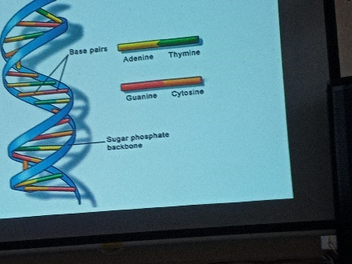
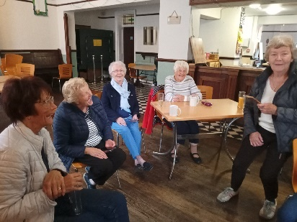
Nine of us enjoyed a talk on DNA by Joyce Oneill, who made a complicated subject easier to understand. We learnt some very interesting facts one that will stick in my mind is that we share 60% of our DNA with fruit flies! The talk was followed by a discussion on hereditary illness, blood groups and why some people can roll their tongues and other subjects. A very interesting afternoon.
It was nice to see some new people at the group, hope to see you again.
Future meetings
Weds 18th Oct afternoon | Visit to Veolia | Fully booked
Thurs 9th Nov | To be announced
Thurs 14th Dec | No meeting

Group Co-ordinators
Group | Name | Email | Tel
NATURAL HISTORY SCIENCE AND TECHNOLOGY | Chris Shervey
WALKING GROUP | Brenda Pearce  Pam Hick
STROLLERS | Sue Cox  Pat Magness
HISTORY GROUP | Barbara Spybey
CRAFTS | Zena Inger
GARDENING | Linda Crossley
PHOTOGRAPHY | Rob Thomson
FRIENDSHIP GROUP | Betty Trinder
INTERNATIONAL DINING GROUP | Chris Wilson  Brenda Pearce
THEATRE GROUP | Jennifer Thomson
SOCIAL EVENTS ORGANISER | Jennifer Thomson
DISCUSSION GROUP | Mary Morris
COULD GROUP LEADERS PLEASE COLLECT THEIR BADGES WHEN COLLECTING THEIR LANYARDS. (Then members at the meeting can identify who they may need/want to talk to)

INTEREST GROUP TIMETABLE
 | MONDAY | TUESDAY | WEDNESDAY | THURSDAY | FRIDAY
1st | 10am – 12pm  CRAFTS GROUP  The Adam Eastwood Building. Warsop |  |  |  | 2pm  FRIENDSHIP GROUP  The Plough Warsop
2nd |  | 10am  GARDENING GROUP  Venue agreed by members |  | 2pm  NATURAL HISTORY  SCIENCE AND  TECHNOLOGY  Plough Warsop
3rd | MAIN MEETING 10.15  Oaklands Centre  Warsop | 10am– 12pm  HISTORY GROUP  Catholic Church Warsop |  | 10am  WALKING GROUP  Carrs Car Park  10am | 11.am  PHOTOGRAPHY  Venue to be agreed by the members.
4th | DICUSSION GROUP  10.30 -12.30  Forest Lodge  Edwinstowe |  | 10.am  STROLLERS  Carrs Car Park  10am
INTERNATIONAL DINING -Location and time as announced
THEATRE GROUP - Location and time as announced
PHOTOGRAPHY GROUP-Please see Newsletter for the on line challenge.

Speakers for the main meetings

2023
September 18th Annual General Meeting

October 16th Funny Turns David Moylan

November 20th Inspector Hopkinsons Discovery Ian Morgan

December Christmas Party

2024
January 15th Wild West with Songs Steve Allen

February 19th A Family History(Title to be confirmed) Peter Slater

March 18th ‘Mind Your Motoring Manners 1928’ Paula Cornwell

April 15th Knickers a Brief History Janet Stain

North Notts Neighbourhood Group
This means that you as a member of Warsop & District can ask to join an interest group in another U3A that is also in the NNNG, as long as the group is not oversubscribed at the time of your request you can join the group without joining the host u3a
The u3as in the NNNG are Mansfield, Sherwood, Dukeries, Rainworth, Forest Town, Ashfield, Sutton in Ashfield, Hucknall and Warsop.

Data Protection Rules
Warsop & District U3A is committed to treating all people equally.
Anyone wishing to see the Privacy and Data Protection policies may view them on the Warsop & District U3A website, alternatively please ask Rob.

Website & Facebook
The Warsop & District u3a website can be found at the address below. If any of the group leaders/facilitators would like to advertise/ promote any of their future activities or change the information shown, please contact Bob Thomson.

Facebook
Warsop & District U3A has a Facebook Group. It is a private group which can be seen by the public but only members can see who’s in the group and what they post.
What this means is that you have to be invited to join the group or have your request to join accepted. Also you need to be on Facebook which some of you may not be. As a member of the group you will be able to put your own posts on the page, please keep them relevant to the U3A and what it stands for. We would ask that you don't put anything on that is in anyway party political or anything that may be offensive to others who may be of a different creed or religion. Hopefully everyone will join, use the page and find it useful.
One of the things that puts people ‘off’ Facebook, is the ‘bad press’ some of the Social sites get. You can join Facebook, choose only to join the Warsop Facebook page and not be involved in any other site, or Friends requests (usually from people that you have never heard of!) The choice is entirely yours.
To request to join the Warsop u3a Facebook page, contact Bob Thomson, email address as per the Website.

Committee Members | Role
Jim Shervey | Chairperson
Mel Mitchell | Deputy Chairperson
Irene Clay | Business Secretary
Linda Crossley | Treasurer
Mel Mitchell | Membership Secretary
Jim Shervey | Speaker Seeker
Chris Shervey | Groups co-ordinator
Chris Shervey | Newsletter editor
Jennifer Thomson | Social Events
Jennifer Thomson | Welfare Officer
Rob Thomson | Website & Facebook manager
Ann Ayodele | Refreshments rota
June Whittle | Raffle
Betty Trinder | Social events assistant

