Issue 68 July 2023
Warsop & Distict
Notes from the Chairman
Hi
Welcome to the July newsletter.
Can I remind you that the AGM is in September and that AGM details can be found at the end of this newsletter. Also remind you that we are in dire need of new committee members. If you are willing to help in any way please complete a nomination form.

While I am on about the AGM we are trying something different in September. We are holding a silent auction. This does’nt mean you have to sit in silence while lots of items are auctioned off. That would be boring! What happens is items are on tables around the room with a bidding sheet next to them and you write your bid and name on the sheet. There are further details below in items of interest.

Car parking comes in 2 parts today. Please remember to park in the overflow car park when at the Oaklands if the main car park is full. Secondly, we have been asked by the Parish Council to move our meeting place from the Carrs to the Tudor Barn car park if we intend to car share and leave cars parked for any length of time. Can you let any members of your groups know about the change, don’t forget visiting members from other u3as.

There are some social events coming up, Barn Dance and The Last Night of the Proms, which along with the International dining group all need action from you in the near future if you are interested. Any suggestions about a Christmas meal will also be gratefully received by Jen.
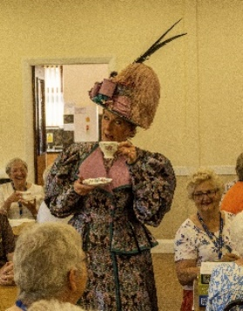
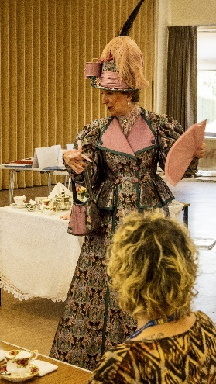
I found the speaker last month very enjoyable, Baroness Bolsover was very entertaining and educational. We all know how to sit properly, stir our tea correctly and how to manage our serviettes and why.
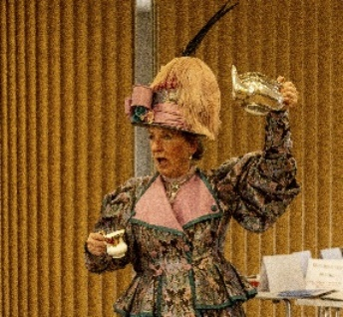

The speaker next week is Graeme Appleby he is coming to talk to us about bees, ants and wasps.

See you all on Monday.
Jim Shervey
Chair
Silent auction

The deadline for including articles/information in the next newsletter is Friday 11th August Send contributions to Chris Shervey.

Rota for refreshments and greeting.
Starting Monday 19th June at the Oaklands
Please be there around 9.30 am. Any problems please let me know, thanks Ann.
Date | Refreshments 1 | Refreshments 2 | Meet & Greet 1 | Meet & Greet 2
July 17th | Julia Easom | Lynette Cullerton | Anne Barnes | Ray White
August 21st | Glenys Fearn | Patricia England | Anne Poultney | Jean Hayes
September 18th | Jo-Ann Wheatley | Janet Harford | Brenda Pearce | Chris Wilson
October 16th | Audrey Gilbert | Zena Inger | Jillian Greer | Barbara Hartshorn
Items of interest
Notice to all groups
Groups not just our u3a meet at the Carrs (as it is a convenient place to meet) and once a car share has been sorted some cars are left there for an hour or two. We have been politely asked by the Parish Council not to do this as it takes up parking space for people wishing to use the Carrs. Instead the Parish Council say we can meet up at the Tudor Barn car park and leave cars there.

We will be holding a Silent Auction at the AGM in Sept if you have any items for the auction could you please bring them to the July and August main meeting. All proceeds to our u3a funds. (A Silent Auction is when the items are placed on a table, if you wish to bid you write your bid and name on the paper with the item. To bid higher you simply write a higher price and your name on the paper).There will be no Raffle Books or Jigsaw tables on that day.

Forest Town u3a are holding a Summer Ball, Saturday 22nd July at the Forest Town Arena starting at 7.30pm.
We thought an event like this would be a chance to invite other local u3as to come along and enjoy meeting people within our network.
The event is £15 a ticket with a complimentary drink on arrival and buffet later in the evening, we will be entertained by Ravenshead Swing Band playing Swing, dance and pop music.
If any of your members would like to join us they can send me an email on the above address. Kathryn

Robin Hood Lottery
Warsop and District U3A is a cause registered with the Robin Hood Lottery.
To buy a ticket you can now register on line at www.robinhoodlottery.co.uk and set up regular payments. If you buy a ticket every week for a year Warsop U3A will receive £26.
Remember the more members that have a go (specifying Warsop & District U3A) the more money we get for our funds.

Bottle Tops
Could you please keep collecting plastic tops from bottles of milk to raise money for the JOHN EASTWOOD HOSPICE. Bring to the main meetings. Thank you Barbara Hartshorn.
Cups Please will as many of you as possible bring your own mug for your tea or coffee. This is not only more environmentally friendly but also would save us a lot of money as the paper disposable cups we use are surprisingly expensive. Ann.

Raffle. £47 made at the June meeting. RAFFLE PRIZES NEEDED PLEASE ESPECIALLY ONES SUITABLE FOR MEN.

Books and Jigsaws 50p. £6.10 made at the June meeting. WE HAVE HAD LOTS OF NEW BOOKS AND JIGSAWS GIVEN SO PLEASE HAVE A LOOK. The books are sorted into genres e.g. Crime Non- Fiction Historical etc so it is easier to find a book you like.

Group News
Social Events
By the time this newsletter reaches everyone we will have held our latest Quiz night at the Plough. Here's hoping it's as enjoyable as usual.
The trophy has been polished!

Barn Dance, Friday 20th October at 7pm, in The Oaklands Centre. £20 each includes buffet and professional caller. Bring a friend!
I am collecting deposits of £5 for this event, there are only 3 months before this event so please book your place as soon as possible.

Last Night of the Proms, Saturday 11th November at The Hostess. £30.00. 6.30pm for 7.00
Deposits have been paid and if anyone wishes to pay the balance by instalments I am happy to collect.

Christmas Lunch! It won't be too long before we need to book this, nights are drawing in! Please let me have suggestions for a venue as soon as possible.
Jen

Welfare
Don't forget to notify me if you know of any members who have been unable to attend meetings for 2 or 3 months due to illness. Thanks, Jen.

Theatre Group
This Photo by Unknown Author is licensed under CC BY-NC-ND
The group doesn't have anything planned at the moment, so we will meet on Friday 4th August at 2pm in the Plough.
Anyone who has expressed an interest in joining the group is very welcome to join this meeting, we will be choosing our next show.
Our last visit, to see G4 in Retford, was a great night out, let's plan another!
Jen
The Friendship Group
The Friendship Group will meet at The Plough Inn on the 4th August at 2.00p.m. Look forward to seeing everyone.

Betty

Bowls
The Lawn Bowls season is in full swing. Our u3a members are invited to join Welbeck Bowling Club who have a very nice club house in a lovely setting on the Welbeck estate. Anyone who would like a trial go at bowls can contact Linda Crossley to make arrangements.

Dukeries u3a has a bowls club/group with access to the bowling green at Ollerton, if anybody is interested. It is not lawn bowls, but crown green bowls. A whole different ball game! If you are interested ask me for contact details. Chris Shervey

International Dining
For our last outing of the year we have provisionally booked 20 places for the ‘Steak Club’ (main menu also available) at the Half Moon, Whitwell Common
Venue: Half Moon, Chesterfield Road, Whitwell Common, Worksop S80 3EE
Date: Thursday 10th August 2023
Time: 5.30pm for 6.00pm
We will be taking bookings at the July meeting. Together with your menu choice and a non refundable £5 deposit. (Menu available online or we have hard copies to view at the meeting)
Brenda & Chris

Walking Group
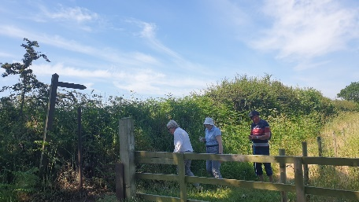
For the June walk five members started from the Oaklands centre for a circular walk round Warsop/ Spion Kop. This 4 mile walk included walking up to Peafield Lane, down to Townroe’s farm, joining the A60, walking up to the farmstead in Spion Kop then rejoining the dusty road towards the recycling centre. Although only a few of us present, we enjoyed each other’s company on what was a very hot morning.
The July walk (Thursday 20th) is Clumber/Crookford circular. This walk is approximately 6 miles so we will be out until late afternoon. Please bring refreshments and drinks as we will be making a couple of stops along the route. We will leave The Tudor Barn car park at 10.00 am prompt.

Kind regards
Brenda and Pam

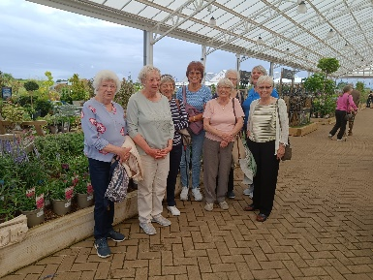
Garden Group
The Garden group took a trip to Blue Diamond Garden Centre at East Bridgeford today where we browsed the indoor shops and plants and had a lovely lunch. Very heavy showers with thunder and lightning had made us decide to change to an indoor venue.
Our next outing is 8th August meeting at The Tudor Barn car park at 10am.

Photography Group
The Photography Group visited the Walled Garden in Climber park on Friday 16th June 23, when it was a very warm, dry and sunny day. Conditions in the Long Glass house were even warmer, but the back offices and storerooms were nice and cool!
The Online ‘Themed’ challenge continues with this months challenge being ‘Anything that begins with either U or V’.
Joyce O’Neill – Clumber Walled garden - Flowers
U = Under water
Bob Thomson – Clumber Walled Garden

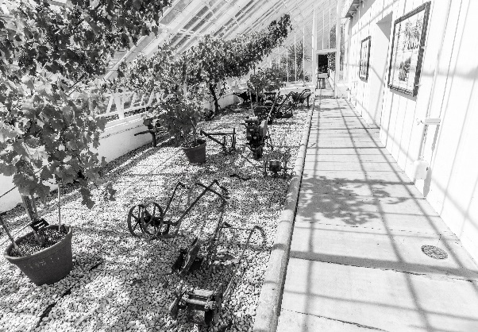

Joanne Wheatley – Umbrellas & Viaduct

Jen Thomson – Vesuvius & Unusual sculpture

U /V = Under the Colosseum & Vatican City

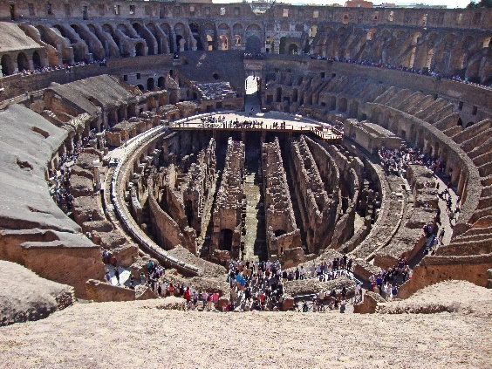

A BIG thanks to Jen Thomson, for her contribution to the ‘Themed’ challenge.
The next ‘Themed’ challenge is ‘Anything beginning with either W or X’. Best of luck with X!
As usual the challenge is open to ALL u3a members, so GET YOUR PHONE OUT, AND GET SNAPPING!
The next ‘Face to Face’ meeting will be on Friday 21st July 23, time and venue to be confirmed.

Strollers
26th July 2023
Meet 10.00 am at the Tudor Barn car park for car share to Vicar Water Country Park"

Bridge Club
The Dukeries u3a Bridge Group meet on the Second and Fourth Tuesday of each month at the Jubilee Hall (NG22 9AP) from 1 – 4PM. The cost of each session is currently £3.
All U3a members are welcome to attend.

Craft Group
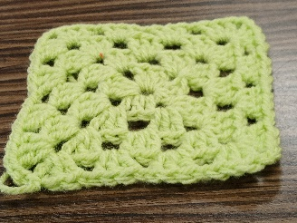
Craft group Monday 3rd July.
We were shown by one of our crafting ladies, Karen, the basics of crochet. We made “Granny Squares” There was a lot of laughter and cursing but we all had a good morning with refreshments.
Karen was very patient and helpful to those of us who were struggling to grasp the instructions and by the end of the session we had all managed to produce something small to call our own work!
I personally found it very relaxing once I got going, I hadn’t done any crochet for quite a few years
and was surprised at how quickly it all came flooding back (almost!!).
Unfortunately, not many photos were taken, I think we were all too busy chatting!
Due to school and personal holidays the group has decided not to meet in August.
The next meeting will be on Monday 4th September 2023 10 am – 12 noon in the Adam Eastwood
Building, Wood Street, Warsop. There is a gate next to Rowlands chemist if your walking, or there is
a large car park through the green metal gates off Wood Street. (Turn into the road next to the
Dentist and take the first left, then turn left at the end, the gates are along this road on the right,
down towards the new build bungalows).
Enjoy your summer.
Zena

Silver Screeners
Savoy cinema Worksop. For the over 50’s. Every Wednesday at 11.30. £4.15, includes a drink and free raffle.
19th July Indiana Jones and the Dial of Destiny
Harrison Ford returns as the legendary hero archaeologist in the highly anticipated fifth installment of the iconic “Indiana Jones” franchise, which is directed by James Mangold. 154min.

CALLING ALL BOOKWORMS!!!
Members of the Book Group met at the Plough on Wednesday 5 July. Various books were discussed but it was agreed that the Book of the Month must be-

“The Cat Who Came in From The Cold
by Deric Longden

The little cat Deric Longden saw sitting forlornly on an upturned bucket belonged to the neighbours, but somehow when it began to rain it seemed only natural to bring him inside. Once there he slipped so easily into Deric and Aileen's lives that there was an unspoken agreement that he had found his real home. Little did he know that he had entered the Longden world, in which the unexpected (almost) always happens. . .
Aileen being Aileen, it was probably inevitable that sooner or later the kitten would be trapped in the refrigerator. And Deric being Deric, the obvious way to thaw him back to life was to make a little coat for him out of a shrunken thermal vest. Thus the cat who came in from the cold got his name - Thermal - and joined the wonderful cast of characters in the ongoing Longden saga.
The next meeting of the Group is scheduled for Wednesday 2 August , 2pm at the Plough Inn Warsop .
I look forward to seeing all members then and we will be pleased to welcome any new members to our group. We have an enjoyable time and review a variety of different books.

If you would like more Information please contact me.

Mel

History Group
Warsop & District U3A History Group Meeting on Tuesday 20th June 2023
There was a good turnout of members and guests despite the heavy rainfall and we welcomed Chris Weir who spoke to us about the history of medicine in his talk, ‘Kill or Cure.’
His interest in this field was influenced by the fact his father was a GP in Glasgow and Chris’ two brothers also became doctors. His talk spanned the development of medicine from circa 400BC up to Victorian times. Chris began his talk by recommending a visit to the Doctor’s House at the Potteries Museum.
Amongst the many interesting things Chris had to tell us were these. Around 400 BC in Ancient Greece Hippocrates and Galen were pioneers in medicine. Pottery surviving from this time shows a physician bloodletting a patient. Physicians at this time commonly analysed the four humours – bile, phlegm, black bile and sanguine. Hot baths were considered crucial to maintaining health, but people had to be rich in order to afford them. Around this time many amphitheatres were built as entertainment was considered beneficial to health.
Chris spoke about the plague village of Eyam. It was believed cures for the plague at this time included elder leaves, red bramble leaves, red wine and ginger.
King Charles 11, following a sudden fit, was treated by undergoing bloodletting, taking laudanum, laxatives and tincture of human skull every day leading up to his death.
Chris then told us about the case of a farm worker in the village of Rolleston who received a dog bite and contracted rabies, in 1705. The details of this case were found in the Nottingham Archives. The man was given the liver of the dog to eat and a draft of ale before dying an agonising death.
Chris cited Edward Jenner (1749-1823) and Joseph Lister (1827-1912) as being pioneers of vaccination and infection control respectively. In Victorian times the concept of ‘taking the waters’ in spa towns became a popular belief of how to look after one’s health – an echo of Ancient Greek belief.
Jesse Boot (1850-1931) established the first nationwide pharmaceutical company from beginnings in Nottingham.
Chris finished his talk with a quote by a framework knitter by the name of James Hutchinson from Nottingham, which he found in the Nottingham Archives Date Book. This was a recipe for a long and happy life.
‘Leave milk to curdle and then eat it when it becomes cheesecake.’
The records show that James did indeed live a long life!
Anyone interested in the history trip to Southwell Workhouse on August 15th please make sure you have confirmed with Barbara that you will be coming and let her know if you are a National Trust member as we have to confirm numbers in advance of the trip.
Our next meeting is on Tuesday 18th July at 10am at St Theresa’s Church hall when Steve Horne will be talking to us about his research into Warsop in the C17th. We look forward to seeing you then.

Revised History Group Meeting Plan
18th July 2023 | In house – hall booking switched from August | St Theresa’s Church Hall 10am
15th August 2023 | Visit to Southwell Workhouse | Meet at 10am at The Tudor Barn car park Warsop
19th September 2023 | Visit to Richard III Museum Leicester | Meet at 10am at The Tudor Barn car park Warsop
17th October 2023 | Presentation - Secret Passages and Hidden Tunnels  By James Wright | St Theresa’s Church Hall 10am
21st November 2023 | Presentation – Curious Occupations?  Denis Hill | St Theresa’s Church Hall 10am

Natural History, Science and Technology
Thank you Mike for a very interesting talk on Britains Nuclear Deterrent, with fascinating facts about the original Polaris submarines and their weapon systems. Also learning how vunerable we have been in the past eg when we would have a 4 minute warning of nuclear war and the rocket we had to combat this took 14mins to launch!! Fortunately we were assured the present systems are fit for purpose.
Future meetings
Friday 11th Aug | Visit to Stainsby Mill | To be confirmed
Thurs 14th Sept | DNA | Plough Inn 2pm
Weds 18th Oct afternoon | Visit to Veolia

Group Co-ordinators
Group | Name
NATURAL HISTORY SCIENCE AND TECHNOLOGY | Chris Shervey
WALKING GROUP | Brenda Pearce  Pam Hick
STROLLERS | Sue Cox  Pat Magness
HISTORY GROUP | Barbara Spybey
BOOK GROUP | Mel Mitchell
CRAFTS | Zena Inger
GARDENING | Linda Crossley
PHOTOGRAPHY | Rob Thomson
FRIENDSHIP GROUP | Betty Trinder
INTERNATIONAL DINING GROUP | Chris Wilson  Brenda Pearce
THEATRE GROUP | Jennifer Thomson
SOCIAL EVENTS ORGANISER | Jennifer Thomson

COULD GROUP LEADERS PLEASE COLLECT THEIR BADGES WHEN COLLECTING THEIR LANYARDS. (Then members at the meeting can identify who they may need/want to talk to)
INTEREST GROUP TIMETABLE
 | MONDAY | TUESDAY | WEDNESDAY | THURSDAY | FRIDAY
1st | 10am – 12pm  CRAFTS GROUP  The Adam Eastwood Building. Warsop |  | .  2pm  BOOKS & LITERATURE GROUP  The Plough Warsop |  | 2pm  FRIENDSHIP GROUP  The Plough Warsop
2nd |  | 10am  GARDENING GROUP  Venue agreed by members |  | 2pm  NATURAL HISTORY  SCIENCE AND  TECHNOLOGY  Plough Warsop
3rd | MAIN MEETING 10.15  Oaklands Centre  Warsop | 10am– 12pm  HISTORY GROUP  Catholic Church Warsop |  | 10am  WALKING GROUP  Tudor Barn Car Park  10am | 11.am  PHOTOGRAPHY  Venue to be agreed by the members.
4th |  |  | 10.am  STROLLERS  Tudor Barn Car Park  10am
INTERNATIONAL DINING -Location and time as announced
THEATRE GROUP - Location and time as announced
PHOTOGRAPHY GROUP-Please see Newsletter for the on line challenge.

Speakers for the main meetings

2023

July 17th Bees, Ants and Wasps Graham Appleby

August 21st Lesley Taylor Talks Rubbish Lesley Taylor

September 18th Annual General Meeting

October 16th Funny Turns David Moylan

November 20th Inspector Hopkinsons Discovery Ian Morgan

December Christmas Party

2024
January 15th Wild West with Songs Steve Allen

February 19th A Family History(Title to be confirmed) Peter Slater

March 18th ‘Mind Your Motoring Manners 1928’ Paula Cornwell

April 15th Knickers a Brief History Janet Stain

July riddles
1 What always goes to bed with it's shoes on?

2 What falls but never gets hurt?

3 Where do fishes keep their money?

July quick quiz All the answers start with the letter A except one.

1 What is the study of celestial bodies and the universe called?
2 What is the name of the dam on the river Nile?
3 Who was the first female British MP? ( last name A)
4 What is the name of the early warning radar station on the North York moors?
5 Who was the Greek goddess of war /wisdom?
6 An ancient civilisation in southern Mexico?
7 A famous Scottish racecourse ?
8 Who was the famous male dancer of the 1930's? (last name A)
9 The ----------- was a failed invasion of England in 1588?
10 What is the title for designing and constructing buildings?

July quiz Can you fill in the missing word from these songs/ pieces of music about animals and birds?

1 Little Red ------------ Rolling Stones
2 Nellie the --------- Mandy Miller
3 Eye of the --------------- Survivor
4 Paddy McGintys ----------- Val Doonican
5 How much is that -------- in the window Patti Page
6 Puff the Magic ---------- Peter Paul and Mary
7 A----------- Fleetwood Mac
8 ------ out of Hell Meatloaf
9 The -------- ascending Vaughn- Williams
10 Busy Busy --------- Arthur Askey
11 B------ Michael Jackson
12 -------- Lake Tchaikovsky
13 Never smile at a ------------- Disney film Peter Pan
14 A -------- lived in a windmill Ronnie Hilton
15 Delaneys ------------- Val Doonican
16 Carnival of the --------- Saint -Saens
17 Little White ----------- Tommy Steel
18 ------- Trap Boomtown Rats
19 If I could talk to the ------------ Dr Dolittle film
20 ---------- Rock Elton John
21 ----------- crackers in my soup Shirley Temple
22 Old --------- Elvis Presley
23 Peter and the ---------- Prokofiev
24 When the red red ------------ Doris Day
25 Bye Bye -------------- Nina Simone

Well I didn't know that!

The Peregrine Falcon is the fastest bird and the fastest member of the animal kingdom with a diving speed of 242mph!

Sea Anemones are considered to be the slowest animal in the world has they rarely move of the rock they are attached to!

The African Elephant is the largest land animal with males capable of reaching 10ft in height and 7 tons in weight.

The Antartic Blue Whale is the largest animal in the world weighing up to 200 tons and reaching 98ft long!

Answers JUNE QUIZ Polysemes- one word, two meanings eg bring out / make a picture answer DRAW
1 a dish / throw a ball BOWL
2 popular sport / trying to get information FISHING
3 pay rise / lift up RAISE
4 discard / outbuilding SHED
5 tool / choice PICK
6 hair ornament / cut CLIP
7 castle tower / payment for lodgings KEEP
8 caress / a sudden illness STROKE
9 to hold eg wood / sin VICE
10 bread / laze about LOAF
11 sports area / tar PITCH
12 criticise / cooking utensil PAN
13 dog noise / tangled up SNARL
14 give advice / form of government COUNCIL
15 thread / story YARN
16 journalists / to iron PRESS
17 to fight / container BOX
18 piece of wood / to record LOG
19 to follow constantly / flower stem STALK
20 to sieve / under pressure STRAIN
21 to choose / tool PICK
22 a dance / holder for cotton REEL
23 to do something / part of a play ACT
24 fastener / to eat food quickly BOLT
25 wooden pole / bet STAKE
26 mine entrance / handle SHAFT
27 sum of money given before it is due / move forward ADVANCE
28 to give support ( an event) / part of a body HEAD
29 type of / gentle KIND
30 old car / slang for a type of food BANGER (Sausage)

Answers June riddles
1 What has to be broken before you can use it ? AN EGG

2 What month of the year has 28 days? ALL OF THEM

3 What is always in front of you but cannot be seen? THE FUTURE

June quick quiz All the answers are colours
1 Flight Recorder? BLACK BOX
2 Billy Bunters School ? GREYFRIARS
3 Resort known for it's illuminations? BLACKPOOL
4 Mick Hucknall is the singer of which pop group? SIMPLY RED
5 In the song what was given on the 5th day of Christmas? 5 GOLD RINGS
6 A USA detective agency? PINKERTONS
7 Where the cenotaph stands in London? WHITEHALL
8 The transport of the owl and the pussycat in Lears poem? PEA GREEN BOAT
9 Another name for Mercury? QUICK SILVER
10 Winner of 3 Grand Nationals? RED RUM

North Notts Neighbourhood Group
This means that you as a member of Warsop & District can ask to join an interest group in another U3A that is also in the NNNG, as long as the group is not oversubscribed at the time of your request you can join the group without joining the host u3a
The u3as in the NNNG are Mansfield, Sherwood, Dukeries, Rainworth, Forest Town, Ashfield, Sutton in Ashfield, Hucknall and Warsop.

Data Protection Rules
Warsop & District U3A is committed to treating all people equally.
Anyone wishing to see the Privacy and Data Protection policies may view them on the Warsop & District U3A website, alternatively please ask Rob.

Website & Facebook
The Warsop & District u3a website can be found at the address below. If any of the group leaders/facilitators would like to advertise/ promote any of their future activities or change the information shown, please contact either Bob Thomson or Ann Ballinger.
www.u3asites.org.uk/Warsop

Facebook
Warsop & District U3A has a Facebook Group. It is a private group which can be seen by the public but only members can see who’s in the group and what they post.
What this means is that you have to be invited to join the group or have your request to join accepted. Also you need to be on Facebook which some of you may not be. As a member of the group you will be able to put your own posts on the page, please keep them relevant to the U3A and what it stands for. We would ask that you don't put anything on that is in anyway party political or anything that may be offensive to others who may be of a different creed or religion. Hopefully everyone will join, use the page and find it useful.
One of the things that puts people ‘off’ Facebook, is the ‘bad press’ some of the Social sites get. You can join Facebook, choose only to join the Warsop Facebook page and not be involved in any other site, or Friends requests (usually from people that you have never heard of!) The choice is entirely yours.
To request to join the Warsop u3a Facebook page, contact either Ann Ballinger or Bob Thomson, email addresses as per the Website.

Committee Members | Role
Jim Shervey | Chairperson
Mel Mitchell | Deputy Chairperson
Irene Clay | Business Secretary
Linda Crossley | Treasurer
Mel Mitchell | Membership Secretary
Jim Shervey | Speaker Seeker
Chris Shervey | Groups co-ordinator
Chris Shervey | Newsletter editor
Jennifer Thomson | Social Events
Jennifer Thomson | Welfare Officer
Rob Thomson | Website & Facebook manager
Ann Ayodele | Refreshments rota
June Whittle | Raffle
Betty Trinder | Social events assistant
Ann Ballinger | Assistant IT manager

Notice of Warsop and District Annual General Meeting (AMG)
Monday 18th September 2023 10.15am at Oaklands, Oaklands Lane,Warsop, NG20 OJE
It will soon be time for the AGM and these papers are in preparation for the event.
At the AGM the membership has to vote in the four Honorary officer posts of Chair, Vice-Chair, Treasurer and Business Secretary.
The current officers, Jim Shervey - Chair, Mel Mitchell - Vice-Chair, Irene Clay - Business secretary Linda Crossley – Treasurer
All of these positions are open for nominations and the nominating and seconding process is necessary for each office. More positions are available and nominations would be most welcome from members wishing to join the committee in a non-officer role. Which means that you would be able to take on a role or be available to help other committee members as needed, which will ultimately lessen the load on each individual.
The nomination forms are included with this document, the completed forms must be returned to Irene (Business Secretary) by the 14thAugust 2023. The votes will then be taken at the AGM.
The committee holds at least 3 meetings a year, sometimes more, usually lasting about 2 hours.
The role of the committee is to ensure that Warsop & District u3a runs as well as it can for the members. If you feel that you would like to join the committee come and talk to one of the current team.
The current positions are (there can be up to 15 committee members):
Committee Members | Role
Jim Shervey | Chairperson & Speaker Organiser
Mel Mitchell | Vice Chairperson & Membership Secretary
Irene Clay | Business Secretary
Linda Crossley | Treasurer
Chris Shervey | Groups co-ordinator & Newsletter Editor
Ann Ayodele | Refreshments & Meeters + Greeters
Jennifer Thomson | Social Events Organiser & Welfare
Betty Trinder | Social Events
June Whittle | Raffle organiser
Bob Thomson | Website and Face-book manager
Ann Ballinger | Website and Face-book

NOMINATION FOR HONORARY OFFICER- Chair/Vice chair/Business secretary/Treasurer
NOMINATION FOR COMMITTEE MEMBER- Committee member or named role

Post nominated for (Choose from above)-

Name of Nominee-

Signature

Address

Telephone

Email

Name of proposer

Signature

Name of Seconder

Signature

Return to the Business Secretary - Irene Clay, Business Secretary.

