Issue 66 May 2023
Warsop & Distict
Notes from the Chairman
Hi Everybody

Another month has gone by very quickly. But it has been a very busy month with the usual group meetings taking place and the Coronation Garden party. Thank you to all those who attended, there were about 40 of us. I enjoyed the afternoon chatting and taking part in the various activities, even the damp weather could not hold us back, we all managed to stay dry. Thank you Bob for helping set the tent up the day before and for the helpers who assisted and those for tidying up and taking the tent down.

The talk at the meeting this month is being given by Autumn Rose and is on road safety, I have heard good reports about the presentation and am looking forward to it.

An early warning for next months meeting. We have Baroness Bolsover with an Afternoon Tea + Etiquette demonstration. It is an interactive talk and we need to bring with us a cup and saucer, a spoon and a napkin. (People who have seen her before say she is very entertaining and worth seeing)

See you all on Monday.
Jim Shervey
Chair

The deadline for including articles/information in the next newsletter is Friday 9th June. Send contributions to Chris Shervey.
Rota for refreshments and greeting.
Starting Monday 15th May at the Oaklands
Please be there around 9.30 am. Any problems please let me know, thanks Ann.
Date | Refreshments 1 | Refreshments 2 | Meet & Greet 1 | Meet & Greet 2
May 15th | Jo-Anne Wheatley | Kate Guest | Moira Heslop | Yvonne Brown
June 19th | Wendy Sterland | Janice Thorlbury | David Buckinger | Ruth Murphy
July 17th | Julia Easom | Lynette Cullerton | Anne Barnes | Ray White
August 21st | Glenys Fearn | Patricia England | Brenda Pearce | Chris Wilson
September 18th | Jillian Greer | Janet Harford | Anne Poultney | Jean Hayes
October 16th | Audrey Gilbert | Zena Inger | Caroline Brankin | Barbara Hartshorn

Items of interest
We will be holding a Silent Auction at the AGM in Sept if you have any items for the auction could you please bring them to the July and August main meeting. All proceeds to our u3a funds. (A Silent Auction is when the items are placed on a table, if you wish to bid you write your bid and name on the paper with the item. To bid higher you simply write a higher price and your name on the paper).

Sherwood U3A Trip
Malton and Eden Camp Tuesday 13th June 2023 Cost £26 per person.
Leaving Morrisons Mansfield Woodhouse 8.15am. You can leave a car parked at Morrisons all day no problem also leaving Iceland Mansfield 8.30am.
Itinerary - Free time explore Malton and coffee etc. On to Eden Camp for free time to explore the 2nd world war outdoor and indoor exhibitions and other interesting exhibitions. Leave Eden Camp 4.00pm.
Chris Wilson will collect any names of people that want to come with us at your May meeting.
Many thanks Ray and Jean Baker

Robin Hood Lottery
Warsop and District U3A is a registered cause with the Robin Hood Lottery.
To buy a ticket you can now register on line at www.robinhoodlottery.co.uk and set up regular payments. If you buy a ticket every week for a year Warsop U3A will receive £26.
Remember the more members that have a go (specifying Warsop & District U3A) the more money we get for our funds.

Bottle Tops
Could you please keep collecting plastic tops from bottles of milk to raise money for the JOHN EASTWOOD HOSPICE. Bring to the main meetings. Thank you Barbara Hartshorn.
Cups Please will as many of you as possible bring your own mug for your tea or coffee. This is not only more environmentally friendly but also would save us a lot of money as the paper disposable cups we use are surprisingly expensive. Ann.

Raffle The February raffle raised £54 for funds. Thank You.
RAFFLE PRIZES NEEDED PLEASE ESPECIALLY ONES SUITABLE FOR MEN.

Books and Jigsaws 50p The books are sorted into genres e.g. Crime Non- Fiction Historical etc so it is easier to find a book you like. £4.10 was made from the books and jigsaws in February.

Group News
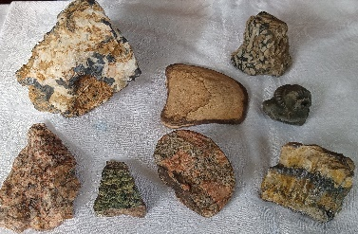
Natural History Science and Technology
We had a very interesting talk given by Jim on how rocks are formed through weathering, pressure and heat. We looked at Metaphoric Sedimentary and Igneous rocks and Jim had examples of all the types for us to handle and discuss. We also discussed plate tectonics, Whitby Jet the formation of diamonds and the Marianna Trench.

Theatre Group
This Photo by Unknown Author is licensed under CC BY-NC-ND
Those going to see G4 in June need to let me have £5 deposit for the pre show meal, which has been booked at The Rondo Lounge in Retford.
I also need £0.90 booking fee from everyone too please. I shall collect at the May meeting.
Thank you, Jen.
The Friendship Group
The Friendship Group met and enjoyed a sociable afternoon. Looking ahead our June meeting will be on Friday 2nd June at 2.00 p.m. venue as usual at The Plough.

Betty Trinder

Bowls
The Lawn Bowls season will start this April. Our u3a members are invited to join Welbeck Bowling Club who have a very nice club house in a lovely setting on the Welbeck estate. Anyone who would like a trial go at bowls can contact Linda Crossley to make arrangements.

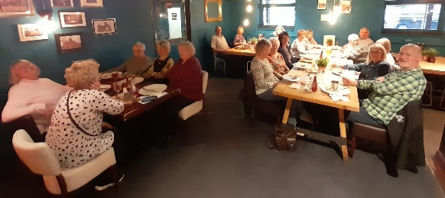
International Dining
Eighteen of us had a good time at the Tap Haus on the 4th May. Good company and good food.The next outing is already being planned.

Walking Group
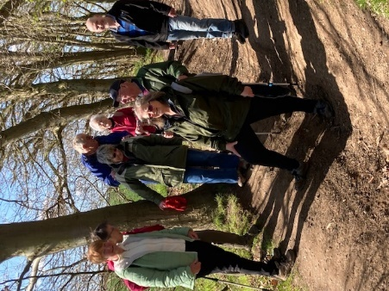
This year we didn’t miss the Bluebells. Twelve of us set off for the walk following footpaths along The Carrs then through Church Warsop Woods/ Cuckney Woods and we weren’t disappointed. We were greeted with a carpet of woodland flowers including bluebells, celandines and wood anemone. The walk was a leisurely affair of approximately 3.6 miles.

For our May walk (Thursday 18th May) we will be heading to Idle Valley Nature Reserve (Notts Wildlife Trust)
North Road
Retford
DN22 8QR

Leaving The Carrs at 10.00. a.m. prompt to travel to Idle Valley (we will car share where possible). There is a car parking donation charge of £3.
Please bring a snack and drink as we will not arrive back to Warsop till mid afternoon.

There are 4 designated walking routes which range from 2 miles to 5.8 all easy flat walking. Hopefully weather permitting we will do the longer walk with stops along the way.

About the reserve
This reserve consists of a beautiful 375ha network of lakes, wetland, grassland and scrub. It is home to a diverse range of wildlife and is recognised as one of the richest birding sites in the region. Look out for birds such as gadwall and little grebe in winter and breeding wading birds including little ringed plover and redshank in spring and summer. Rare breed cattle and sheep can be seen in various areas around the reserve.

The Beavers are back.
A pair and a family with 4 kits have been released into an enclosed section of the reserve

Note: June walk Warsop/ Spion Kop circular approximately 4 miles. On this occasion we will be leaving The Oaklands at 10.00

Brenda & Pam
Photography Group
The first ‘Face to Face’ meeting scheduled for last month had to be cancelled due to inclement weather conditions, but the online ‘Themed’ challenge of ‘Things beginning with either Q or R’ continued to operate. This month we had some new contributors to the challenge. A BIG thank you to Ann Ayodele, Jen Thomson, and Jim and Chris Shervey for their photos.
Ann Ayodele – Quince & Quixo
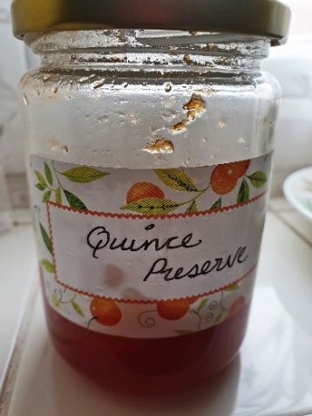
Jen Thomson – Quilts
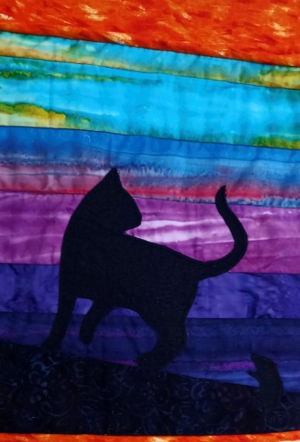
Jim Shervey – Quadruple Quadrupeds
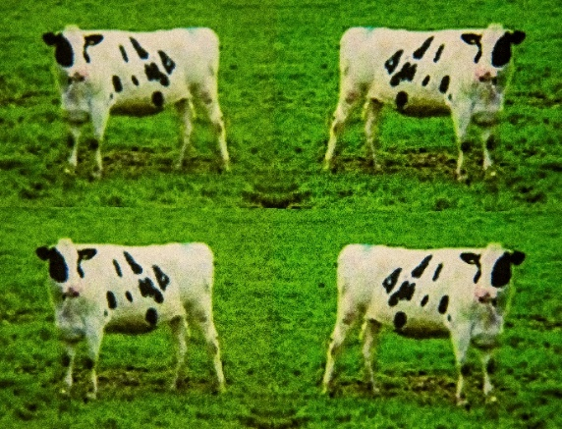
Chris Shervey – Queens & Rabbit
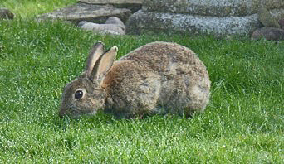
Joanne Wheatley - Quokka & Rheas
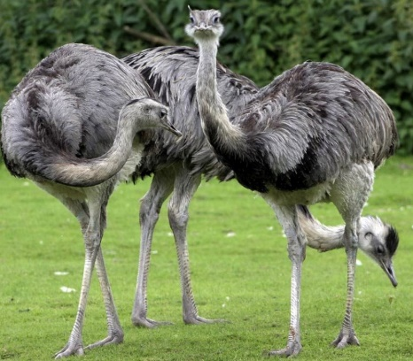
Joyce O’Neill – Queens Funeral & Roof
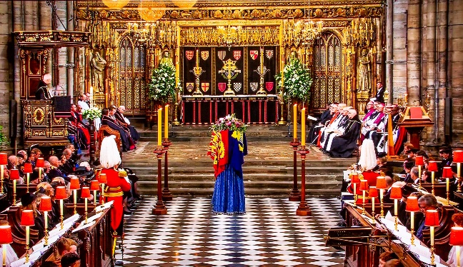
Betty Trinder – Queens & Rose
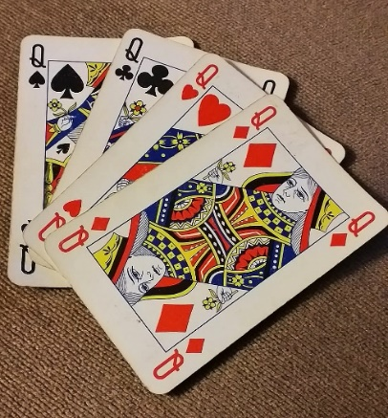
Bob Thomson – Quay side & Red Dragon fly
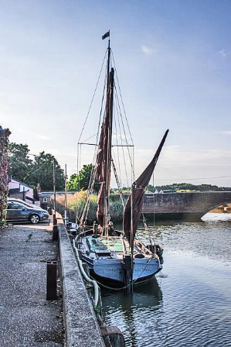
The next online ‘Themed’ challenge is ‘Anything beginning with either S or T’
As usual the challenge is open to ALL u3a members, it doesn’t matter if the photos are taken with a DSLR/Mirrorless or mobile phone camera, just as long as the subject is relevant, and hopefully in focus!
For the next ‘Face to Face’ meeting, we will try again, and hopefully visit the St Edwins Chapel Cross (Iron Cross) situated in the Birklands Forest, Warsop.
Parking and directions same as last months email. Meeting at 11am Friday 19th May 23.

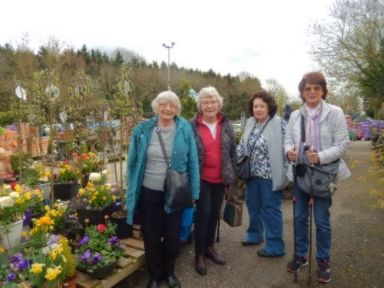
Garden Group
The Gardening Group had a very enjoyable day out to Reg. Taylor's Garden Centre and Southwell Garden Centre in April. We had coffee at Reg Taylor's and a very pleasant walk around the Garden Centre and the gift areas. We then proceeded to Southwell Garden Centre where we had a very nice lunch and again a look around the many plants for sale. The next meeting will be to Tissington Hall in Derbyshire on Tuesday, 13th June meeting at The Carrs at 10.00 a.m.
Betty

Strollers
"Due to unforeseen circumstances, we were unable to visit Rufford Park on our last walk. However seven members did go to Cresswell Craggs. We had a very pleasant morning and we did see some bluebells along with cowslips, all looking very colourful in the Spring sunshine. It was even warm enough for us to sit outside for our refreshments at the Craggs cafe.
May 24th 2023 - Rufford Park
Meet at 10.00 am at the Carrs car park for car share to Rufford. New members welcome.
Pat and Sue"

Bridge Club
The Dukeries u3a Bridge Group meet on the Second and Fourth Tuesday of each month at the Jubilee Hall (NG22 9AP) from 1 – 4PM. The cost of each session is currently £3.
All U3a members are welcome to attend.
Craft Group

The next meeting will be on Monday 5th June 10am - 12noon at the Shed (behind the Dr's surgery)
We will doing macrame work. This is a challenge for some of us 🫤 but if you want an enjoyable, sociable morning with good company, a cuppa with a biscuit or two then please come along and join the fun.
P.S. what happens in the group stays in the group. 🤫
Zena

Silver Screeners
Savoy cinema Worksop. For the over 50’s. Every Wednesday at 11.30. £4.15, includes a drink and free raffle.
On the 17th May the film is The Unlikely Pilgrimage of Harold Fry
Starring Academy Award Winner Jim Broadbent and Penelope Wilton, The Unlikely Pilgrimage of Harold Fry is an uplifting tale of self-discovery and learning to seize the moment.

CALLING ALL BOOKWORMS!!!
The members of the Book Group met at the Plough on Wednesday 3 May.
Only 4 members attended due to other members having other commitments,
Two of the books we reviewed were

“Five People You Meet in Heaven “
By Mitch Albom

The Five People You Meet In Heaven is a 2003 novel by Mitch Albom. It follows the life and death of a ride mechanic named Eddie who is killed in an amusement park accident and sent to heaven, where he encounters five people who had a significant impact on him while he was alive.

Another book we discussed chosen for the Newsletter Review is.
Lost For Words
By Deric Longdon

Deric Longden's mum was a wonderfully endearing, eccentric lady whose passions ranged from pot plants and her beloved pussycats to Buttercup Syrup which she consumed in vast quantities. She also provided comfort, advice and her own particular brand of wisdom in the years when Deric was struggling after the death of his first wife, Diana. Deric's many happy memories include the vision of his mother's unmistakeable backside as she charged through Marks & Spencers; the way in which she charmed everyone she met, including the surliest of youths, and her unusual technique of selling a house which involved plying potential buyers with iced buns whilst pointing out the damp patches and dodgy electrics. Strangely, it worked. Lost For Words is a funny, poignant and ultimately heart warming book that may well make you cry, but will certainly make you laugh.

The next meeting of the Group is scheduled for Wednesday 7 June, 2pm at the Plough in Warsop.

I look forward to seeing all members then and we will be pleased to welcome any new members to our lowbrow not highbrow group.

If you would like more Information please contact me.

Mel

History Group
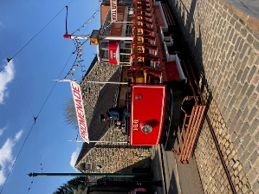
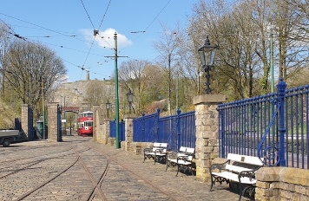
The history group enjoyed a visit to the Tram Museum in Crich on the 18th April. We were blessed with a beautiful sunny day to wander this amazing museum. The museum was founded in 1959 on the site of an old quarry which was previously owned by George Stephenson. The volunteers who began work here wanted to preserve the history of our tram system, which at this time was being dismantled across the country at the end of a century of providing cheap and accessible transport to ordinary people. From humble beginnings this project grew to what we see at the museum today.
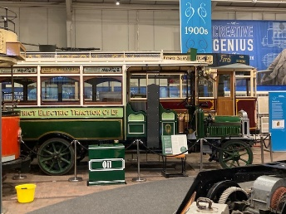
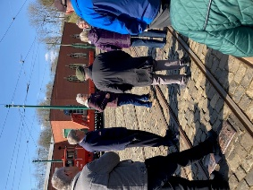
Our guide, Michael, took us on a forty-minute tour of the Great Exhibition Hall where he spoke about each tram on display and told us the story of the tram age in this country which spanned a century from 1860 to 1960. Initially the museum hoped to preserve twenty trams but now has sixty in its care. In addition to the Great Exhibition Hall where the trams are displayed new buildings were erected to house the trams, and to repair and renovate them in. Ironically, fifty years later we are once again seeing trams operating in our cities.
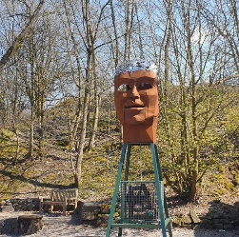
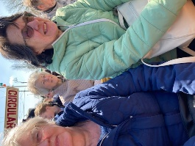
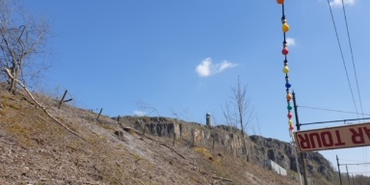
A track stretches the length of the site and trams run every ten minutes between the Model Village and Glory Mine. We took a ride in an open topped tram. Views across the Derwent Valley were breath-taking. A short climb up the footpath at the Glory Mine stop takes you up to the Crich Memorial. This is a war memorial for the Sherwood Foresters Regiment. The tower is manned by volunteers, and it is possible to climb to the top of the tower when it is open. We remained on the tram and travelled back to the Model Village, but it is possible to take a leisurely walk back along the woodland path and through the Sculpture Trail where the C18th Stokoe Lead Condenser can be seen, currently cared for by the Industrial Archaeological Association.
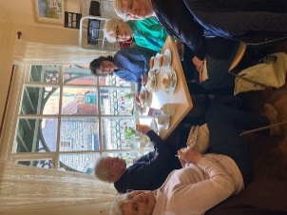
We had a choice of lunch venue, either a picnic in Victoria Park or on the Woodland Trail or Rita’s café or the Red Lion pub at the Model Village. We opted for a light lunch at Rita’s. This was followed by another tour with Michael, this time around the Model Village.
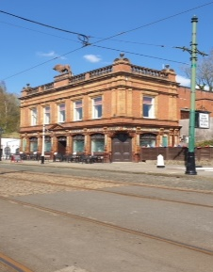
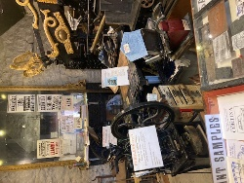
In addition to preserving and running the trams a model village was constructed at the museum with the aim of putting the trams into the context of the times they were operational using building frontages and other street furnishings from the 1860 to 1960 period. Many of these buildings related to the trams. The Red Lion pub for example, was taken down brick by brick and then rebuilt at the museum brick by brick, tile by tile, was once used by the tram way men when they received their wages. Michael also explained how the Derby Assembly rooms frontage came to be at the museum, along with a penny bank and tram office. These now house an exhibition about electric trams then and now downstairs and an extensive library of documents and small items relating to the tram era upstairs. Original stone buildings on the site include a forge and one has been converted to a printing press.
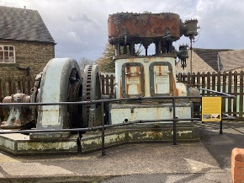
Decorative Victorian and Edwardian railing adorn much of the site, the main gates having been part of a railway station at one time. We saw a Lucy box, used when the trams changed from being drawn by horse back to being operated by electricity. There was an electricity generator, used before there was a national grid, various telephone, and post boxes from different times of the tram era and a police box – but we didn’t get to meet Dr Who!
Our thanks go to Michael for such excellent and informative tours and all the dedicated volunteers who have created this excellent museum for us all to enjoy. More development is planned but currently put on hold due to fall in income during the covid pandemic and fewer visitors following this. The tour guides, tram drivers, people carrying out restoration and majority of the people working at the tram museum are all volunteers. They truly have done an amazing job as they receive no Government funding; they are reliant on the money they raise from entrance fees and events to fund the work they do. There are no additional charges to ride the tram. Participate in guided tours or enter any of the exhibitions – it is included in the ticket price and full price tickets allow re-entry to the museum for a year. I think it is definitely a great day out for all the family.
Also thank you to Ann Ballinger for providing some of the photos of our visit to share in this newsletter article.
Next month we meet on Tuesday 16th May at St Theresa’s Church Hall at 10am when we welcome Denis Hill who will be speaking about Wellow’s history and heritage. The walking group may be interested to know there is a heritage walk of Wellow available from Denis. Refreshments will be served as usual at the meeting. We look forward to seeing you there; bring a friend, everyone is welcome.
Local Events of Interest
Friday 19th May - Local History Event - Warsop Library 10am-12noon
Look through the Old Warsop Society’s albums of pictures of Warsop’s past and share your memories of how Warsop used to be.
Revised History Group Meeting Plan
16th May 2023 | Presentation -Wellow History and Heritage  Denis Hill | St Theresa’s Church Hall 10am
20th June 2023 | Presentation - Kill or Cure  Chris Weir | St Theresa’s Church Hall 10am
18th July2023 | In house – hall booking switched from August | St Theresa’s Church Hall 10am
15th August 2023 | Visit to Southwell Workhouse | Meet at 10am at The Carrs Warsop
19th September 2023 | Visit to Richard III Museum Leicester | Meet at 10am at The Carrs Warsop
17th October 2023 | Presentation - Secret Passages and Hidden Tunnels  By James Wright | St Theresa’s Church Hall 10am
21st November 2023 | Presentation – Curious Occupations?  Denis Hill | St Theresa’s Church Hall 10am
Social Events
Coronation Garden Party
This will have been held by the time you receive this, let's hope the weather didn't spoil the fun!

Trent River Cruise, Friday 9th June, 11.45am for 12.00 sailing from River Lodge, 100 Racecourse Road, Colwick, NG2 4RF.
I must collect the balance of £17.75 from everyone at our May meeting, as it must be paid over by 26th May. Thank you.
(Please let me know if you have problems getting to the departure point.)

Quiz Night with supper at the Plough, Thursday 13th July. £6 each. Each member may bring one guest.
I shall be collecting for this event at the May and June meetings.

Barn Dance 2023! Friday 20th October, 7-10pm at the Oaklands
Cost to be confirmed after the next committee meeting, hopefully the same as last year.

Last Night at the Proms, Saturday 11th November at the Hostess. £30.00 includes 3 course meal. Doors open 6.30pm, meal orders taken at 7pm.
Anyone wishing to pay the balance by instalments is welcome to do so. I have paid the deposit for those who booked.

Lots to look forward to, ideas for future events always welcome! Jen.

Welfare
Don't forget to notify me if you know of any members who have been unable to attend meetings for 2 or 3 months due to illness. Thanks, Jen.

Group Co-ordinators
Group | Name | Email | Tel
NATURAL HISTORY SCIENCE AND TECHNOLOGY | Chris Shervey
WALKING GROUP | Brenda Pearce  Pam Hick
STROLLERS | Sue Cox  Pat Magness
HISTORY GROUP | Barbara Spybey
BOOK GROUP | Mel Mitchell
CRAFTS | Zena Inger
GARDENING | Linda Crossley
PHOTOGRAPHY | Rob Thomson
FRIENDSHIP GROUP | Betty Trinder
INTERNATIONAL DINING GROUP | Chris Wilson  Brenda Pearce
THEATRE GROUP | Jennifer Thomson
SOCIAL EVENTS ORGANISER | Jennifer Thomson

INTEREST GROUP TIMETABLE
 | MONDAY | TUESDAY | WEDNESDAY | THURSDAY | FRIDAY
1st | 10am – 12pm  CRAFTS GROUP  The Adam Eastwood Building. Warsop |  | .  2pm  BOOKS & LITERATURE GROUP  The Plough Warsop |  | 2pm  FRIENDSHIP GROUP  The Plough Warsop
2nd |  | 10am  GARDENING GROUP  Venue agreed by members |  | 2pm  NATURAL HISTORY  SCIENCE AND  TECHNOLOGY  Plough Warsop
3rd | MAIN MEETING 10.15  Oaklands Centre  Warsop | 10am– 12pm  HISTORY GROUP  Catholic Church Warsop |  | 10am  WALKING GROUP  Carrs Car Park  10am | 11.am  PHOTOGRAPHY  Venue to be agreed by the members.
4th |  |  | 10.am  STROLLERS  Carrs Car Park  10am
INTERNATIONAL DINING -Location and time as announced
THEATRE GROUP - Location and time as announced
PHOTOGRAPHY GROUP-Please see Newsletter for the on line challenge.

Speakers for the main meetings

2023

May 15th Road safety (more interesting than it sounds) Autumn Rose

June 19th Baroness Bolsovers Afternoon Tea + Etiquette Baroness Bolsover
Demonstration. Participation required!!

July 17th Bees, Ants and Wasps Graham Appleby

August 21st Lesley Taylor Talks Rubbish Lesley Taylor

September 18th Annual General Meeting

October 16th Funny Turns David Moylan

November 20th Inspector Hopkinsons Discovery Ian Morgan

December Christmas Party

2024
January 15th Wild West with Songs Steve Allen

February 19th A Family History(Title to be confirmed) Peter Slater

March 18th ‘Mind Your Motoring Manners 1928’ Paula Cornwell

April 15th Knickers a Brief History Janet Stain

MAY RIDDLES
1 What band never plays music ?

2 What have Alexander the great and Winnie the Pooh in common?

3 What room has no windows or doors?

May Quiz Can you name these pop groups?

1 Hard Shelled Insects?
2 Excellent Weed?
3 Unemployment document?
4 Elizabeth Mary Anne?
5 Dog Sheep and Cows?
6 Small Motor?
7 Keepers of the law?
8 BSc MA BA?
9 Primates?
10 Slim Queen?
11 Brothers?
12 Frozen Primates?
13 Dance in a German prison?
14 Enter through these?
15 Nuclear Cat?
16 Spinning rocks?
17 German with heart monitors?
18 Weapons and flowers?
19 Primary Colour?
20 Violence where plants grow?
21 American bombers?
22 Large birds?
23 Merlin?
24 Sticks to your boots?
25 Coloured Jalapenos?
26 Last Course?
27 Cheerful start to the week?
28 Vehicles?
29 Easy Primary Colour?
30 Not clear?
31 Watering hole in a desert?

Well I didn’t know that! British Number One Hits

1 The Beatles have had the most number one hits.
2 Brian Adams had the longest stay at number one with Everything I Do for 16 wks
In 1991.
3 The longest song was All around the world by Oasis in 1998 at 9mins 35 secs
4 The shortest song was What Do You Want by Adam Faith in 1959 at 1min 35secs
5 The first foreign language song to be number one was J T’Aime by Jane Birkin
In 1969
6 The best selling number one song was Candle In The Wind by Elton John in 1997
selling 4,770,000 records.

May quick quiz All the answers are colours.
1 Horse adventure,written by Anna Sewell?
2 Moby Dick was a -------------?
3 A former Prime minister?
4 Environmental campaigners?
5 A Strauss waltz?
6 Elvis’s famous footwear?
7 Fossilised resin?
8 Young deer?
9 Ena Sharples in Coronation Street?
10 Horse racing venue in Yorkshire?

Answers April riddles
1 What has a bottom at the top? LEGS

2 What gets wet while drying? TOWEL

3 What can you catch but not throw? A COLD

April quiz --commercial break can you complete these famous advertising slogans.

1 Go to work on an EGG Egg Marketing Board
2 Everyones a FRUIT and NUTCASE case? Cadburys Fruit n Nut Chocolate
3 A finger of FUDGE is just enough to give your SELF a treat? Fugge bar
4 SNAP! Crackle! and POP ! Rice Krispies
5 Let your FINGERS do the WALKING Yellow Pages
6 It does EXACTLY what it says on the TIN Ronseal
7 Schhhh you know WHO Schwepps
8 Top BREEDERS recommend it Pedigree Chum
9 And all because the LADY loves MILK TRAY Chocolates
10 The ultimate DRIVING machine BMW
11 A MARS a day helps you WORK rest and PLAY Chocolate
12 I liked it so much I bought the COMPANY Remington
13 BEANZ meanz HEINZ Baked beans
14 My mate MARMITE
15 You know when youv’e been TANGO’D Soft drinks
16 Don’t just BOOK it THOMAS COOK it Holiday firm
17 For mash get SMASH Instant Mashed Potatoes
18 HEINEKEN refreshes the parts other BEERS cannot REACH
20 Ah BISTO
21 Let the TRAIN take the STRAIN British Rail
22 The APPLIANCE of science? Zanussi
23 CLUNK CLICK every trip Seat Belt Campaign
24 Made in SCOTLAND from GIRDERS Iron Bru
25 KILLS all known germs DEAD Domestos
26 Drinka PINTA MILK a day
27 Follow the BEAR Hofmeister
28 Vorsprung durch TECHNIK AUDI
29 HAPPINESS is a CIGAR called Hamlet
30 Finger LICKIN good KFC

April quick quiz All the answers are letters
1 What letter represents 500 in Roman numerals? D
2 What is the name of James Bonds boss? M
3 Which letter is most commonly used? E
4 Name of an 80’s pop band? INXS
5 What is the emergency call … --- … ? SOS
6 What letters did Roman soldiers carry into battle? SPQR
7 What letters does a medical doctor have after his name? MD
8 What letter is worth 5 in Scrabble? K
9 How do you write 27 in Roman numerals? XXVII
10 Which letter is used the least? Z

North Notts Neighbourhood Group
This means that you as a member of Warsop & District can ask to join an interest group in another U3A that is also in the NNNG, as long as the group is not oversubscribed at the time of your request you can join the group without joining the host u3a
The u3as in the NNNG are Mansfield, Sherwood, Dukeries, Rainworth, Forest Town, Ashfield, Sutton in Ashfield, Hucknall and Warsop.

Data Protection Rules
Warsop & District U3A is committed to treating all people equally.
Anyone wishing to see the Privacy and Data Protection policies may view them on the Warsop & District U3A website, alternatively please ask Rob.

Website & Facebook
The Warsop & District u3a website can be found at the address below. If any of the group leaders/facilitators would like to advertise/ promote any of their future activities or change the information shown, please contact either Bob Thomson or Ann Ballinger
www.u3asites.org.uk/Warsop

Facebook
Warsop & District U3A has a Facebook Group. It is a private group which can be seen by the public but only members can see who’s in the group and what they post.
What this means is that you have to be invited to join the group or have your request to join accepted. Also you need to be on Facebook which some of you may not be. As a member of the group you will be able to put your own posts on the page, please keep them relevant to the U3A and what it stands for. We would ask that you don't put anything on that is in anyway party political or anything that may be offensive to others who may be of a different creed or religion. Hopefully everyone will join, use the page and find it useful.
One of the things that puts people ‘off’ Facebook, is the ‘bad press’ some of the Social sites get. You can join Facebook, choose only to join the Warsop Facebook page and not be involved in any other site, or Friends requests (usually from people that you have never heard of!) The choice is entirely yours.
To request to join the Warsop u3a Facebook page, contact either Ann Ballinger or Bob Thomson, email addresses as per the Website.

Committee Members | Role
Jim Shervey | Chairperson
Mel Mitchell | Deputy Chairperson
Irene Clay | Business Secretary
Linda Crossley | Treasurer
Mel Mitchell | Membership Secretary
Jim Shervey | Speaker Seeker
Chris Shervey | Groups co-ordinator
Chris Shervey | Newsletter editor
Jennifer Thomson | Social Events
Jennifer Thomson | Welfare Officer
Rob Thomson | Website & Facebook manager
Ann Ayodele | Refreshments rota
June Whittle | Raffle
Betty Trinder | Social events assistant
Ann Ballinger | Assistant IT manager

