live laugh learn
NEWSLETTER _{Spring 2024}

Tadcaster and Villages u3a

Chairman’s Introduction.
Welcome to the Spring Issue of our Newsletter. As blossoms and buds burst out everywhere we are entitled to feel happier than during the long wet winter. The same goes for our u3a, as
we have had a welcome number of additions to the number of groups with a Book Club and a Table Tennis group both taking root. Sadly, a new Spanish Group has stalled and a Tap Dancing Group failed to germinate as nowhere in Tad had suitable flooring.
Another area of change is in your Committee. Steve Cobb has become Vice Chairman and Peter Carlton Scott is now the Treasurer. This means the Committee is now up to strength with five trustee members.
The change sees the departure of Chrissie Des-Forges, who has
been at the centre of our u3a lives since the summer of 2019 when we began. She has guided us with exemplary care through the complexities and mechanics of creating our constitution and all the essential little bits of bureaucracy. We are hugely grateful to her for all that she has done to establish us on a solid footing. Thank you, Chrissie.
We have an exciting programme of speakers at our General Meetings in the coming months (see below) and we are planning changes to their format. We also want to develop ways of helping new members to meet current members and learn more about how to join our groups.
John Fielden

GROUP MEETINGS

Circle Dancing:

last Friday of every month

2
-
pm at the Old Boys
4
Sunday

School

led by
Felicity Hall

Craft:

Third Thursday of every month in
Appleton Roebuck 1.30
-
4
pm

Contact Glenda Smith

Days Out:

The Group Leader
,
a program of
visits is being planned and Denise Gent
will
contact

Members

Drawing and Painting:

F
irst Tuesday, 1.30

-

pm.
3.30

In The Barn Susan Notley is
the leader

Flower Arranging:

Led by Julie Goldthorpe
om the
Second Thursday of each month at
a. at Sutton Village
10.30

Hall

Nature/Wildlife:

Fourth Tuesday every

month. Meeting place varies
.
.
Gil Firth,

Group Leader will advise

members

Quiz/Social:

Second Monday each month
from 10.30am at the Kelcbar Community
Centre

led by Jan Burg

Woodwork:

second Monday afternoon
in John Land, the Leader's workshop in
Aberford.

The Book Group:

Second Wednesday
each month from 2.00 to 4pm in the
Tadcaster Library, Leader is Karen Baxter.

Photography:

Second
Monday of the Month,
meeting 2.00
-

4
pm in the Kelcbar Centre.

Alex
Svenson is the leader
.

PLEASE NOTE THE

CHANGE OF DATE

Walking
Group.

The Walking Group meet
every first Saturday of the month and is led by
Felicity Hall and Joyce Webster

Unfortunately

the Spanish group, announced
in the Winter issue, has had to be cancelled
and is no longer available.

Our thanks to Sue Wilson for her efforts

Focus on the Wildlife Group
In November the group took two cars to Askham Bog near the
Askham Bar Park & Ride.
Before entering the Reserve we crossed the road to look at the waste ground near the traffic lights. At first there were carpets of Lady’s Bedstraw but this gave way to grassy scrub studded with lots of Orchids. There were a few Bee Orchids but most were bright pink, either Marsh Orchids or Pyramid Orchids, or both.
Strolling back to the Reserve and within it we found Self-heal, White Campion, Agrimony, Achillea, Cinquesfoil, Prickly Lettuce, Hemlock, Meadow Knapweed, Pignut, Stone
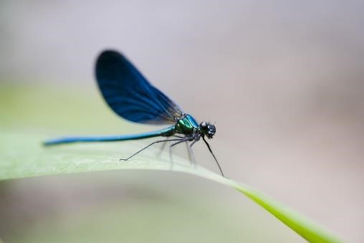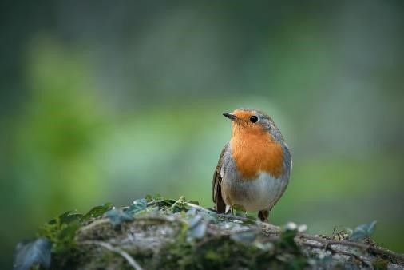
Parsley, Herb Robert, Convolvulus/Bindweed, Honeysuckle (smelling wonderful),
Houndwort, Meadowsweet, Flag Iris (both yellow and purple), Loosestrife and Bittersweet, plus a few more I’m sure.
We were accompanied around the Reserve by a very friendly Robin and head Oystercatchers overhead, Willow Warbler and somewhere nearby, a Green Woodpecker.
In places there were Hazel busVhes with nuts already forming, two huge Royal Ferns, Gatekeeper and Ringlet butterflies and one keen member spotted a beautiful Dragonfly.

News From the 2024 AGM
The 2024 AGM was held on 18th March 2024 and several changes were made to the management of the local u3a.
Chrissie Des-Forges stepped down as Vice Chair and was replaced by Steve Cobb following his successful nomination
The committee would like to thank Chrissie Des-Forge for all her service and hard work for the committee since 2019. Chrissie is now stepping down from here duties after having been one of the founders of our local u3a having been a key player in its success

Chrissie Des-Forges will continue to administer the FaceBok page and Website this until
another person can be trained to take over. She will attend a training session on the new website system and will then be in a position to train others.
Please continue to contact Chrissie with anything to e included on this media.
John Fielden has been undertaking the role of Chair and Treasurer and It is pleasing to announce that Peter Carlton-Scott has stepped forward and was nominated as Treasurer, leaving John to concentrate on his role as Chair.
Also, John has been a very successful Speaker Finder, having secured some excellent speakers for the Monthly Meeting. Once again it is pleasing to announce that Karen Baxter has offered to take over this role. John has arranged speakers up until the end of the year and John will hand over his notes to Karen in preparation for next year.
Welcome to our new team.
Other outcomes from the AGM are
- Refreshments to be served at the end of the Monthly Meeting with the aim of improving the social aspects of the meeting, allowing new members to get to meet the rest of us as well as allowing Group leaders to promote new and existing groups.
- It is hoped to set up a ‘buddy system’ to welcome and re-assure new members to the group.

Contact detail for Tadcaster and Villages u3a Trustees 2024
Chair John Fielden chairtadu3a@gmail.com
Vice Chair Steve Cobb stevecobb5252@gmail.com
Treasurer Peter Carlton-Scott peter.carltonscott@talktalk.net
Membership Sec. Glenda Smith membership1tadu3a@gmail.com
Business Secretary Paul Bissett tadsecu3a@gmail.co
