TADCASTER & VILLAGES u3a

ANNUAL REPORT
1st SEPTEMBER 2022 – 31st AUGUST 2023

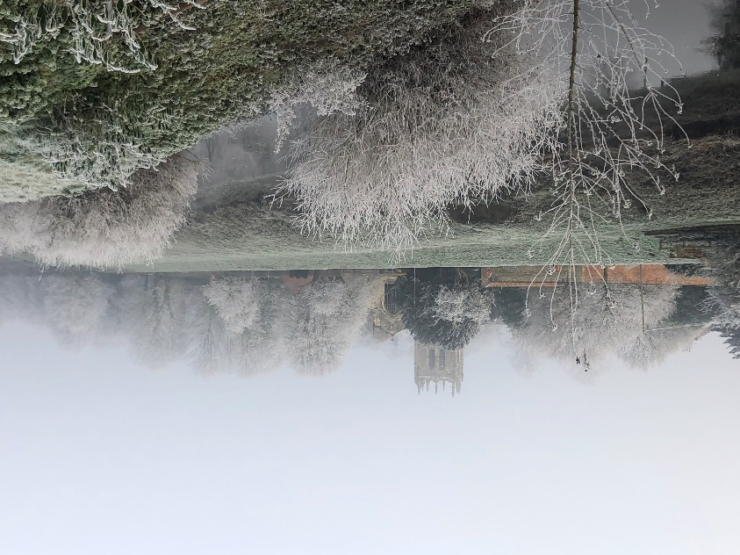

ANNUAL GENERAL MEETING – 18th March 2024

Introduction

We are pleased to produce the Third Annual Report for Tadcaster & Villages u3a (T&Vu3a) and hope our members will find the contents interesting and informative.

The purpose of the Annual Report is to inform our members on how we have managed and progressed Tadcaster & Villages u3a throughout the year after our world gets back to normal after the Covid pandemic.

Members have slowly returned to the regular Monthly Meetings and Group Activities during the year and there have been some interesting and thought provoking talks at the meetings You will see in the Membership Secretary’s report that, in line with most local u3as, Tadcaster & Villages u3a we have seen a reduction in the number of members who have renewed their subscription.

Beacon continues to be used by many group leaders to contact their members. Our activity groups are all doing well and new onesare being introduced as leaders come forward.

Tadcaster & Villages u3a continues as part of the CYGNET group (Central Yorkshire Group Network), this group links several u3as in our area, although Trustee attendance at meetings is sporadic as our time resources are limited. CYGNET, however enables our members to take part in activities outside our area if space is available and the correct procedure is used.

REPORT FROM THE CHAIR
This last year has seen a revived programme of external speakers in our General Members Meetings and a gradual growth in the number of interest groups. However, our overall numbers are stubbornly static (at between 70 and 80) despite our attempts at marketing. These have involved the regular updating of our shop window in Bridge Street (formally Guys Restaurant then Tea Fayre), a programme of promoting membership to those about to retire from Tadcaster’s companies and our staffing of a stall in the town’s Christmas Fair.
During the year we also regularly updated our website and the Facebook pages. In addition, using a generous donation we produced an improved brochure for general marketing and promotion. These activities do help, but a survey of members told us that the main reason they joined was hearing about us through word of mouth. We must build on this finding.

Glenda Smith has settled into her new role as Membership Secretary very well as has Paul Bissett as Business Secretary and has proved to be valuable additions to Trustee team.

The main challenge, in common with all u3a’s throughout the country, is renewing committee membership. In our AGM in March 2024, we will report the wish of some key people who wish to stand down as such the number of Trustees on the Committee will fall below the quorum set out in our constitution. We need more volunteers to fill several key posts. Unless we can overcome this challenge, there is a risk that the u3a will have to close or merge with a neighbouring body.

Treasurer’s Report for the year Accounts 20223-2023 (See Annex A)

This year we returned to normal after the hiatus of the Covid years. Membership fee levels stayed unchanged and the numbers were also almost static.

Our income was greatly helped by a generous anonymous donation of £200 which will be used to produce better marketing material so that we can grow in numbers. The income from coffee mornings and refreshments at members General Meetings just about equals the cost of hiring the Boys Sunday School for our main meetings.
As ever, the largest elements of cost are the various dues that we must pay for the central activities of u3a. In the year these amounted to £651, a high percentage of our total expenditure.

In July and August we asked members to agree to an increase in their subscription levels from £12 to £15 (with similar changes for Associate and Joint members).The reasons were that hire charges for venues have increased and speakers are increasingly requesting fees or money towards expenses. We need to set aside funds for this. Happily, the new subscriptions were accepted by almost all members.

We ended the year with a comfortable bank balance, largely due to the inward flow of membership subscriptions for the coming year.

Membership Secretary’s Report

Our Membership rose steadily through the year, from low 70’s in September 2022 to mid- 80’s in July 2023. We were very sorry to lose some Members as they moved out of the area, were seriously ill or, sadly, passed away. Most of our Members and Associate Members did renew for 23/24, but 14 chose not to. This means that we had a loss of nearly 12% which appears to be normal across u3a’s.
A Members Survey showed that most of our new Members initially came along with a
friend. We hope that this will continue to be the case in the coming year.

- Interest/Activity Groups
The dedication of Group Leaders who continue to volunteer their time is greatly appreciated. Their support should not be underestimated. New Group Leaders continue to come forward and new groups are starting in the coming year.
We currently have 9 interest/Activity groups namely:
- Circle Dancing led by Felicity Hill

This group meets monthly in the Old Boys Sunday School on the fourth Friday each month 2-4 pm and learn and practice a variety of dances from throughout the World in a friendly social way (of course including tea, coffee and biscuits!). All are welcome and no experience is necessary.

- Craft Led by Glenda Smith
The Craft Group remains small and friendly. We meet monthly to pursue our own craft interests, to share ideas, and to advise and help each other if necessary.
Occasionally one of our will teach the group a new skill. We are happy to accept new members and to teach crafts if desired.

- Days Out led by Denise Gent

- Digital Photography led by Alex Svenson
The Group meets on the first Monday of each month. We discuss topics such as composition, useful software packages and look at online tutorials, as well as critiquing each other’s photographs..

- Flower Arranging led by Julie Goodthorpe
This group meets on the second Thursday of the month at 10.30 at Stutton Village Hall. All welcome.

- Nature/Wildlife Lead by Gil Firth

The Wildlife Group meets on the fourth Tuesday each month to walk and the meeting place varies but is mostly in the local area, looking at the wildlife through the seasons. This year, we have visited Hazlewood Castle, Grimston Park, RSPB St Aidan’s, and Wetherby as well as exploring the local places along our riverbank, Stutton and much more. We
have found quite remarkable wildlife right here, all we need to do is just look carefully.
We are a friendly group and welcome any new members who are inquisitive about what we see around us.

- Painting and Drawing led by Susan Notley
There are nine in the group but not all are able to come to every meeting.
Average attendance is five or six.
We encourage discussion on topics of interest and if a few members are asking about the same things we have a session on it at the next meeting.
The group meets on the first Tuesday of the month in the Barn on Joseph Street Tadcaster at 1.30pm to 3.30pm.

- Quiz/Social led by Jan Burg
The group meets on the Second Monday each month from 10.30am in the Kelcbar Community Centre.
The meeting is well attended and splits into teams of 4 or 5 members. Every meeting consists of five rounds – usually of 10 questions each. There are 2 or 3 rounds before a vital cuppa and of course a few biscuits – you are charged £1 for the refreshments. Each month we have a guest round. A group member volunteers to set a round which can be on any subject or topic of their choice.
New friends are always welcome

- Walking led by Felicity Hill
The walking group is led over a wide range of local routes. Each walk is about 4 miles. The group meets at Tadcaster bus station at 10 am on the first Saturday of the month. All are welcome

- Coffee Morning
The Coffee Mornings are held on the first Thursday of every month from 10.30 – 11.30am at the Barn.
It is a social and friendly environment and a good place to catch up and keep up to date with what’s going on in u3a and the local villages.

Please see the shop window (formally Guys then Tea Fayre) on the High Street for further information on any of our groups or contact any of the committee members. Details are also available on the T&V u3a website.

Regular meetings of Group Leaders have been introduced and these are proving very useful for both the leaders and committee.
Although there are some new groups being set up to start at the beginning of 2024, (look out for Spanish, Woodwork, Books and Table Tennis), we need members to volunteer to help set up activities, several (such as Gardening) have been requested by members but need leaders. If you are interested in helping, please contact one of the committee members.

GUEST SPEAKERS
Although our Speaker Arranger resigned for personal reasons towards the end of the year, our Chair John Fielden stepped into the gap (temporarily) and was able to book speakers for most of 2024. During the year there has been a succession of interesting talks including:
The Whitby Tour Walk
Energy in the Home
Jo & Her Hearing Dog Joey
The British Love Affair with the Seaside
Since speakers have been secured for most of 2024 any volunteer will begin with an easy job. Why not volunteer?

- u3a Website
The website is still up and running and contains everything all the information you may need on Tadcaster & Villages u3a.
The website editor will be stepping down in 2024 and we are in desperate need of a new editor if it is to remain useful.

If anyone is interested in the role of Website Editor, please contact the Web Editor for a demonstration on how to edit the site or one of the committee members to have a chat.
3. Invitation to Committee Meetings
Any members who are interested in helping with the running of our u3a is invited to come along to a committee meeting where they can talk with us and find out what we do.

Structure, Governance and Management

Tadcaster & Villages u3a is managed and administered by your elected Committee of
Trustees comprising no less than five and no more than 15, as set out in the
Constitution. Every trustee is a paid-up member of the u3a.

On Monday, 18th March 2024 it is the Annual General Meeting (AGM) and at least one of the Trustee’s is obliged to stand down having completed the 9 years maximum service in a role. At this AGM one Trustee will be standing down for personal reasons (All Trustees step down at an AGM, but can self-nominate and or be nominated for the same or another role if the maximum service has not been reached in their current role.)

This year has been conducted with only four trustees with the Chair doubling up as Treasurer. This is against the constitution. To add to this, one Trustee will be resigning at the AGM for personal reasons which reduce the committees only three members.
Volunteers on the vacant posts are therefore urgently nee

The first Trustees appointed for Tadcaster & Villages u3a adopted the u3a Model Constitution 2018 on 7th May 2019. Since being adopted there have been minor changes to the current Model Constitution 2018 concerning the use of hybrid and online meetings) which was a decision made by the Third Age Trust.

The Committee operates within the legal and financial framework set out by The Third Age Trust.

The Committee communicates with the membership through monthly meetings, emails, website, telephone, post, and Facebook. Members are asked to contribute regularly to the u3a Newsletter and website and provide interesting topics.

- Workshops
The Trustees attended some of Yorkshire & Humber Regional Workshops to which they were invited. When Trustees were unable to attend, either due to ill health or other personal commitments, the Business Secretary has received minutes of the workshops and emailed the information to the Trustees to keep them up to date on matters.

Workshops are for sharing best practice and to discuss solutions to common u3a challenges and are important for keeping up to date with items of importance.

- Challenges
As outlined earlier, member numbers of Tadcaster & Villages u3a remains problematical. A membership of about 80 including Associate members limits the funds available to the committee to administer and market the organisation. This is in contrast with other local u3a’s which have membership in the high hundreds or even the thousands.

Requests for volunteers to help on the committee have been constantly made at monthly meetings, on posters, Facebook, e-mail and by word of mouth, but few have been forthcoming.

The list of the present Trustees and Committee Members is at Annex B.

THANK YOU FROM YOUR COMMITTEE

Thank you for reading the Annual Report and a special thank you to all the members for their continued support during the year.

The Chair and the Committee Members.

Contact details

Chair and Treasurer John Fielden: treasurertadu3a@gmail.com
Vice Chair Chrissie Des-Forges: vicechairtadu3a@gmail.com
Membership Secretary Glenda Smith: membership1tadu3a@gmail.com
Business Secretary Paul Bissett: tadsecu3a@gmail.com

ANNEX A
Income and Expenditure Accounts for the year to 31st August 2023
 | 22/23 |  | 21/22
Income | £ |  | £
Membership fees 23/24 | 240 |  | -
Membership fees 22/23 | 726 |  | 153
Membership fees 21/22 |  |  | 417
Grants: u3a Day |  |  | 57
Donation | 200 |  | 14
Refreshments income | 292.6 |  | 306
Held for Circle Dancing Group | 312 |  | 240
Income total | 1770.6 |  | 1187
Expenditure
Cost of Third Age Matters | 241.35 |  | 119
Dues paid to Third Age Trust | 328 |  | 609
Purchase of equipment |  |  | 137
Office costs | 133.7 |  | 85
Venue hire | 594 |  | 459
Speakers fees |  |  | 30
Sundry expenses: u3a Day | 141.26 |  | 37
Beacon licence fees | 82 |  | 84
Total expenditure | 1520.31 |  | 1560
Surplus or Deficit (-) | 250.29 |  | -373
Bank balance 31.8.23 | £700.03 |  | 554

ANNEDIX B

TADCASTER & VILLAGES U3A COMMITTEE MEMBERS

The Chair John Fielden

The Vice Chair Chrissie Des-Forges

The Treasurer John Fielden

The Business Secretary Paul Bissett

Assistant Treasurer Vacant

Membership Secretary Glenda Smith

Group Coordinator Vacant

Speaker Coordinator John Fielden

Website Editor Chrissie Des-Forges

Volunteers are needed to help with:

Meet and Greet at monthly meetings and
Refreshments at monthly meetings.

