St. Ives (Cambs) U3A Birdwatching Group
Trip Report Number 90

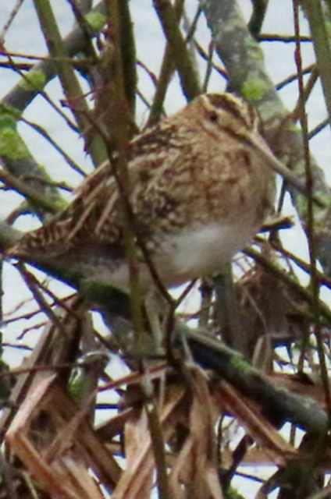Lackford Lakes

Date : February 21st 2024
Weather: Rain
Temperature: 8°
Visibility: Poor
Time: 10.00 – 13.00
Present: 5 members

38 birds seen:
Robin Blue Tit
Shoveler Wigeon
Blackbird Shelduck
Sparrowhawk Oystercatcher
Teal Snipe
Mute Swan Greylag Goose photos Tony Plant
Gadwall Canada Goose
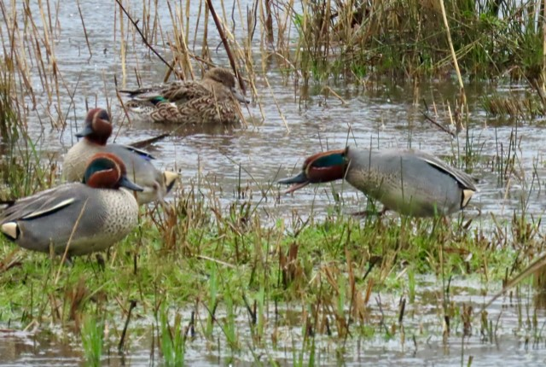Mallard Wood Pigeon
Moorhen Lapwing
Carrion Crow Great Tit
Buzzard Long-tailed Tit
Tufted Duck Pochard
Cormorant Coot
Little Egret Siskin
Magpie Goldfinch
Black-headed Gull Goldcrest
Greenfinch Blackbird
Dunnock Reed Bunting
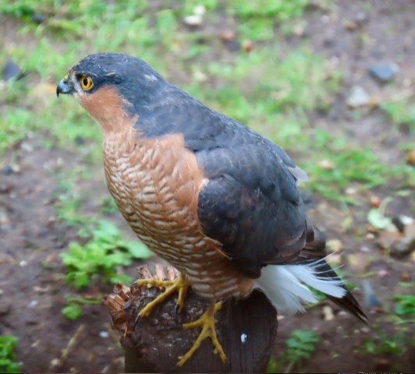Red Kite Heron

Mammals: Muntjac Deer
Distance walked: 2.5 miles.
