St. Ives (Cambs) U3A Birdwatching Group
Trip Report Number 91
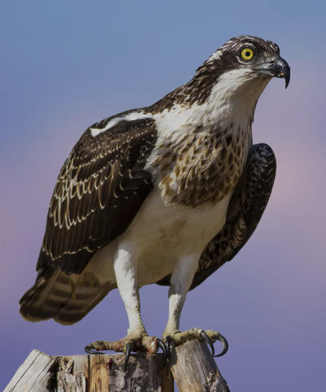

Rutland Water
Date : March 20th 2024
Weather: Light rain then dry
Temperature: 12° - 16°
Visibility: Fair
Time: 10.00 – 15.30
Present: 6 members

43 birds seen:

Robin Chaffinch
Shoveler Wigeon Photo RSPB
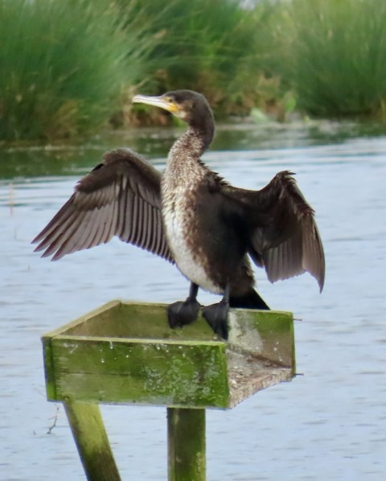Blackbird Shelduck
Oystercatcher House Sparrow
Teal Great Crested Grebe
Mute Swan Greylag Goose
Gadwall Canada Goose
Mallard Wood Pigeon
Moorhen Lapwing
Carrion Crow Great Tit
Buzzard Blue Tit
Tufted Duck Pochard
Cormorant Coot
Great White Egret Chiffchaff
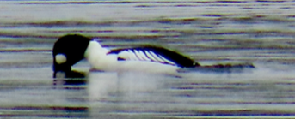Magpie Curlew
Black-headed Gull Redshank
Avocet Herring Gull
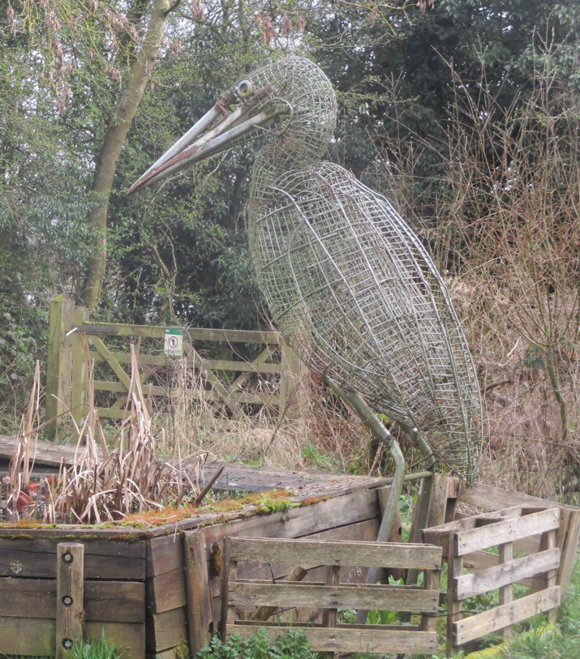Jackdaw Reed Bunting
Red Kite Grey Heron
Goldeneye Osprey
Pheasant Little Grebe
Great Spotted Woodpecker

Birds heard only: Cetti’s Warbler
Distance walked: 5 miles.
Photos Tony Plant

