St. Ives (Cambs) U3A Birdwatching Group
Trip Report Number 89
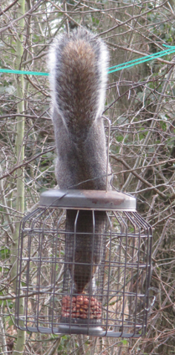
Wandlebury Country Park

Date : January 17th 2024
Weather: bright and sunny
Temperature: 2 - 4°
Visibility: Good
Time: 10.00 – 13.30
Present: 6 members

21 Birds seen

Wood Pigeon Magpie
Carrion Crow Jay
Jackdaw Pheasant
Blue Tit Great Tit
Long-tailed Tit Coal Tit
Bullfinch Goldfinch
Nuthatch Treecreeper
Robin Dunnock
Buzzard Grey Wagtail
Fieldfare Song Thrush
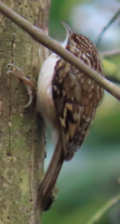Blackbird
Photos Tony Plant
Total number of bird species seen on trips so far: 165

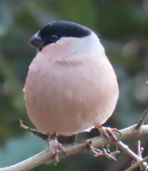Distance walked: 3.14 miles (approx.)
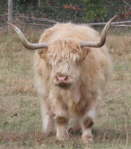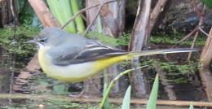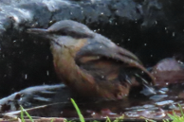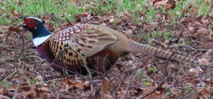Other: Muntjac Deer, Grey Squirrel

