St. Ives (Cambs) U3A Birdwatching Group
Trip Report Number 87
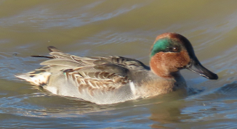
Grafham Water Nature Reserve &
Paxton Pits Nature Reserve

Date : November 15th 2023
Weather: Bright sunshine, windy
Temperature: 9º - 11º
Visibility : Good
Time: 10.00 – 14.15
Present: 8 members
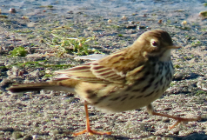
Birds seen: 28
Wood Pigeon Cormorant
Shoveler Linnet
Teal Jackdaw
Mallard Pied Wagtail
Wigeon Kestrel
Gadwall Tufted Duck
Canada Goose Meadow Pipit Photos Tony Plant
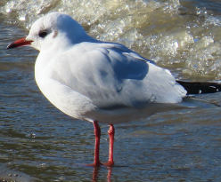Great Black-backed Gull
Green-winged Teal* Rook
Mute Swan Coot
Black-headed Gull Moorhen
Grey Heron Goldfinch
Buzzard Magpie
Carrion Crow Little Grebe
Great Crested Grebe

*Bird not seen on a previous trip

Total number of bird species seen on trips so far: 165

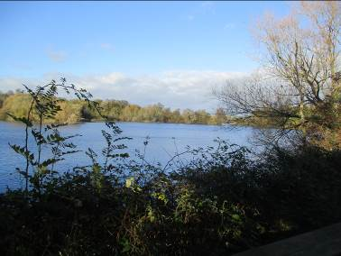Distance walked: 4.5 miles
