Newsletter 13 April 2021

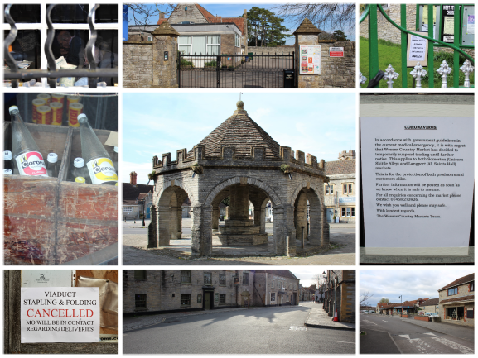
Somerton u3a
April Chairman’s Message
Due to unforeseen circumstances, there will be no Newsletter this month, but I want to keep you all up to date with Somerton u3a.
To help the committee build up a picture of what has been happening over the past year with the groups, all the leaders were contacted recently by phone and invited to take part in a short survey.
The overall response was very positive, with the Group Leaders already planning how their groups can safely meet in the coming months, whilst adhering to any government guidelines still in place.
……………………………………………………………………………………………..
We will continue to hold two Zoom talks with guest speakers meeting each month.
Friday 9th April, 11.00 am
Manners Please Dearest!
Presented by David Allen
Friday 23rd April, 11.00 am
Brilliant British Humour in the Forgotten Art of the Postcard 1840 -1950
Presented by James Taylor
I do hope you can join these very popular meetings.
……………………………………………………………………………………………..
Another important date for your diary is the AGM, which will be held, by Zoom, on Friday 23rd July.
As many of you know, Wednesday 2nd June in National u3a Day. Some of you have asked what will be happening on that day.
Under normal circumstances, the committee would have planned a whole day of events to celebrate the many and varied activities of Somerton u3a. This year, by necessity, the event will be scaled back and will concentrate instead on raising the profile of our activities.
We want to promote what we do best - Learn - Laugh - Live

Somerton u3a Facebook and Twitter
We are planning that social media will be centre stage in all our future activities. Here is a message from Marilyn Muffett, our Membership Secretary, with details of how to access them.
Hopefully, with the easing of restrictions coming soon, we can all start to plan for future events and re-energising our u3a.
To that end, and with recruitment in mind, we have looked at ways to ‘spread the word’ and reach a wider section of the community. Therefore, we now have a Facebook page and Twitter account. Either can be found by entering ‘u3a somerton’ in the search box on Facebook or Twitter, either using their web page or once you have downloaded the apps, if you haven’t already done so.
You will be able to post news and photos of your group activities and keep up with everything that is happening, as well as following what other u3as are doing.
If any of you are unsure of how to post, items can be sent to me and I can help.
Please join in and share your ideas.
……………………………………………………………………………………………..
Enrolment Day is in the diary for 10th September. We are hoping that the Edgar Hall will be able to accommodate us and provide the opportunity to welcome new members and showcase our activities and the new groups.
……………………………………………………………………………………………..
I hope you will have received the details of the October holiday to the Isle of Man. Jane Redgrove has kindly volunteered to organise this exciting trip.
……………………………………………………………………………………………..
As you can see there is a lot going on and much planning needed to ensure we have a successful relaunch.
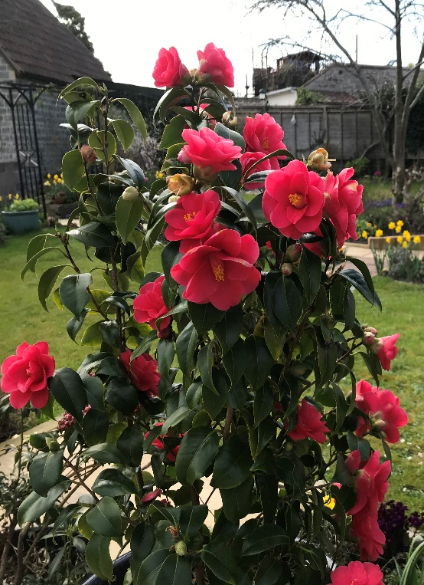
We are going to require lots of volunteers so if you would like to be involved, please contact any of the committee or telephone me on 01458 250280.
It only leaves me to hope you enjoy your Easter lunch, with whoever you might be sharing it with.
The gardens have an abundance of spring flowers in bloom so it is a reminder that brighter times are definitely around the corner.
With best wishes
Judi
Chairman Su3a
ISLE OF MAN

Would you be interested in a holiday on the Isle of Man in October 2021?
We would fly from Bristol and stay in a 3*hotel in Douglas for 4 nights.
We would explore the history, culture and scenery with the help of a Blue Badge guide.
£799
This price includes flight, hotel, all dinners, executive coach on the island, day trips with a Blue Badge guide, entrance fees (excluding N.T. properties), train and tram journeys.
Please let me know by 10th April if you would be interested.
There will be more detailed information available then, if enough people show an interest.

Jane Redgrove redgrove@btinternet.com or 01458 899962
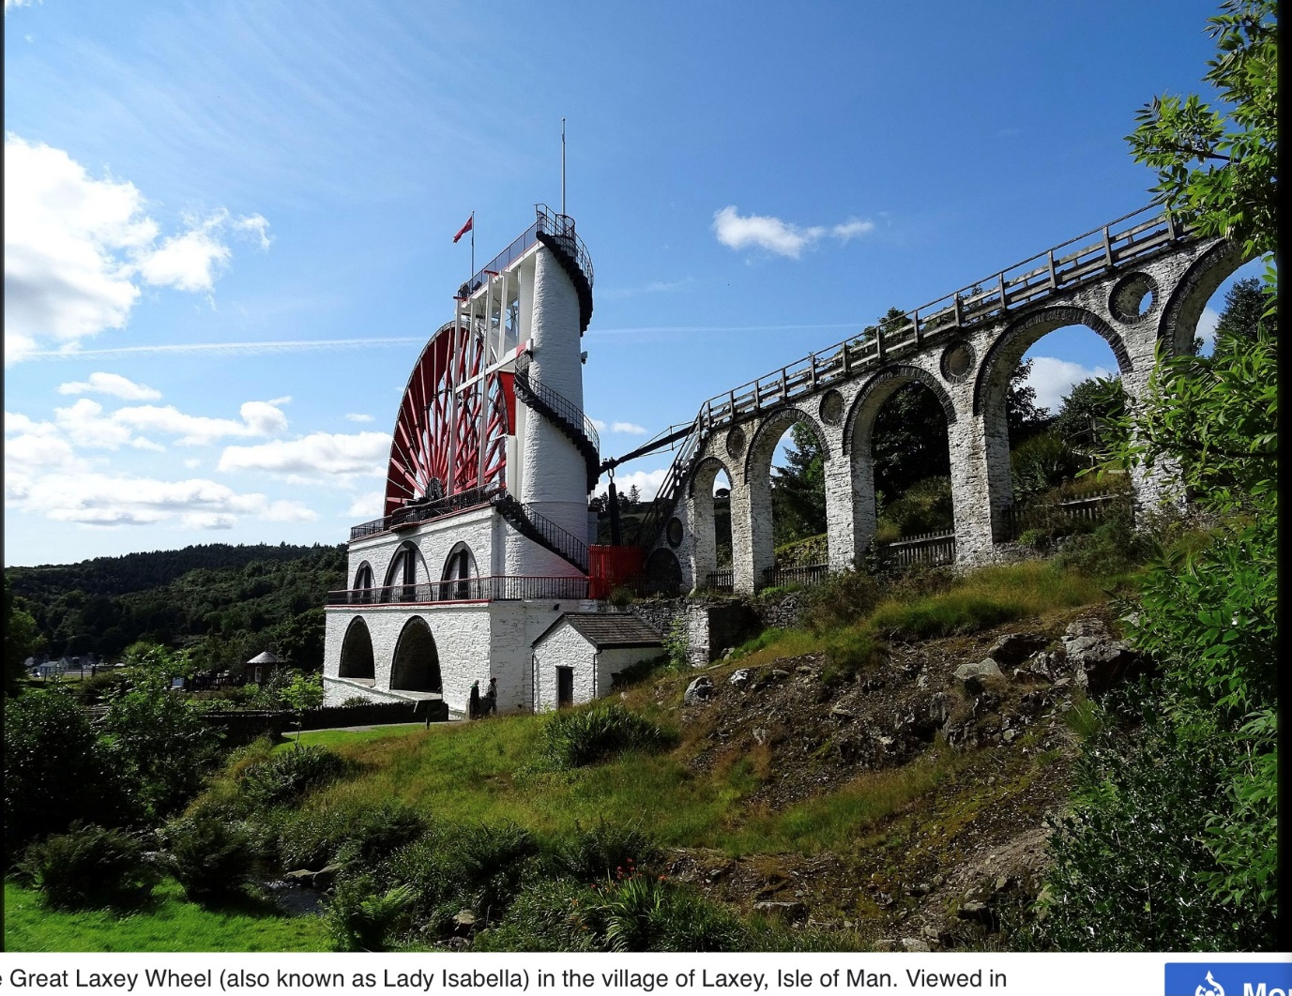

Great Laxey Wheel (also known as Lady Isabella) in the village of Laxey, Isle of Man

