2024 COACH TRIP INFORMATION
SOLIHULL U3A
‘Taking Mystery out of History’ &
‘conversational French’ groups
Present an inclusive 5 night trip to:
The Opal Coast, France.
Thursday 8th to Tuesday 13th May 2024

With half board accommodation at
Hotel du Moulin aux Draps, Desvres.
Pas de Calais.
We are travelling with COGO Group Travel of Brighton, who own the hotel!
This Company and hotel were featured in the Spring 2023 edition of the
Association of Group Travel Organisers Magazine
Penny and I did a recce and stayed at this hotel in November 2022.
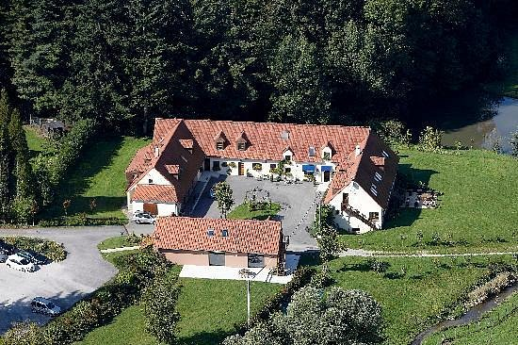

The price of £725 (plus single supplement £20 per night)
includes coach travel from SOLIHULL,
Five nights half board accommodation
(Breakfast & Evening Meal with wine).
Four FREE Excursions as all entrance fees are included.
Featuring The Somme Bay Scenic Railway & Agincourt Museum.

You will need a valid passport and since we are no longer members of the EU,
you will also need the new 2024 ETIAS EU visa waiver.
WE CAN HELP YOU GET THESE with NO PROBLEM!

ITINERARY
Day 1 – Thursday 8th May
We depart by coach from outside Solihull Station at 6am and travel to Dover for the 13:00pm sailing. Travel time is 45 mins from Calais to le Moulin. After we have checked in to the hotel, we will have complimentary aperitifs in the bar and then our 2 course evening meal with wine, followed by a local cheese and wine tasting quiz with your animateur!
Day 2 – Friday 9th May
Morning visit to Boulogne with your animateur. Lunch (payable locally) at a well known fish restaurant by the port, then an afternoon visit to the very impressive Comtal Castle Museum.
Day 3 - Saturday 10th May
We visit St Omer – it is Market Day with a bustling street market, then we visit the Blockhaus d’Eperlecquess a massive WW2 V2 bunker, never used to its full potential due to the actions of the RAF.
Day 4 – Sunday 11th May
We visit the Bay of the Somme Scenic Steam Railway from the pretty fishing port of Le Crotoy to the medieval city of St Valery sur Somme, with time to get some lunch and do some sightseeing! Penny and I have been and it is lovely!
Day 5 – Monday 12th May
In the morning we visit Azincourt (French spelling) Battlefield centre, then in the afternoon, we visit an artisanal cheese farm.
Day 6 – Tuesday 13th May
Check out after breakfast, en route we visit the hypermarket for some stores! We will board the 3:00pm sailing and expect to arrive back in Solihull around 7:00pm

