Looking at Maths around us
Next meeting: Monday 8th May 11 a.m. in the library
All are welcome

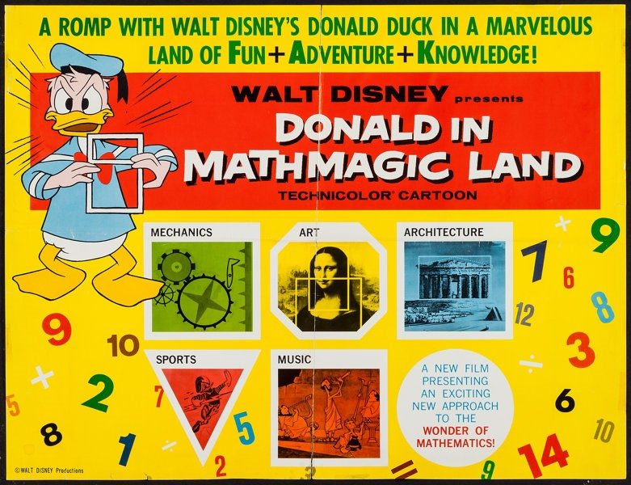
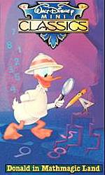
Mathmagic Land: for children and young souls of all ages
And additional focus on Tiling:
