Looking at Maths around us
Next meeting: Monday 12th February 2024 11 a.m. in the library
All are welcome.
THE GOLDEN RECTANGLE

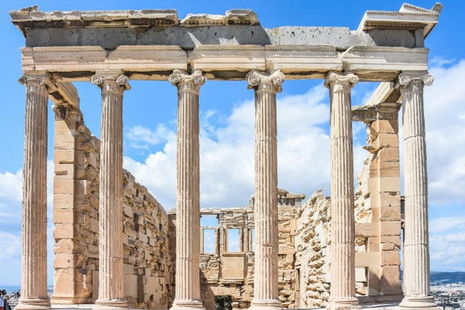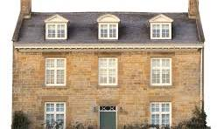

THE GOLDEN RATIO
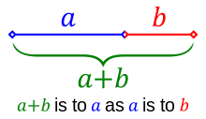

THE GOLDEN SPIRAL

