Looking at Maths around us
Next meeting: Monday 9th October 2023 11 a.m.
All are welcome.
Circles, their use and importance
Numbers
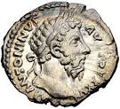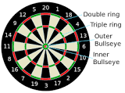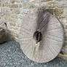

360, 22/7, 3.141....
