Looking at Maths around us
Next meeting: Monday 13th February 2023 11 a.m. in the library
All residents are welcome.
Today we also welcome Pat, Jill, Georgina from Sidcup U3A

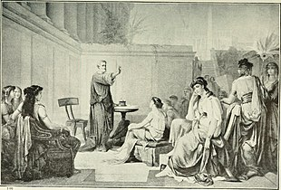

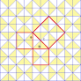
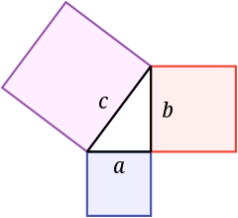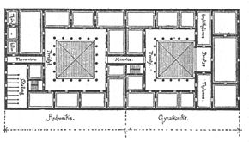

(3, 4, 5) (6, 8,10) (5, 12, 13) (8, 15, 17)

