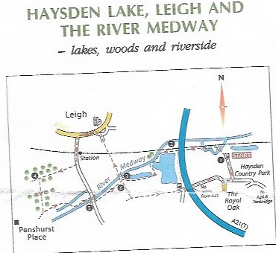

Pub Post code TN11 8RL
- Park on the road towards the station. Fleur de Lis pub is on the corner. This is the start and end point.
- We will be following the route from the pub towards points 4,5 & 6.
- We then pick up points 3 & 2 around the lakes towards the Parking sign.
- Unfortunately, due to flooding, the environment agency is carrying out extensive work in the area. Therefore, we are not able to cross under the A21 to Haysden Country Park. Hence the change to the starting point.
- Follow the route back to point 6, cross the Medway, go under the railway and onto the green.
- Left towards the Pub.

