September 22 u3a Newsletter
Welcome back from holidays and I hope you all enjoyed yourselves.
Events
Our own George Cogswell, following the talk about bees has offered to take people to the Hives at Moor Nook Park.
Following interest on the visit by the Family History Group and others, George is happy to organise another tour of Brooklands Cemetery. His knowledge is second to none and the tour will be interesting, to anyone who wants to join. Both will have to be booked ASAP as George is only available until September 16th. Please contact George on george.cogswell@virginmedia.com to arrange.
For George following September 16th he will be preparing for an event in Walton Park where a memorial will be unveiled to commemorate the Wellington Bomber which crashed there on August 3rd, 1943, killing two of the Australian Air Force Crew-the pilot and the bomb aimer who were both positioned in the front of the aircraft. The pilot skilfully managed to lift the aircraft over 2 houses in its dying moments saving the remainder of his crew, and undoubtedly local residents as well. The unveiling will take place at Walton Park (Raglan Road entrance) at 11.00 am on Wednesday September 21st and everyone is welcome to attend.
OPEN DAY
Our open day will be on Friday September 23rd at Sale Moor Community Centre from 1-4 pm. Afternoon tea will be included, and the Mayor of Trafford has been invited. We are celebrating 40 years of the u3a like many others across the country, but also our 30th anniversary so we have much to celebrate.
Spare Spectacles
One of our members has contacted me regarding spare spectacles. Do you have spare glasses, no longer required? If so, why don’t you bring them to the centre, they can be collected to send to people in countries who could benefit from them and who have little access. Please if you can include the cases, they came in. Thanks to Heather Bradshaw for the suggestion.
Shared Learning
Whilst there has been little happening during August, I did attend a u3a Shared Learning Conference in Preston. It was a packed day with presentations from different groups across the country. There were several presentations including the Foundling Hospital project by High Peak who transcribed, documents. Another was Beyond the High Street, Postal Pensioners, the 1820 Rising in Glasgow, A film unit from Northern Ireland and a presentation from Sheffield who have 1000 members. Field Archaeology at Burnham on Crouch was presented by members in medieval costume. They are a u3a of 300 members. Their archaeology project was featured in this month’s newsletter.
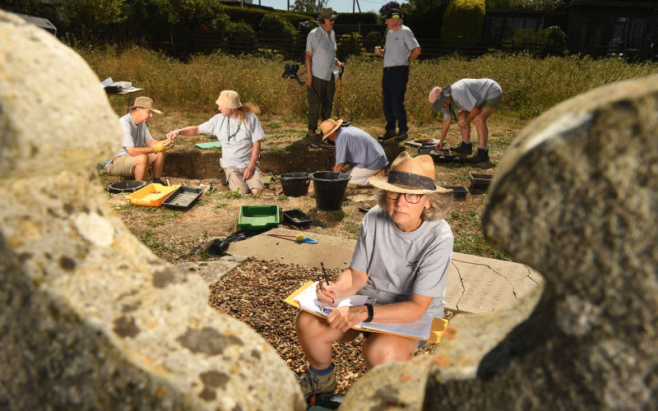
Burnham u3a Archaeology Group photographed by Russell Sach

Read all about the fascinating and ground-breaking discoveries by Burnham u3a’s Archaeological Group in the Autumn issue of Third Age Matters magazine, including uncovering a medieval palace...

At the beginning of the day, it was emphasised how important research was and the u3a contribution to positive ageism was cited as was the Design Age Institute after research, was looking at blister packs and tops which are child proof and age proof. Hopefully they will come up with something which protects the child but eases the frustrations of the older person!

Join A German Reading Group
Alastair, Subject Adviser for German, runs a monthly Reading Group in which members read and discuss German short stories together. Find out more details and get involved on Alastair's Subject Advice page.
If you don’t access the newsletter you can sign up for it on the u3a web page. All you do is give an email address and create a password.
Groups
Groups recommence September 5th
Friday talk is on September 30th at 2 pm Egyptology, Kathryn Fyfe. Please come along and Kathryn is looking to commence an Egyptology Group following the talk. Names will be taken then for those interested.
AGM
Our AGM will be in December, and we will be looking for new Committee members. If you are interested, please get in touch with judithlloyd@rocketmail.com
If you want to see what we do you are welcome to attend Committee meetings on the first Tuesday of the month 10 am at Sale Community Centre. It is important we refresh the Committee as new people come with new ideas. Similarly, if you have a particular interest you would like to share with others, why not become a Group Leader

