**October 22 Newsletter**

We were saddened at the death of Queen Elizabeth 2nd and the following message was left at the u3a book of condolences:

“On the sad passing of her Majesty the Queen Sale u3a send condolences to the Royal Family on the death of Queen Elizabeth.  This is a very sad time for the country which has been united in grief.  We should also commemorate her life of service which she dedicated to the country on her accession to the throne.  She fulfilled that promise admirably with grace and dignity uniting the country in the memorable events throughout her reign.”

**Open Day**

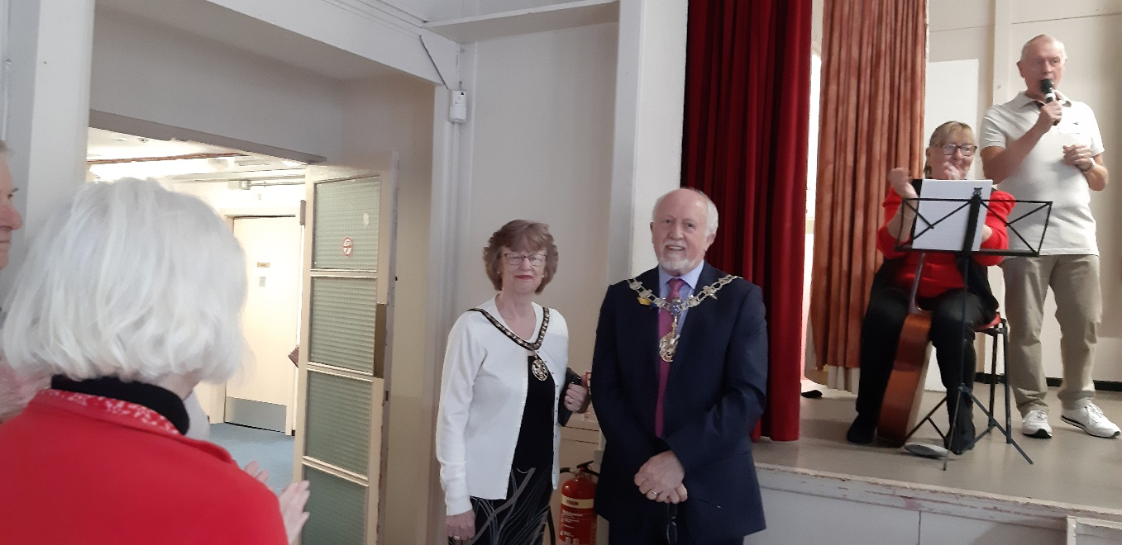

Many thanks to all who attended what was a very successful Open Day attended by the Mayor and Mayoress of Trafford. We had more than 160 people attend and have 4 more groups starting up. Other Groups have increased numbers. We have signed up 16 new members, and there may be more. Thanks also go to the meeters and greeters, the tea makers, all those who set up for the day and Group Leaders.

**Maureen and John Nugent**

The Mayor on Open Day also presented Maureen and John Nugent with a Lifetime Membership certificate. Sale u3a owe them both a debt of gratitude for their contributions to our organisation. John has been doing the sound for the last year and longer virtually on his own (and is doing a training session for those who would like to help). John and Maureen are regular contributors to the Friday talks but recently have stepped in at the last minute. Congratulations to them both

**New Groups:**

Watercolours, Cycling, Origami and Egyptology. If you are interested in attending the new groups, please can you contact: [judithlloyd@rocketmail.com](mailto:judithlloyd@rocketmail.com) and I will forward your email or phone number to the relevant Group Leader.

**Walton Park WPW Memorial**

Due to the passing of HM Queen Elizabeth 2nd, George Cogswell has re-arranged the unveiling of the WPW memorial is on **Monday October 17th 11am at Walton Park.** A memorial will be unveiled to commemorate the Wellington Bomber which crashed there on August 3rd, 1943, killing two of the Australian Air Force Crew-the pilot and the bomb aimer, who were both positioned in the front of the aircraft. The pilot skilfully managed to lift the aircraft over 2 houses in its dying moments saving the remainder of his crew, and undoubtedly residents as well. You are welcome to attend and support George.

**u3a AGM**

José Anderson and I will be attending the AGM on Thursday. It is a hybrid meeting so we will be attending online. The resolutions confirm the change from U3A to u3a. There are some changes to wording of directors and terms of office. It looks like subscriptions to the rates will go up and there are a few resolutions, with different suggestions and it is the amount we pay to the national u3a only.

**Sale AGM & New Committee Members**

This will be on December 9th. We are still looking for new Committee members. If you would like to get more information, please speak to any Committee member. It is important we refresh the committee on a regular basis as this can bring in new ideas and new skills or learn them. If we are unable to recruit new committee members and unable to replace members, then Sale u3a cannot exist.

**Friday Talk**

**The next Friday meeting is on October 28th, with Julie Mullaney speaking on Irish Women’s Writing. As usual it as at 2pm. Prior to the meeting we will be having a Leaders meeting.**