Sale u3a December Newsletter
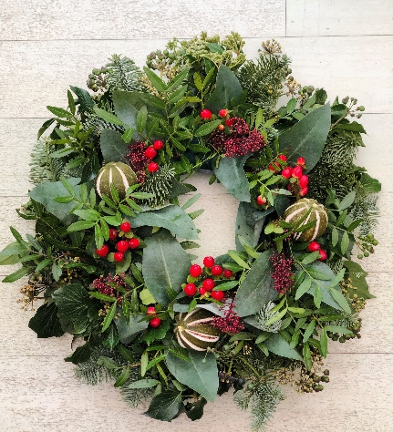Happy Christmas to everyone and all the best for the New Year

Thanks to all who have led and attended Groups and the Friday afternoon talks. The Friday talks will continue to be monthly.
AGM and Committee
The AGM of Sale u3a was held on December 9th. No questions were raised at the meeting. A new Committee has been appointed:
Carole Barley, Secretary. Judith Lloyd, Chair. José Anderson, Vice Chair. Guy Robson Treasurer. Ian Hamilton, Membership secretary, John Hemsworth Group Coordinator, Barry Brotherton website and Facebook, Kathleen Chirema organises the Friday talks. If you can recommend a good speaker please contact us. Charlene Pullan, and Jean McDonald continue.
We are joined by 4 new Committee members, as well as John Hemsworth, we have Ben Cheung, Kathryn Fyfe, and Margaret Loftus. Ben and Kathryn will be responsible for publicity and communications. We need photographs of Group activity which can be displayed on the website and included in the newsletter. This year publicity was given in the Messenger and George Cogswell featured in TAM. We will be looking to raise the profile of Sale u3a and we need your help.
On the Community noticeboard we will be displaying photos of the Committee Members and a brief biography, so you all know who they are.
Quiz
Following the AGM, a quiz was held. It is attached to the newsletter and answers will be given in January.
José addressed the meeting as she is looking at organising a day trip giving a choice of destinations. As the result was a tie José will be organising 2 trips:
DAY TRIPS 2023
NORTH LANCASHIRE CIRCULAR TOUR
FRIDAY 12TH MAY 2023 £16.50p.p.
There’s no better way to explore North Lancashire than on our whistle-stop, circular, tour
Pendle is our first stop, famous for its warm-hearted welcome! Situated on the southern edge
of the Yorkshire Dales, the iconic Pendle Hill offers breath-taking views. You can also delve
into what happened here during Britain’s biggest witchcraft trial.
Next up, the ancient market town of Clitheroe. Set in the Ribble Valley, it dates back to the
Saxon times, and Clitheroe Castle is said to be the smallest Norman castle in England.
Stop by the award-winning Byrnes Wine Shop to pick up a bottle from all over the world, and Cowman’s Famous Sausage Shop which sells more than 75 varieties.
We’ll finally stop at Cobble Hey Farm which is a fully working family run farm.
You’ll have the opportunity to get hands on the farming process [including feeding the
animals], exploring the award-winning flower gardens, and pick up a sweet treat in the café.
---------------------------------------------------------------------------------------------------------------
GORDON RIGGS NURSERY AND SKIPTON
FRIDAY 16TH JUNE 2023 £16.50p.p.
Garden lovers hop aboard! We’re off to Gordon Riggs Nursery, one of the largest gardens
centres in the Northwest [ you may need to bring your wheelbarrow!]. The garden centre has
traded since 1945 and remains a family-owned business. You’ll be in retail heaven with the
variety of indoor and outdoor plants, garden furniture, bird care, pet care, floristry, gifts… we
could go on! When you’re in need of tea and cake, there’s the Cotton Weavers Café to enjoy
some well-deserved refreshments.
We’ll then drive over to Skipton for you to explore its award-winning market, which still
operates under a Charter granted by King John over 800 years ago! In the heart of the town
centre, the stalls vary from day to day and include clothing, footwear, fresh produce,
household goods and jewellery - all at great prices.
Volunteers needed.
We will be going to Sale Library where they have a warm hub in January. If you can spare a couple of hours, once a month, we will be there introducing people to Sale u3a. If you can spare some time, please get in touch with Judith: judithlloyd@rocketmail.com or 07952 922630
Friday meeting
The next Friday meeting will be on January 27th at 2pm. The speaker will be Neil Hanson on “Inn & Out at the Top” is a laugh-a-minute tour of the quirks and foibles, highs and lows of his time running Britain’s highest inn back in the 1970s and 1980s.

