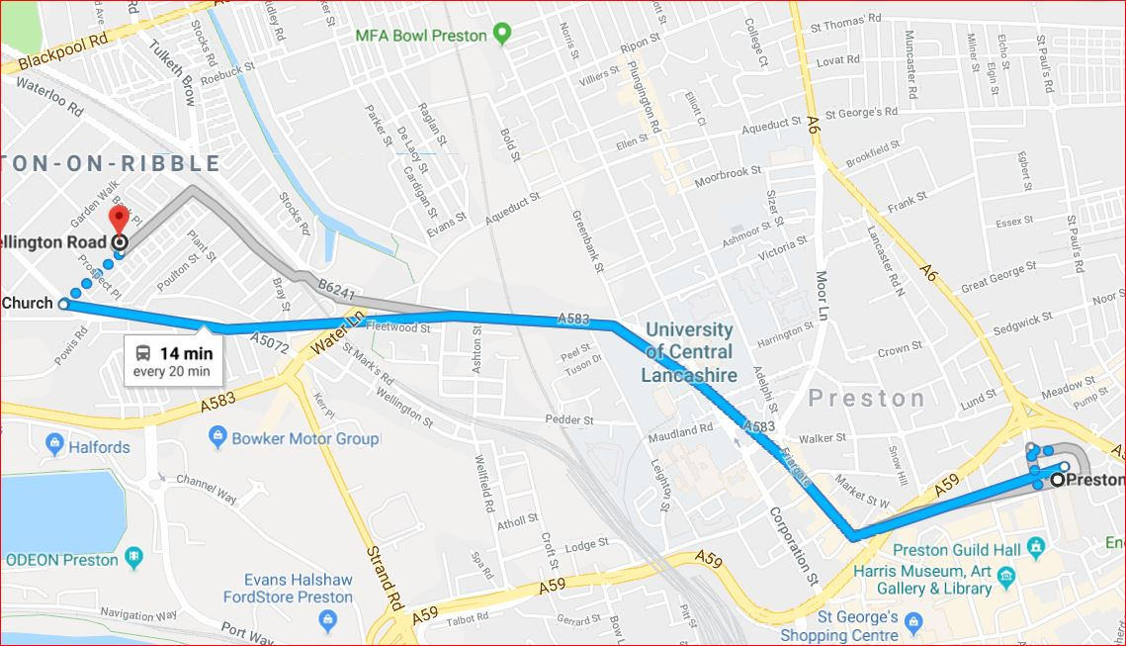
Bus Route to Ashton Methodist Church Centre, Wellington Rd
Take no 68 Bus (Blackpool) from Stand 4 Preston Bus Station get off at St Michaels Church, cross Tulketh Road and walk down Wellington Road.
Your destination is on your left after about 200 yards.

