Paisley & District u3a Press Release:

No Embargo: Friday 26 March 2024

Paisley u3a learns crimeland secrets

Crime story fans can enjoy a free talk by Paisley & District u3a’s next speaker.

Alex Gray, the international and best-selling crime writer, gives the lowdown on what makes a killer story. This popular author bases fictional tales in and around Glasgow.

Attendees will hear first-hand tips for successful crime writing on Thursday 2 May at 2pm. Refreshments at u3a monthly meetings are available from 1.30pm in the Salvation Army Hall, Mill Street (PA1 1ND).

u3a chair, Kathy O’Donnell commented: “I think most of us love a good crime mystery and try hard to guess ‘whodunnit.’ Thrillers remain in the top five most common fiction genres. My guess is our speaker has a few plot twists and surprises to share with us!”

Author Alex Gray remarked: “A good crime novel for me must be well written, with credible characters and a setting I can see in my mind’s eye, as well as a story that grips me from beginning to end.

“It’s also what led me and fellow crime novelist, Lin Anderson to devise and co-found this country’s biggest annual crime writing event. The Bloody Scotland festival still showcases the best International and national authors, as well as giving a hand to those who will be tomorrow’s crime authors or are at the very start of their career.”

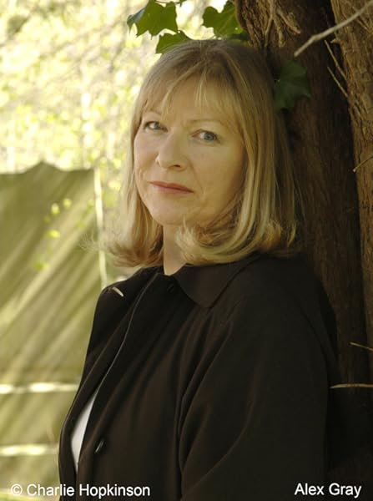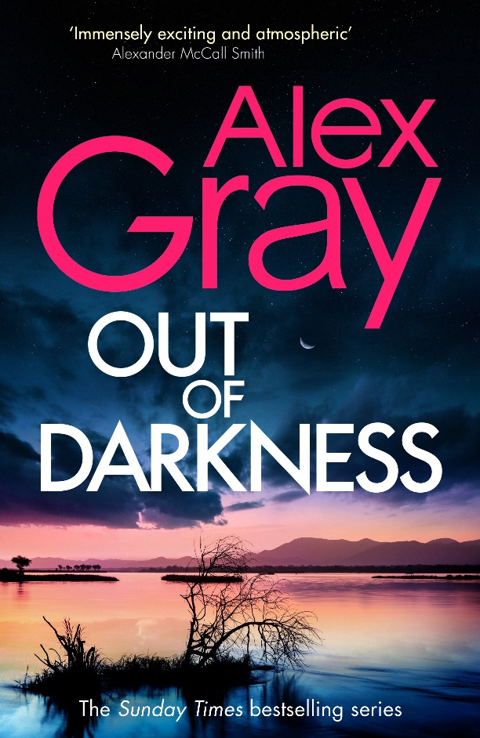

Find u3a groups/activities and how to join at: https://u3asites.org.uk/paisley/welcome

ENDS
Notes to the Editor

- Photo credit: crime writer Alex Gray by Charlie Hopkinson.

- Alex Gray is the speaker at Paisley & District u3a’s monthly meeting on Thursday 2 May 2024 at 2pm in the Salvation Army Hall, Paisley, PA1 1ND. For more details or to interview Alex Gray, please contact PR Advisor, Allana Parker on M: 07483 820027

- Alex Gray is the Sunday Times bestselling author of the Detective William Lorimer series. Born and raised in Glasgow, she has been awarded the Scottish Association of Writers' Constable and Pitlochry trophies for her crime writing. She currently has 19 published novels and is co-founder (with Lin Anderson) of the international Bloody Scotland Crime Writing Festival, now the biggest annual crime writing event. She will discuss the latest Alex Gray novel entitled Out of Darkness. To find exclusive articles, reviews and the latest news about Alex Gray and the DSI Lorimer series, visit www.alex-gray.com.

- Paisley & District u3a is Scotland’s 50th self-help learning organisation for people who no longer work full time. u3as are run by local volunteers freely sharing their knowledge and skills. Members are part of a UK-wide and international educational movement. The u3a motto is ‘Learn, laugh, live.’ Scotland has around 12,000 members in 55 u3as who enjoy the social side of new activities, interests and hobbies: https://u3asites.org.uk/scotland/members Details about this nationwide peer-learning for fun movement, with more than 1,000 u3as across the UK, can be found at: https://www.u3a.org.uk/

