Paisley & District u3a Press Release:

No embargo: 00.00 Monday 23 October 2023

Paisley u3a learns secrets of ageing well

Senior lecturer in psychology, Dr Louise Brown Nicholls is paying Paisley &
District u3a another visit.

The University of Strathclyde expert researcher will share current findings into brain health with u3a members on Thursday 2 November.

Several studies into older people’s thought processes suggest which indicators may positively impact on everyday lives.

As Director of the Strathclyde Ageing Network, Louise Nicholls will review some key points from her own group’s research. She also details how cognitive and memory outcomes and trends are being explored by a new Scottish Cognitive Ageing Network.

Monthly u3a meetings are held in the Salvation Army Hall, Mill Street (PA1 1ND) with refreshments served from 1.30pm. Anyone not in full time work is welcome to attend.

u3a chair, Kathy O’Donnell remarked: “I’m sure many of us have memory lapses as we get older. It’s simple things like not remembering someone’s name or forgetting a film title. Our u3a was fortunate to first hear Louise speak about the psychology of ageing in 2018. I’m sure she has new tips for brain health and wellbeing from the latest analysis.”

Dr Louise Brown Nicholls said: “I’m both delighted to be visiting Paisley u3a again and sharing our knowledge and experiences regarding how best to promote healthy and active ageing. My key message will be that lifelong social, mental, and physical engagement can benefit us as we age. Since u3a fosters this among its membership, I am excited to learn about the group’s activities and how it has thrived since I was here.”

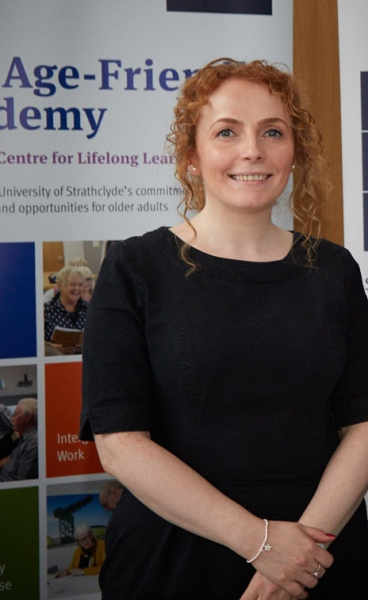

Find u3a groups/activities and how to join at: https://u3asites.org.uk/paisley/welcome
ENDS
Notes to the Editor

Photo: Dr Louise Brown Nicholls (copyright Louise Brown Nicholls). She is the guest speaker discussing ‘Health and wellbeing across the adult lifespan’ at Paisley & District u3a’s monthly meeting. It’s on Thursday 2 November 2023 at 2pm in the Salvation Army Hall, Paisley, PA1 1ND. For more details or to interview Louise, contact PR Advisor, Allana Parker on M: 07483 820027

- Dr Louise Brown Nicholls is a Senior Lecturer in Psychology at the University of Strathclyde where she leads her Memory & Ageing Lab. Louise’s expertise is in the study of cognition, especially memory and attention, and the psychology of ageing. Louise is Director of the Strathclyde Ageing Network, comprising Strathclyde's multidisciplinary ageing-related researchers. She is also a founding member of the new Scottish Cognitive Ageing Network, which brings together cognitive ageing researchers across Scotland. Some of Louise's research has been funded by the Economic and Social Research Council, the Chief Scientist Office, and The Carnegie Trust. Louise also enjoys working with external organisations and older adults in the community to share positive ageing ideas.

- Paisley & District u3a is Scotland’s 50th self-help learning organisation for people in part time work or no longer working full time. u3as are run by local volunteers freely sharing their knowledge and skills. Members are part of a UK-wide and international educational movement. The u3a motto is ‘Learn, laugh, live.’ Scotland has around 12,000 members in 55 u3as who enjoy the social side of new activities, interests and hobbies: https://u3asites.org.uk/scotland/members Details on this nationwide peer-learning for fun movement, with more than 1,000 u3as in the UK, at: https://www.u3a.org.uk/

