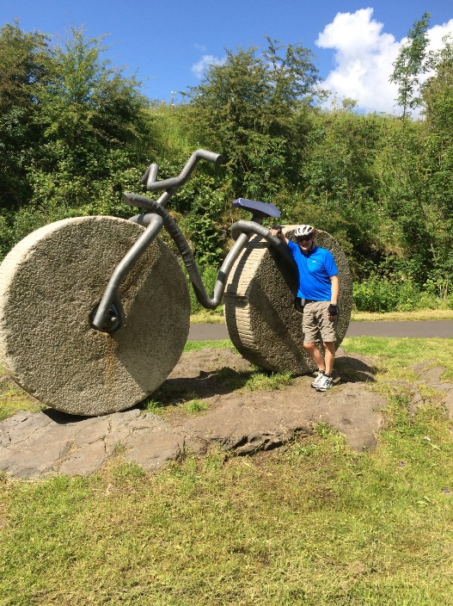

Paisley & District u3a Press Release:

No embargo: 00.00 Thursday 28 September 2023

Paisley u3a sees south-east Asia sights

It’s nearly time to take a photographic tour across Vietnam and Cambodia with
Paisley & District u3a.

On Thursday 5 October, u3a web manager and group leader, Rod Ferrier shares his recent travels to south-east Asia.

A 17 days trip across this region by bike and boat resulted in some spectacular Images of key historical and cultural sites. Among these are the Angkor Wat temples in Cambodia, which have UNESCO world heritage status.

Rod Ferrier’s travelogue and entertaining anecdotes kick start this u3a’s new session. Members’ monthly meetings are held in the Salvation Army Hall, Mill Street (PA1 1ND).

u3a chair, Kathy O’Donnell remarked: “There’s a saying that travel broadens the mind. This presentation promises to be a visual treat and is likely to generate a few questions.

“Before we hear from our guest speaker, there’s the chance to find out more about our u3a groups and activities. Paisley & District u3a now has 20 interest groups available to join for anyone no longer in full time work.

“We are holding an information fayre in the Hall, with refreshments, from 1.30pm-2pm. Anyone who is interested can come along, see what’s on offer and have a chat with any of our volunteers. More than 120 people already enjoy being in our u3a - you can too!”

Rod Ferrier said: “Vietnam has so much to offer, with a rich culture and history which is both old and new. We travelled from the north to the south with a support team and guides. Our small group was incredibly well looked after yet every day was full on!”

Find u3a groups/activities and how to join at: https://u3asites.org.uk/paisley/welcome
ENDS
Notes to the Editor

- Photos: (1) Angkor temples (Cambodia) © Ko Hon Chiu Vincent and (2) Rod Ferrier’s ‘bike’, a sculpture on the National Cycle Network route 7 (copyright Rod Ferrier). He is the speaker at Paisley & District u3a’s monthly meeting on Thursday 5 October 2023 at 2.10pm in the Salvation Army Hall, Paisley, PA1 1ND. For more details or to interview Rod, contact PR Advisor, Allana Parker on M: 07483 820027

- Originally from Aberdeen, Rod Ferrier has lived in Paisley for many years after marrying a local girl, Rhona. He trained as a Biomedical Scientist in Glasgow Western Infirmary’s Pathology Department. He moved to become Laboratory Manager in the University’s teaching/research unit, primarily involved in breast cancer research. After retiring, and looking for something to fill his time, Rod came across the newly-formed Paisley & District u3a. He enjoyed taking part and later became a group leader for art appreciation and for board games. He also joined the u3a committee and took on the web manager role. His interests include cycling, with the Sustrans National Cycle Network route 7 handily located on his doorstep. When and where he can, Rod enjoys cycling during his travels.

- Paisley & District u3a is Scotland’s 50th self-help learning organisation for people in part time work or not working full time. u3as are run by local volunteers freely sharing their knowledge and skills. Members are part of a UK-wide and international educational movement. The u3a motto is ‘Learn, laugh, live.’ Scotland has around 12,000 members in 55 u3as who enjoy the social side of new activities, interests and hobbies: https://u3asites.org.uk/scotland/members Details on this nationwide peer-learning for fun movement, with more than 1,000 u3as in the UK, at: https://www.u3a.org.uk/

