Science and Technology Group of Odiham U3A

Let there be Light - further reading

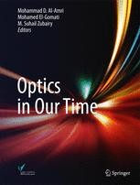

Optics in our time

Thomas Young (scientist) - Wikipedia

Quantum mechanics and the double slit experiment - Bing video

The super bizarre quantum eraser experiment - Bing video

The Quantum Experiment that Broke Reality | Space Time | PBS Digital Studios - Bing video

How the Quantum Eraser Rewrites the Past | Space Time | PBS Digital Studios - YouTube

The first ever photograph of light as both a particle and wave (phys.org)

Two-in-one photography: Light as wave and particle! (sous-titres français)

Double-slit experiment – Wikipedia

Why is the speed of light what it is?
