St Andrews Cathedral, Inverness, A very splendid Victorian building. https://invernesscathedral.org/
Lyn Rutter March 2023. Nairn u3a
Built from red Tarradale stone, giving it a pink sandstone appearance, erected on the bank of the River Ness, looking across the river to the city centre
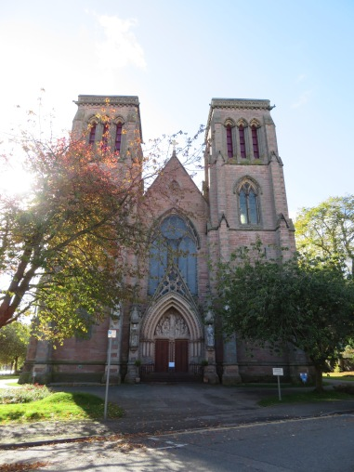
On entering the Cathedral, first impressions were how small the building is and how plain the architecture. I was wrong about the architecture. Standing in the nave looking towards the high alter, the space within the building is divided by large columns each made from a single block of Peterhead granite and right at the top are the carved faces of Bishop Maclean and Alexander Ross, the architect. Unfortunately, the pews are all gone, replaced by chairs but the tiled floor remains and as I walked around the Cathedral, it was a very peaceful atmosphere.
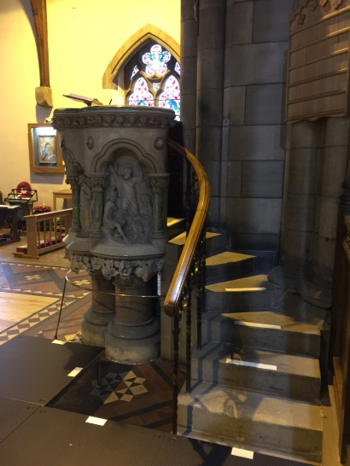
Further down the aisle, the pulpit made from stone from Caen, France with Irish marble and fine grained granite from Abrichan (near Loch Ness). It has carved panels depicting John the Baptist, St Andrew and 2 Angels.
The Choir Screen designed by Robert Lorimer, carved in wood, is also a war memorial giving tribute to members of the congregation who were killed in the First World War. (https://victorianweb.org/art/architecture/ross/2.html)
The stained glass windows beautifully show depictions from the bible (old and new testament) and have to be seen to do them justice (more than I can put into words), especially the west window, which is elaborate and dedicated to St Andrew. ( This website link gives more information: https://victorianweb.org/art/stainedglass/hardman/15.html). The north window shows The Ascension https://victorianweb.org/art/stainedglass/hardman/25.html. Another depicts the Good Samaritan and the Healing of the Lame.
The most impressive of the many statues is the Kneeling Angel font carved from white marble. (https://victorianweb.org/sculpture/redfern/3.html#:~:text=The%20font%20is%20in%20the,bowl%20on%20the%20other%20knee.)

