Inverness Museum and Art Gallery (IMAG)
https://www.highlifehighland.com/inverness-museum-and-art-gallery/
Its taken me 20 years to visit IMAG, having moved to the Highlands in 2004. What a treat.
Walking in through the doors, the first exhibit, Snow Days, nostalgic black and white photographs of Inverness past. (https://www.highlifehighland.com/inverness-museum-and-art-gallery/snow-day/)
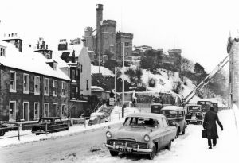
The downstairs gallery takes you on a through the fortunes of Inverness. The Highlands may be remote but not isolated with the region exchanging new technologies and ideas with its neighbours.
From a medieval, small market town with a harbour and castle, as it prospered and declined and prospered again over 500 years. Information boards detail how the arrival of the canals, railways, electricity generation, forestry and technology saw the economy growing, immigration rather than emigration, eventually, an airport in 1930s when Highland Airways carried its first paying passenger from Inverness to Kirkwall. In 1900 21,000 called Inverness home, rising to 60,000 by 1999, the fastest growing city in the UK.
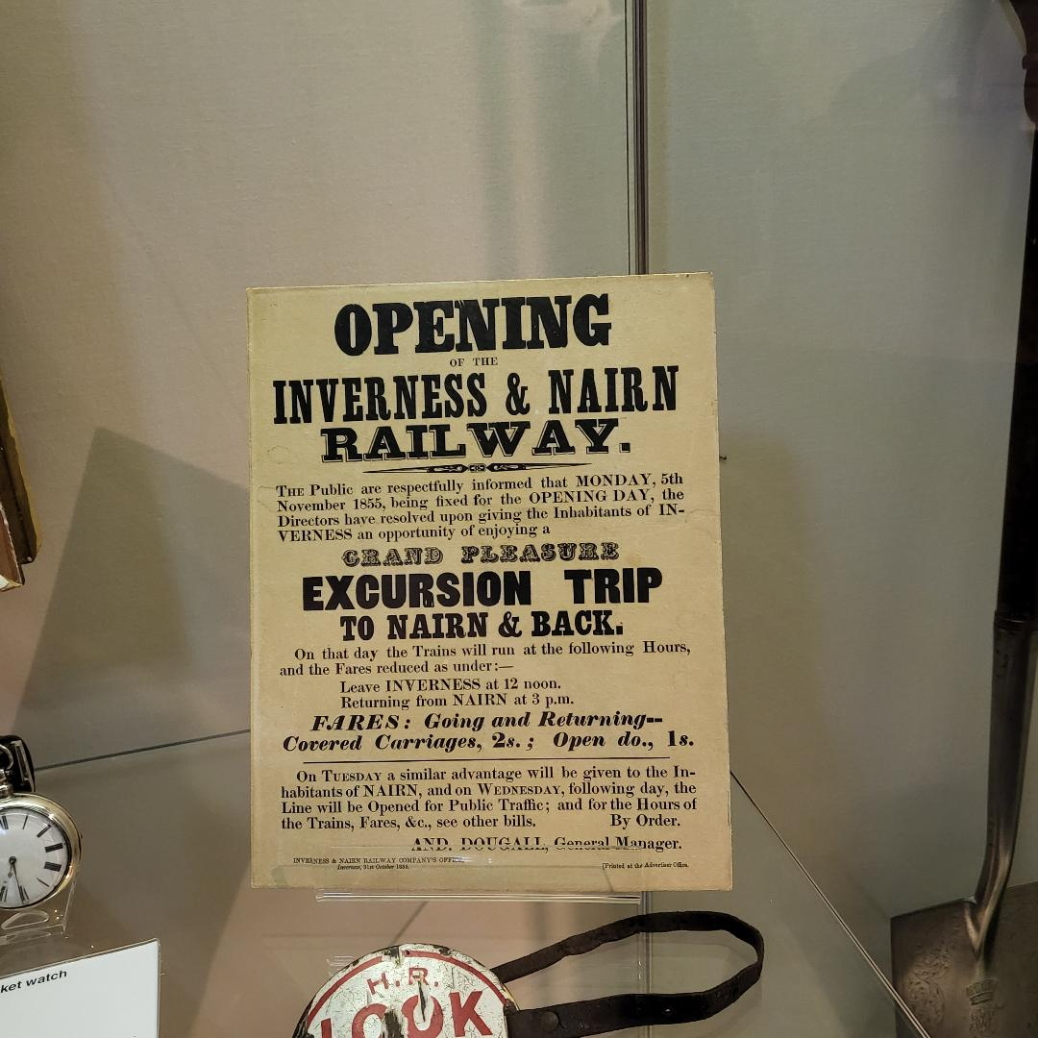
People:
In the upstairs gallery, information boards cover the clearances, the Jacobites and some of Inverness’s notable residents. Kenneth Street, named after Kenneth James Matheson (1854) and his sister Mary (1855), whose mother died after falling off a cliff. Their father was a successful businessman, landowner, Deputy Lieutenant for Ross-shire and Baronet. Kenneth inherited the title.
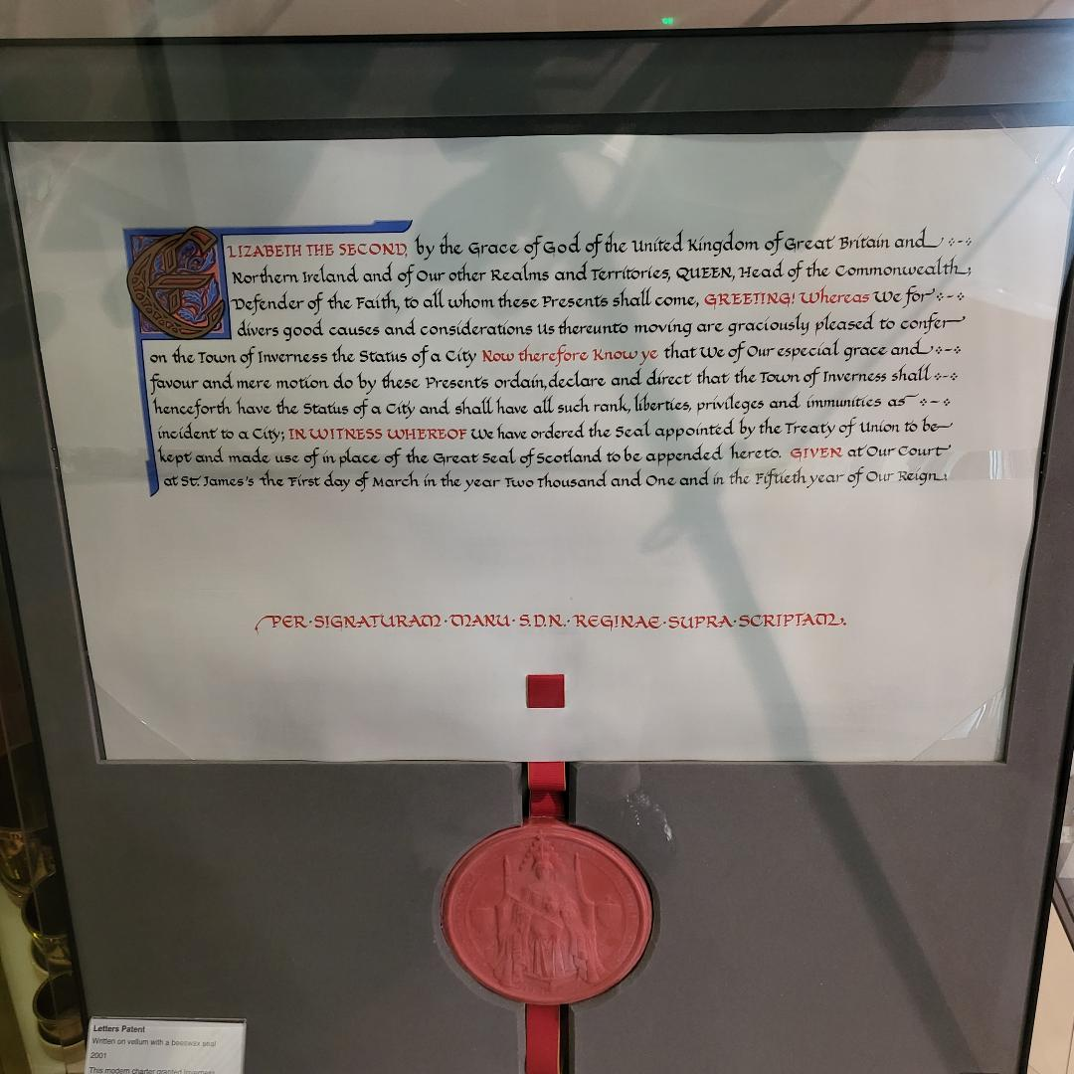
Silver making by highly skilled craftsmen centred around Inverness but also in Tain Wick and Nairn, supplying tableware, quaichs, snuff boxes and jewellery. P G Wilson was a jeweller and watchmaker and during 50 years of trading at various premises in Inverness he produced items for Baron Rothechild, Queen Victoria and other Royals. They never visited the shop, inviting Wilson to Dunrobin Castle and Balmoral Castle. Unfortunately, due to Ill-health, Wilson died in poverty aged 81.
Mairi Mhor nan Oran (Big Mary), a famous Gaelic singer lived in Inverness and composed many songs about the life and conditions of the highlanders and highland events in the 19th Century. In 1872 she was convicted of theft and spent time in Inverness Prison. Alexander Grant designed and made fiddles in his Inverness workshop. He invented a new design of fiddle – the Rondello. He also revolutionised the fishing rod.
In the art gallery and exhibition entitled Lost Threads and Severed Ties by Mark Lomax. Making quilts from everyday pieces of fabric to evoke memories and remembrance.

