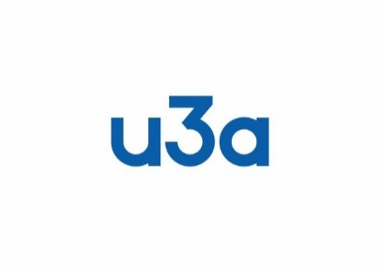
Job Description
U3a Luton

Accessibility Officer (AO)

Purpose
This role is a facilitating one, assisting members and group leaders to reach a satisfactory outcome if either one or both of these two policies need to be implemented.
Equality, Diversity, & Inclusion Policy
Accessibility Policy
Responsibilities
- To work in an advisory or intermediary role with members and group leaders.
- To ensure that due process is followed using the Process Chart as a guideline.
- To consult with the Executive Committee only if an outcome is not forthcoming, to reach a final decision.
- To report to the Executive Committee (for minuting) with regards to the final outcome adhering to GDPR principles.

The Accessibility Officer is supported by the Executive Committee.

GI
Final Version agreed by Executive Committee
17 July 2023

