**Template**

**Everyone Has a Story to Tell**

* Don’t forget to refer to the Step-by-Step Guide if you need help. Page 8-12 has suggestions.
* Begin with your title page, but if you’re not too sure, you can always decide later. For the time being, just write, ‘My Story’ and carry on from there. One day, the final title will make itself known to you.
* You might want to experiment with different fonts and font sizes. The Step-by-Step Guide uses the Verdana Font, but we’ve switched to the Lucida Calligraphy Font here. There are so many different choices!
* That’s it. ‘Is everyone sitting comfortably? Then we’ll begin.’
* Enjoy.

**Step One : Your Title Page**

**Step Two: Your Blank Timeline Grids**

* Find your starting decade timeline grid, deleting the grids that don’t apply to you.
* Then, beginning with your birth year, carry on completing each decade until you reach the present year.
* Check the Step-by-Step Guide if you need any reminders.
* Don’t forget to refer to the Table of Significant Events Over the Last 82 Years (1940-2022) in Appendix C, to assist with the World Events column.

**1930s**

|  |  |  |  |  |
| --- | --- | --- | --- | --- |
|  | Age | My Life |  | World Events |
| 1930 |  |  |  |  |
| 1931 |  |  |  |  |
| 1932 |  |  |  |  |
| 1933 |  |  |  |  |
| 1934 |  |  |  |  |
| 1935 |  |  |  |  |
| 1936 |  |  |  |  |
| 1937 |  |  |  |  |
| 1938 |  |  |  |  |
| 1939 |  |  |  |  |

**1940s**

|  |  |  |  |  |
| --- | --- | --- | --- | --- |
|  | Age | My Life |  | World Events |
| 1940 |  |  |  |  |
| 1941 |  |  |  |  |
| 1942 |  |  |  |  |
| 1943 |  |  |  |  |
| 1944 |  |  |  |  |
| 1945 |  |  |  |  |
| 1946 |  |  |  |  |
| 1947 |  |  |  |  |
| 1948 |  |  |  |  |
| 1949 |  |  |  |  |

**1950s**

|  |  |  |  |  |
| --- | --- | --- | --- | --- |
|  | Age | My Life |  | World Events |
| 1950 |  |  |  |  |
| 1951 |  |  |  |  |
| 1952 |  |  |  |  |
| 1953 |  |  |  |  |
| 1954 |  |  |  |  |
| 1955 |  |  |  |  |
| 1956 |  |  |  |  |
| 1957 |  |  |  |  |
| 1958 |  |  |  |  |
| 1959 |  |  |  |  |

**1960s**

|  |  |  |  |  |
| --- | --- | --- | --- | --- |
|  | Age | My Life |  | World Events |
| 1960 |  |  |  |  |
| 1961 |  |  |  |  |
| 1962 |  |  |  |  |
| 1963 |  |  |  |  |
| 1964 |  |  |  |  |
| 1965 |  |  |  |  |
| 1966 |  |  |  |  |
| 1967 |  |  |  |  |
| 1968 |  |  |  |  |
| 1969 |  |  |  |  |

**1970s**

|  |  |  |  |  |
| --- | --- | --- | --- | --- |
|  | Age | My Life |  | World Events |
| 1970 |  |  |  |  |
| 1971 |  |  |  |  |
| 1972 |  |  |  |  |
| 1973 |  |  |  |  |
| 1974 |  |  |  |  |
| 1975 |  |  |  |  |
| 1976 |  |  |  |  |
| 1977 |  |  |  |  |
| 1978 |  |  |  |  |
| 1979 |  |  |  |  |

**1980s**

|  |  |  |  |  |
| --- | --- | --- | --- | --- |
|  | Age | My Life |  | World Events |
| 1980 |  |  |  |  |
| 1981 |  |  |  |  |
| 1982 |  |  |  |  |
| 1983 |  |  |  |  |
| 1984 |  |  |  |  |
| 1985 |  |  |  |  |
| 1986 |  |  |  |  |
| 1987 |  |  |  |  |
| 1988 |  |  |  |  |
| 1989 |  |  |  |  |

**1990s**

|  |  |  |  |  |
| --- | --- | --- | --- | --- |
|  | Age | My Life |  | World Events |
| 1990 |  |  |  |  |
| 1991 |  |  |  |  |
| 1992 |  |  |  |  |
| 1993 |  |  |  |  |
| 1994 |  |  |  |  |
| 1995 |  |  |  |  |
| 1996 |  |  |  |  |
| 1997 |  |  |  |  |
| 1998 |  |  |  |  |
| 1999 |  |  |  |  |

**2000s**

|  |  |  |  |  |
| --- | --- | --- | --- | --- |
|  | Age | My Life |  | World Events |
| 2000 |  |  |  |  |
| 2001 |  |  |  |  |
| 2002 |  |  |  |  |
| 2003 |  |  |  |  |
| 2004 |  |  |  |  |
| 2005 |  |  |  |  |
| 2006 |  |  |  |  |
| 2007 |  |  |  |  |
| 2008 |  |  |  |  |
| 2009 |  |  |  |  |

**2010s**

|  |  |  |  |  |
| --- | --- | --- | --- | --- |
|  | Age | My Life |  | World Events |
| 2010 |  |  |  |  |
| 2011 |  |  |  |  |
| 2012 |  |  |  |  |
| 2013 |  |  |  |  |
| 2014 |  |  |  |  |
| 2015 |  |  |  |  |
| 2016 |  |  |  |  |
| 2017 |  |  |  |  |
| 2018 |  |  |  |  |
| 2019 |  |  |  |  |

**2020s**

|  |  |  |  |  |
| --- | --- | --- | --- | --- |
|  | Age | My Life |  | World Events |
| 2020 |  |  |  |  |
| 2021 |  |  |  |  |
| 2022 |  |  |  |  |
| 2023 |  |  |  |  |
| 2024 |  |  |  |  |
| 2025 |  |  |  |  |
| 2026 |  |  |  |  |
| 2027 |  |  |  |  |
| 2028 |  |  |  |  |
| 2029 |  |  |  |  |

**2030s**

|  |  |  |  |  |
| --- | --- | --- | --- | --- |
|  | Age | My Life |  | World Events |
| 2030 |  |  |  |  |
| 2031 |  |  |  |  |
| 2032 |  |  |  |  |
| 2033 |  |  |  |  |
| 2034 |  |  |  |  |
| 2035 |  |  |  |  |
| 2036 |  |  |  |  |
| 2037 |  |  |  |  |
| 2038 |  |  |  |  |
| 2039 |  |  |  |  |

**2040s**

|  |  |  |  |  |
| --- | --- | --- | --- | --- |
|  | Age | My Life |  | World Events |
| 2040 |  |  |  |  |
| 2041 |  |  |  |  |
| 2042 |  |  |  |  |
| 2043 |  |  |  |  |
| 2044 |  |  |  |  |
| 2045 |  |  |  |  |
| 2046 |  |  |  |  |
| 2047 |  |  |  |  |
| 2048 |  |  |  |  |
| 2049 |  |  |  |  |

**Step Three: Delving Deeper**

* There are thirty labelled pages from which to choose aspects of your life you’d like to write about. Delete or remove the pages you decide not to use.
* Make sure you begin typing below the line located beneath the illustration. It’s clearly indicated by 
* If you want to extend your typing beyond the title page, a blank will automatically appear when you reach the bottom of the page.
* You may use several sheets to write under one title, but remember, don’t get carried away!
* Don’t forget, there is a page with a blank title box to record your own title. Use as many of these as you need.
* You may want to add your own personal illustrations, photographs or other documents to some of these precious pages.
* The final page, ‘Enduring Words,’ may be downloaded and completed in your own handwriting to add a personal touch.









































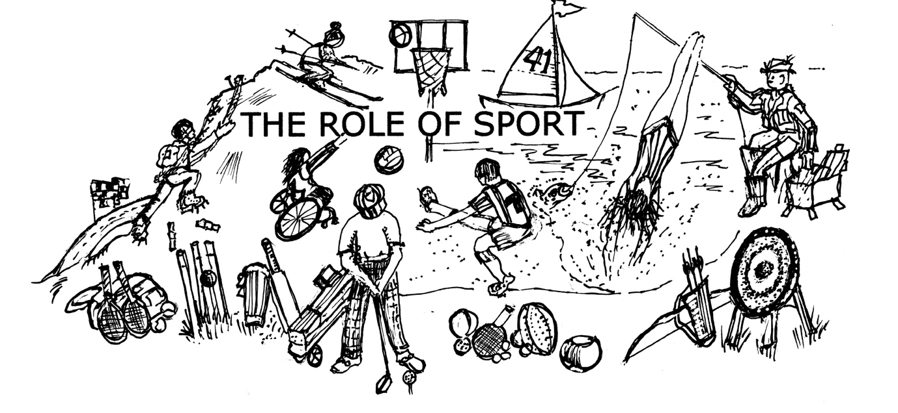



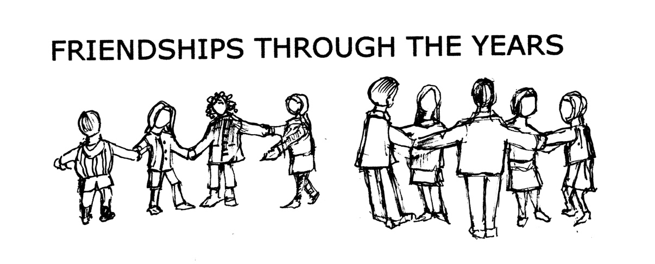



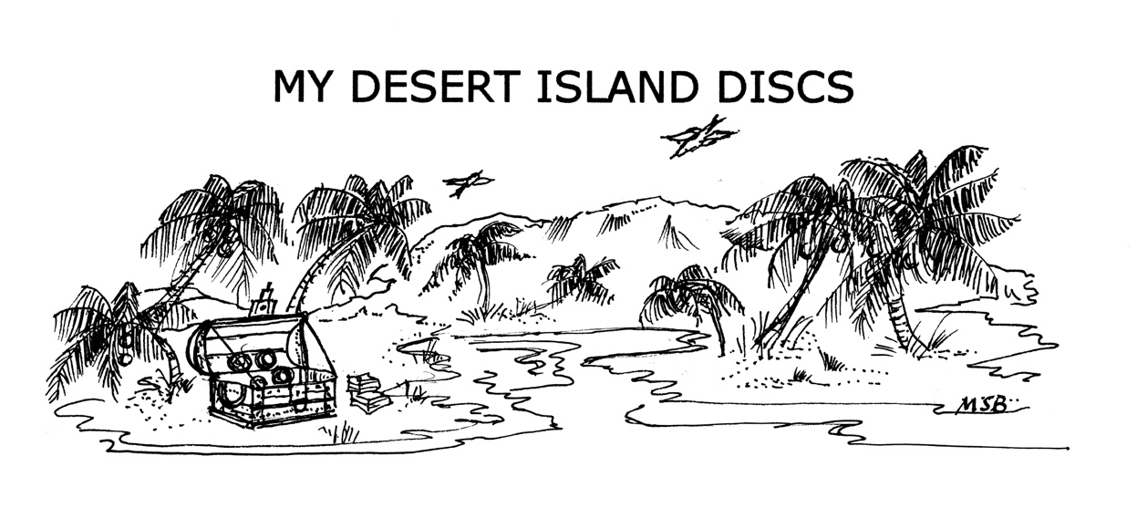







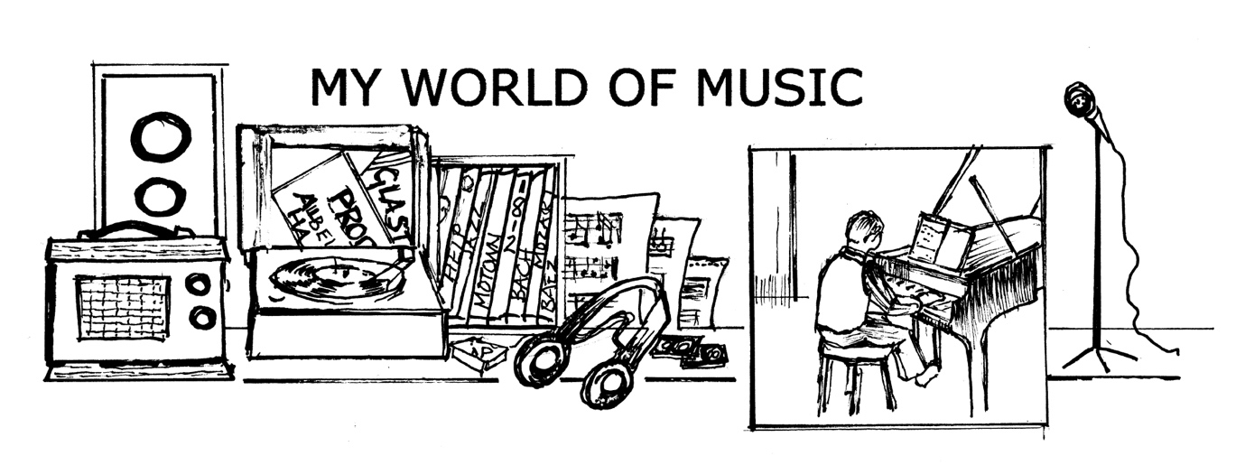







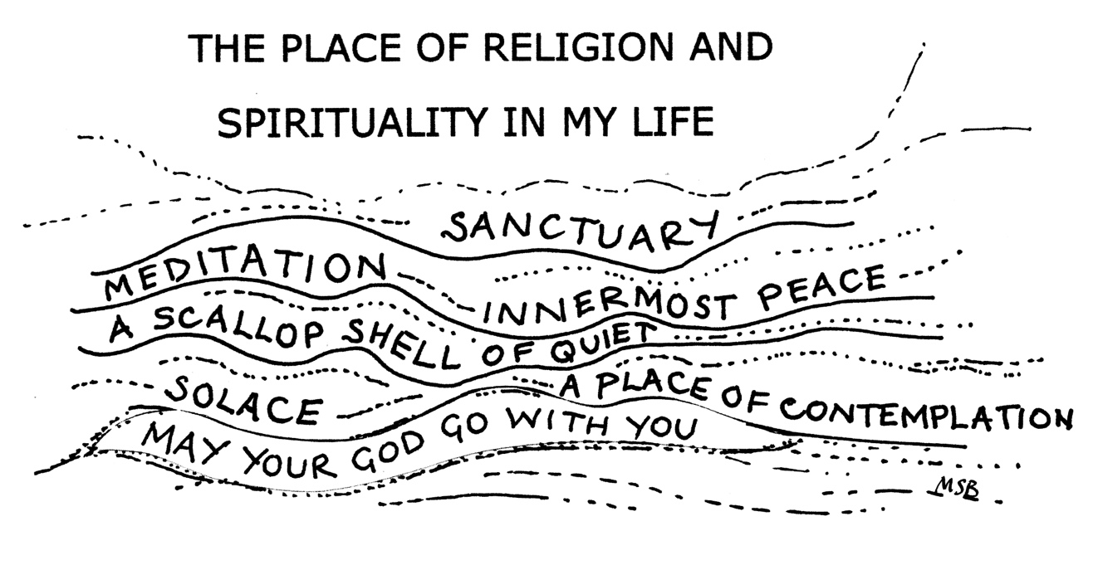



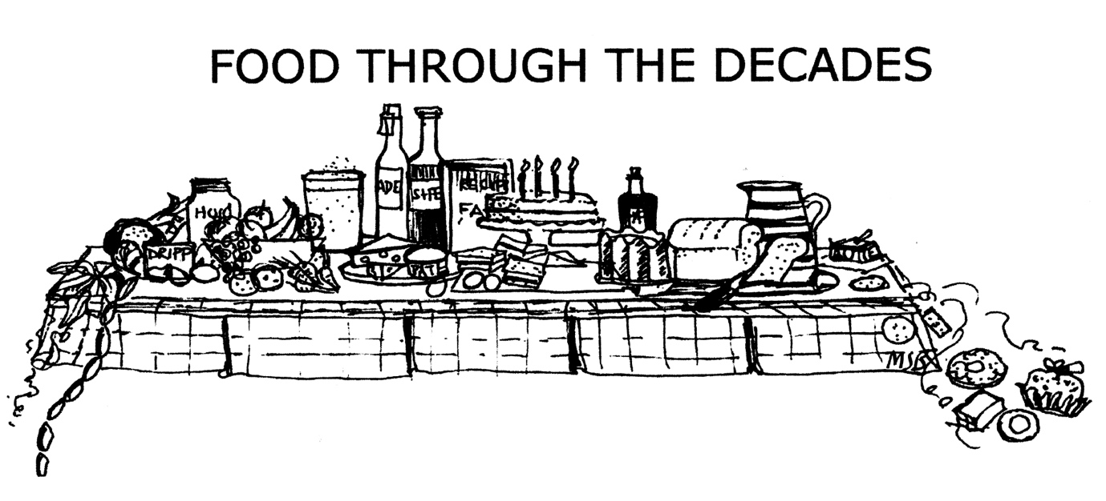



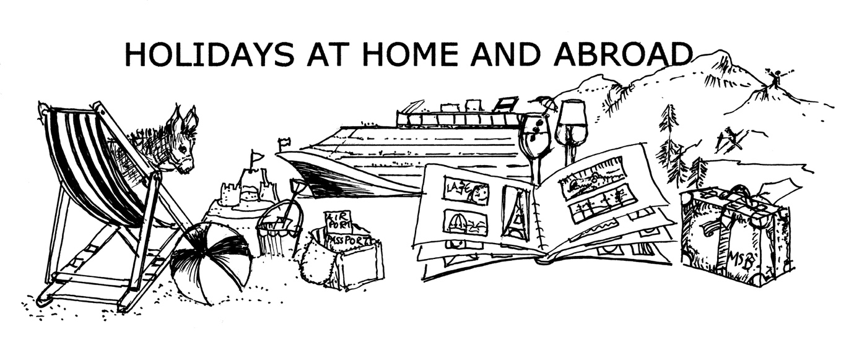



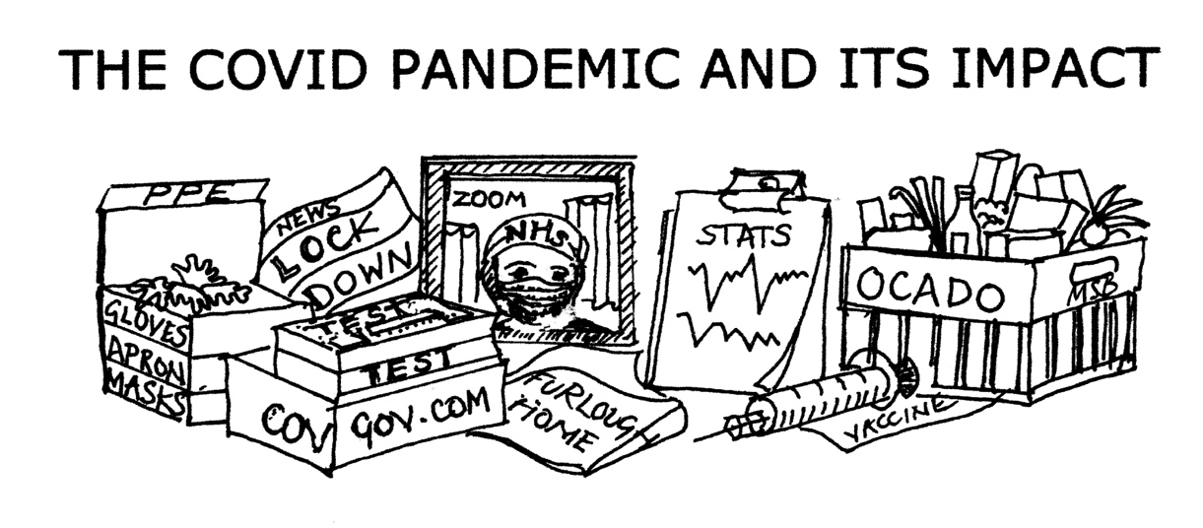



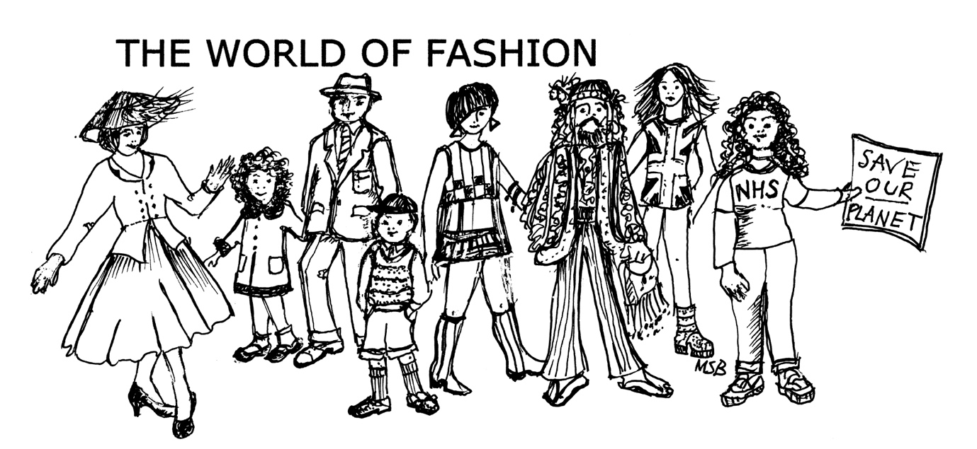



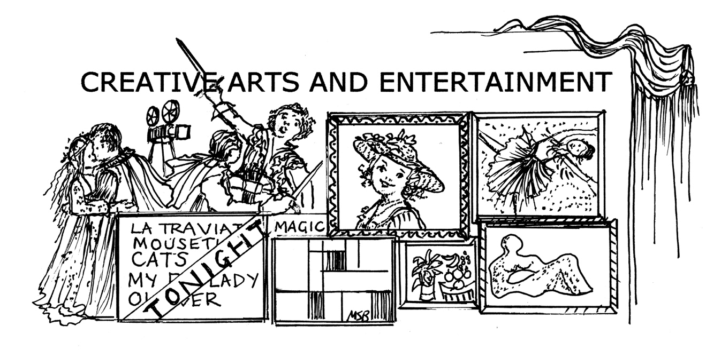



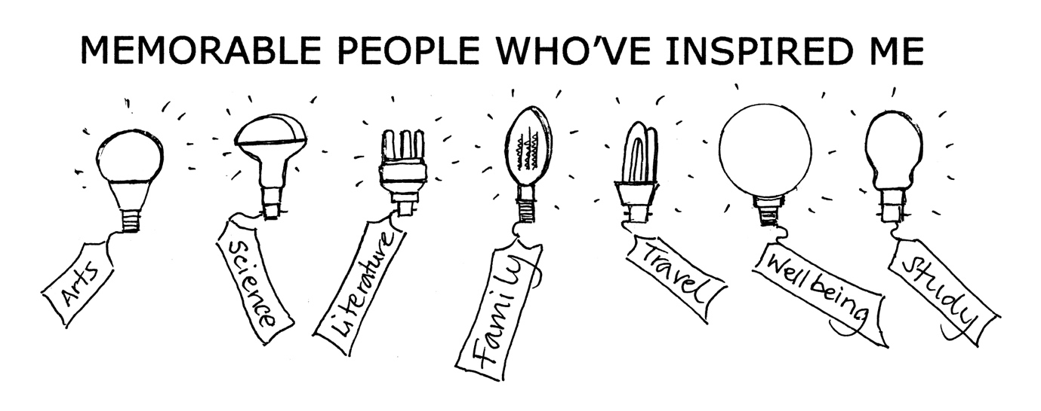







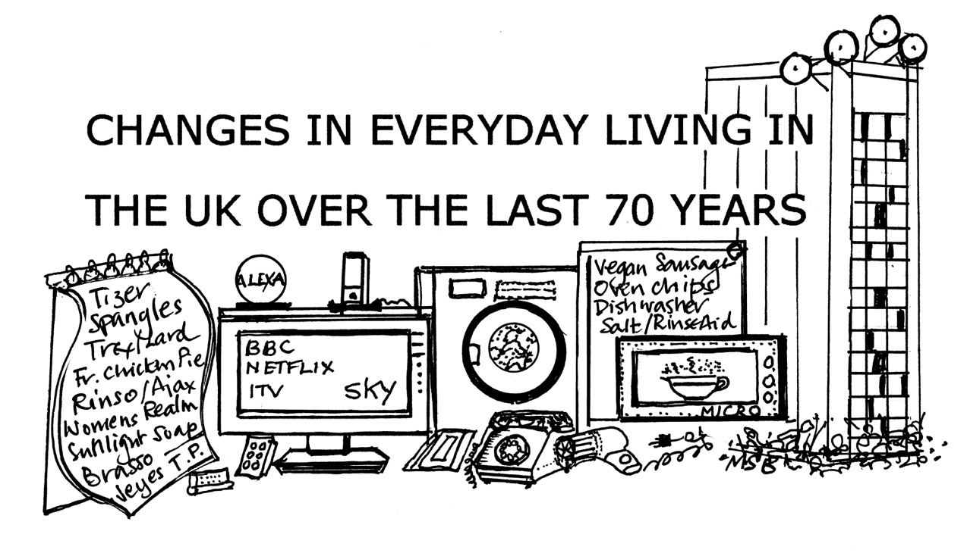



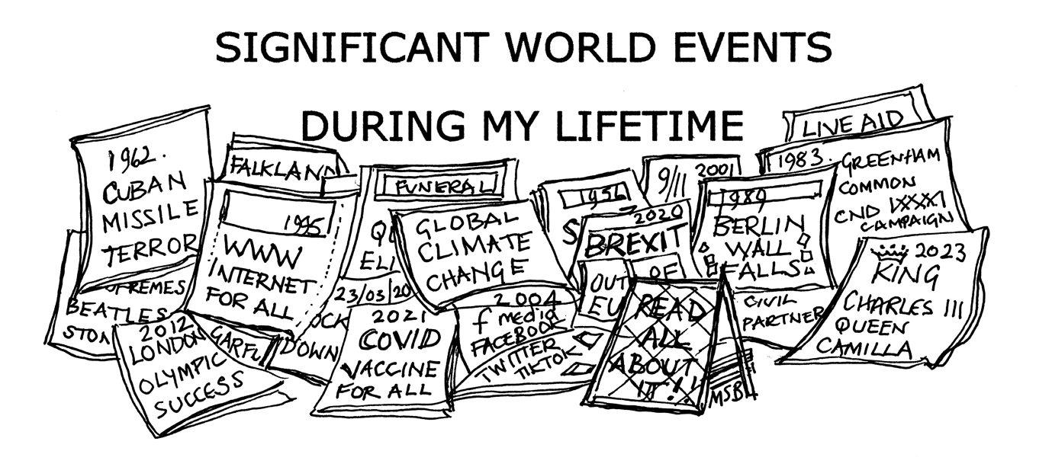



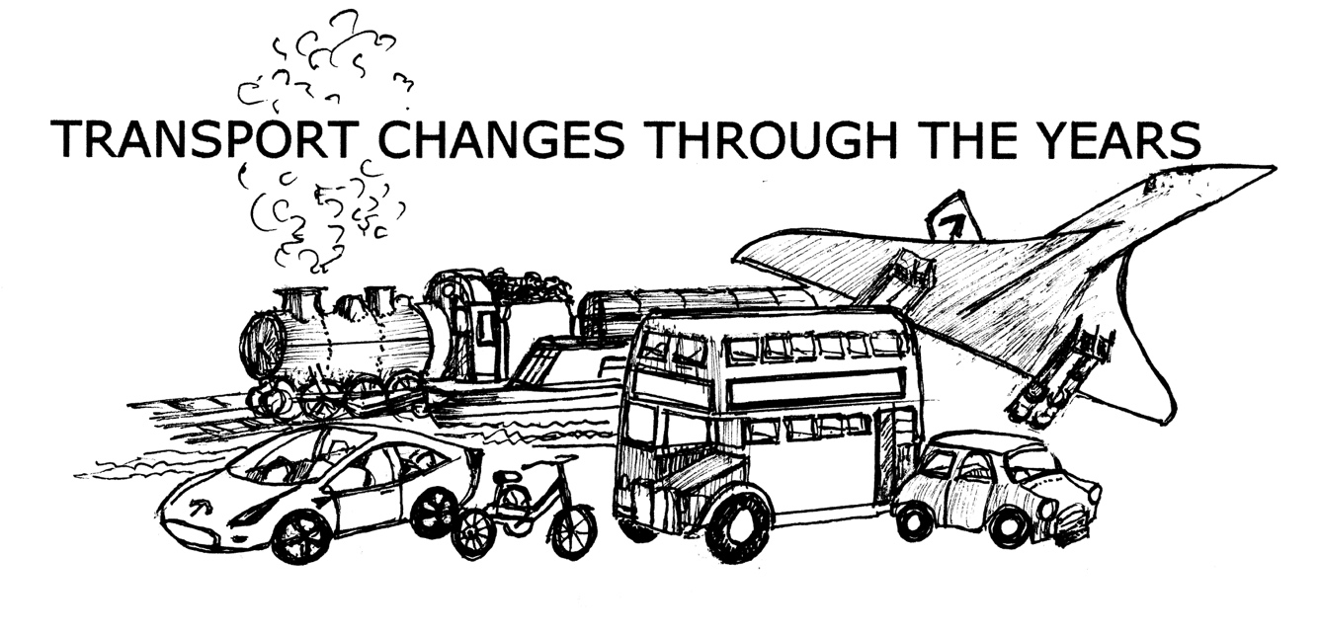



NOT ONLY BUT ALSO



NOT ONLY BUT ALSO



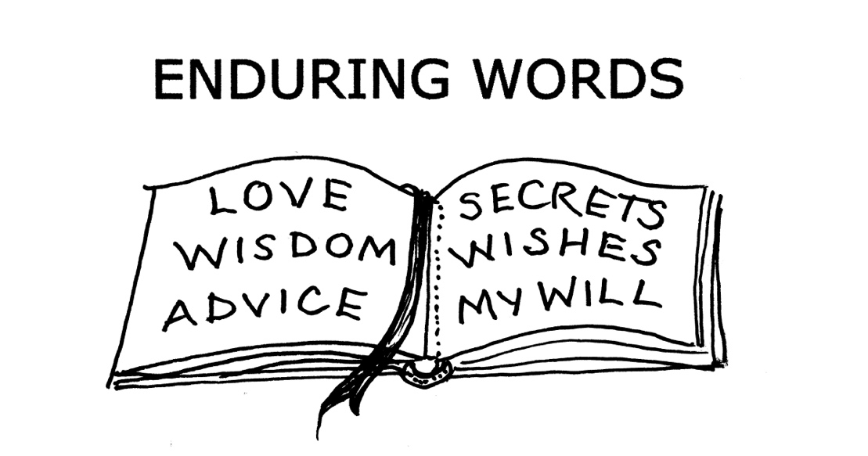



**Step Four: Poems, an optional step**

* If you decide to end your story after Step Three you won’t need the following pages. Well done! Your mission to write your life story is complete. Congratulations. Print off your work and delight family members and friends with your memoirs.
* The remaining pages are for those who wish to end their stories with a poem or two. Please refer to the Step-by-Step Guide (page 13) or refer to Appendix B in the Appendices. You may add as many pages as you wish.
* But…..you may continue your story with information, documents, illustrations, photography pages, additional family tree information or whatever you feel inclined to include.
* ‘From here I can go anywhere I choose.’*

*Wendy Cope poem ‘New Season’