
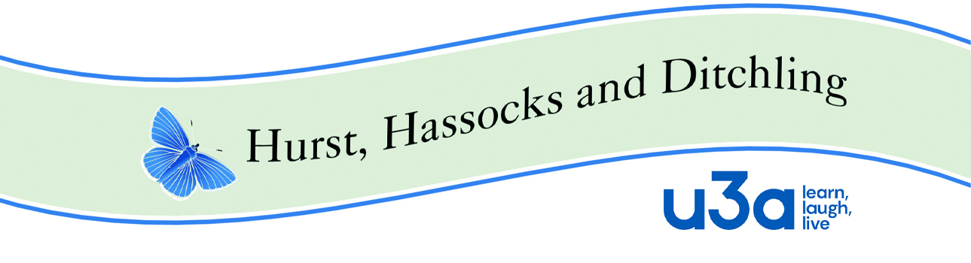
Role description – Chair

Document purpose
To outline the role and responsibilities of a Chair.

Role summary
- To provide inclusive and democratic leadership of the board of Trustees (the committee).
- To ensure the Executive Committee (EC) fulfils its responsibilities for the overall governance, strategic direction, financial stability, administration and sustainability of the u3a.
- To ensure the u3a applies its resources exclusively in pursuance of its charitable objects/purposes, abides by its governing document (the constitution) and complies with charity law and other relevant legislation.
- To ensure the u3a upholds the guiding principles.
- To oversee adherence to the terms and conditions of affiliation to the Third Age Trust.
- To ensure the effective and efficient administration of the u3a.
- To safeguard the good name and values of the u3a organisation.

Main responsibilities
Please note, the specific tasks listed below are in addition to the statutory requirements and responsibilities of trustees of charitable organisations in the UK as laid down by the relevant regulatory bodies. Some u3as may decide to delegate some of these tasks to other members of the EC e.g. the Secretary.

Committee meetings
- To approve the meeting agenda in advance with the Secretary and agree on any papers to be circulated with it.
- To chair EC meetings ensuring that:
  - the meeting starts and ends on time.
  - all necessary business is covered.
  - discussions involve everybody and are not dominated by a few people.
  - discussions remain focussed on the stated agenda items.
  - clear decisions are reached following a unanimous or majority vote of the EC.
  - a timetable for implementation of actions/decisions is agreed.
- To be impartial and encourage objectivity in decision-making.
- To encourage all members to put forward new ideas and initiatives for discussion.
- To provide a casting vote in the event of an equal split.
- To agree the annual cycle of dates for EC meetings.

Annual General Meeting (AGM)
- To approve the Agenda
- To write a Chair’s report for the Annual Report and Accounts and ensure the final draft of the Annual Report is presented to the EC for approval in good time prior to the AGM.
- To chair the AGM ensuring that the business of the meeting is conducted according to laid down procedures and any existing standing orders.
- To ensure that newly elected Trustees have access to Trustee induction material available on the Third Age Trust website, both documentation and workshops.

Governance
- To ensure the EC complies with its constitution and remains focused on the u3a’s stated charitable objects/purposes and its aims.
- To facilitate the committee to determine the strategic direction and short and long term aims of the u3a.
- To ensure the u3a applies its resources exclusively in pursuance of its objects/purposes.
- To ensure that the u3a abides by the guiding principles and ethos of the u3a movement.
- To protect and manage any property and assets belonging to the u3a.
- To ensure that all Trustees clearly understand their duties and responsibilities and can make best use of their particular skills so they can become fully engaged and involved.
- To ensure that relevant Policies are created as required and updated at least bi-annually.
- To ensure all board decisions are implemented in a timely manner.
- To ensure that the EC reviews activities once they have taken place, to highlight what if anything can be learned and improved.
- To develop a strong team ethos within the board and maintain positive working relationships dealing with any conflicts which arise quickly and constructively.
- To encourage the EC to review its own effectiveness and consider whether individual roles can be better organised and/or distributed.
- To ensure the EC reviews risks on a regular basis and puts measures in place to mitigate any which are identified.
- To discuss succession planning and ways of encouraging members to volunteer for the EC.

Finance
- To be constantly aware of the financial position of the u3a through regular communication with the Treasurer.

Members of the u3a
- To ensure the u3a has maximum impact for its members.
- To ensure new members are welcomed and supported and understand the ethos and self-help nature of the organisation.
- To ensure that all possible methods are used to achieve the best level of communication possible between the EC and the members.
- To establish a procedure for members to provide feedback, raise issues and suggest new initiatives to be brought before the EC for discussion.
- To ensure all volunteers feel valued and supported.
- To ensure that the EC regularly reviews its structure, ways of working and relationship with the membership.
- To attend u3a functions and host monthly meetings as required.

External contacts
- To liaise with local organisations and to be the first point of contact.
- To attend or delegate network, regional and national meetings as appropriate.
- To be a spokesperson and an ambassador for the u3a ensuring that the local community is aware of what the u3a is and does.
- To represent the u3a at external functions, meetings and events.

On completion
- To carry out a comprehensive handover to the new Chair.

 | Doc HHD–Role description - Chair | HHD u3a
Version | Description of changes |  | Date
Draft V1 | Amended from TAT base document |  | 25-11-2022
V1 | Approved at ECM |  | 14-12-22

