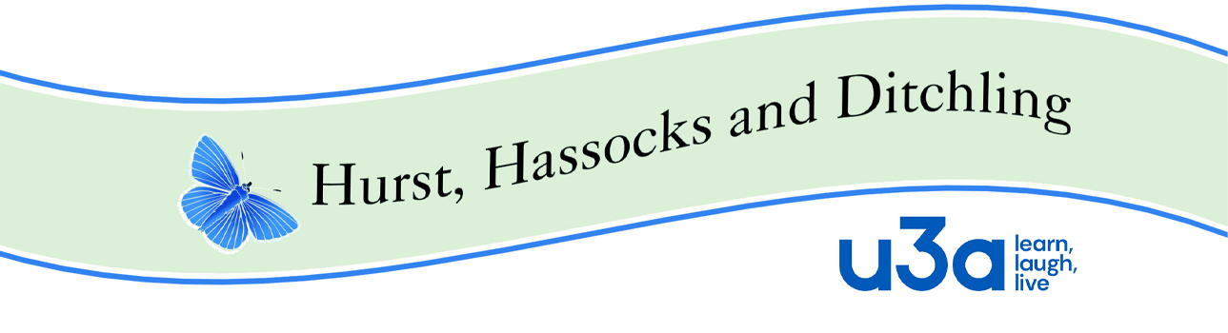

**HHD Policy Guide 16 MEMBER CODE OF CONDUCT**

This version approved by the Executive Committee on **11-10-23**

______________________________________________________________________

# Introduction

## Purpose

The member code of conduct clarifies the standard of behaviour expected from each u3a member.

## Scope

Relevant to all u3a members

## Related documentation

* All HHD Policies that set out expectations of behaviour by u3a members
* HHD Disciplinary procedure.

**1.4. Principles**

* Membership of a u3a is open to all in their third age, which is defined not by a particular age but by a period in life in which full time employment has usually ceased.
* No qualifications are sought or offered. Learning is for its own sake, with enjoyment being the prime motive, not qualifications or awards.
* There is no distinction between the learners and the teachers; they are all u3a members.

**2. Expectations of u3a members**

* Members promote the values of lifelong learning and the positive attributes of belonging to a u3a.
* Members should do all they can to ensure that people wanting to join a u3a can do so and members should support each other.
* Members are expected to abide by all HHD u3a’s policies and procedures.
* Members are expected to treat each other with dignity and respect at all times.
* Additional expectations for Trustees are set out in the Trustees Code of Conduct.