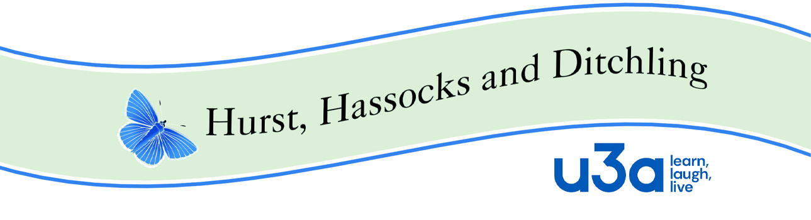

**HHD Policy Guide 15 Complaints Procedure**

This version approved by the Executive Committee on 21-02-2024.

1. **Purpose**

According to the HHD u3a constitution a member may be expelled from the u3a, for a breach of any membership condition such as non-payment of fees, or for any deliberate or continual breach of a policy or procedure of the charity e.g. Code of Conduct, Health and Safety or Equality and Diversity. Any member may make a complaint under this procedure.

1. **Principles**

**2.1** It is important that every member has access to a copy of the Code of Conduct, Health and Safety Policy and Equality and Diversity Policy so that they are clear of what is expected of u3a members. (All Policies and Procedures are available on the HHD u3a website {https://u3asites.org.uk/hhd} then click on HHD u3a, then click on Policies. Copies will be made available on request for members not having Internet access.)

**2.2** Should an issue arise as to whether a member is in breach of the procedures, it is essential that this should be brought to the attention of the member concerned and that all attempts are made to resolve the issue through discussion and informal support.

**2.3** In the event that a breach has occurred, the member concerned must be informed of the potential consequences under the procedures and the potential outcome of expulsion.

**2.4** Trustees must abide by the u3a’s Trustee Code of Conduct.

1. **Procedure**

***Stage 1 (Informal)***

Breaches of HHD policies and procedures may arise through complaints by members about the way they are treated by another member or a group leader, concerns that group leaders or EC members are not acting according to u3a guidelines or any other inappropriate conduct that may come to the notice of the EC.

In the first instance efforts should be made by the Group leader or Groups Co-ordinator to deal with the matter informally, offering training or support if needed.

It is important for the person dealing with the breach to notify the Executive Committee (EC) if the breach is serious.

***Stage 2 (Investigation)***

If the matter is not resolved informally, it should be referred to the EC for formal investigation.

The EC should appoint two members to undertake an investigation using the following steps

1. Write a letter to the individual setting out the allegations and the attempts that were made to resolve the situation informally
2. Interview the person who referred the breach in order to fully understand the issue and speak to any other individuals involved who may corroborate the allegations.
3. Interview the individual who should be invited to bring a friend or support person
4. Inform the u3a Office of the complaint, and follow any guidance offered by them.

***Stage 3***

The investigators should compile a report for the full EC outlining their findings and making a recommendation as to whether they feel the issue could be resolved with further support or training or whether the individual should be expelled. The EC will make the final decision and the Chair will notify the member in writing. This will normally conclude the procedure.

***Stage 4***

In exceptional circumstances where the complaint is about a Trustee and cannot be resolved within the organisation, the EC members dealing with the case will follow the guidance of the u3a’s advisor which may well be the Regional Trustee.

**Good Practice**

While this procedure is very unlikely to be needed, it would be good practice for at least one member of the EC to have relevant training. The u3a’s website has numerous references to assist with the cases, but at all times the guidance of the u3a’s appointed referee must be followed.