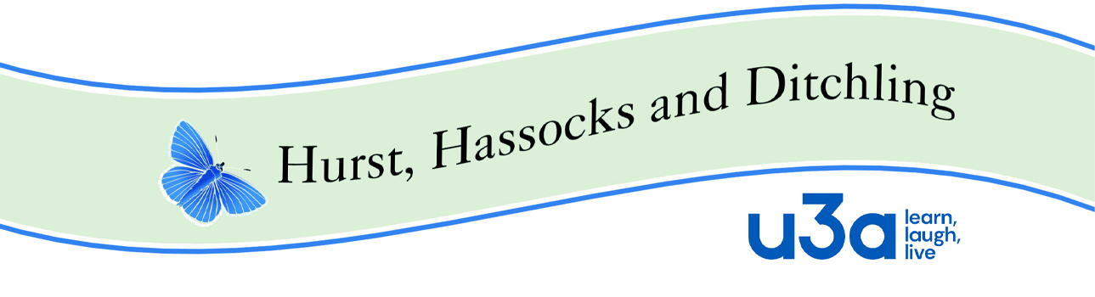

**HHD Policy Guide 14 Equality, Diversity & Inclusion**

This version approved by the Executive Committee (EC) on **13th December, 2023**

1. **Introduction**

This policy has been drawn up to comply with the Equality Act 2010. The Act stipulates that it is illegal for organisations to treat someone unfairly on the basis of ‘protected characteristics’, which the Act defines as

* ethnic origin, nationality (or statelessness) or race
* age
* disability
* religion or belief (including the absence of belief)
* marital or civil partnership status
* sexual orientation
* sex
* pregnancy
* gender reassignment

The Equality Act specifies that organisations need to consider what *‘reasonable adjustments’* can be made in order to accommodate those who may have particular needs and it requires organisations to deal with and remedy issues of exclusion, discrimination or other unfair treatment.

# Statement

The HHD u3a is a learning co-operative and membership charity which enables its members in their third age to share educational, creative and leisure activities. Members draw upon their knowledge, skills and experience to teach and learn from each other (peer to peer learning). HHD u3a recognises that some people are particularly likely to experience discrimination and harassment and HHD u3a is committed to making sure that HHD is as inclusive and welcoming as possible.

1. **HHD Commitment**
2. HHD u3a will strive to ensure that members do not experience discrimination on the basis of their protected characteristics. This will include

* ensuring equal access to all groups and activities
* sensitive, respectful, non-discriminatory behaviour between members, Group Leaders and Trustees.

1. HHD u3a EC will

* review the reasonable adjustments needed for all members
* address issues of discrimination or unfair treatment.
* where necessary, seek guidance and additional support from the U3A National Office.

# Practical approaches to inclusion

HHD u3a will make sure all new members are aware of our policies and procedures in relation to equality, diversity, inclusion and accessibility and the Member Code of Conduct. HHD u3a will make reasonable adjustments to ensure a wide range of people can participate in our activities and meetings. This may include:

* Consideration given to the time of day of meetings and their location.
* Consideration of venues for meetings and activities including:
  + Accessible to wheelchair users
  + Access to PA system and a hearing loop
  + Parking and disabled parking available
  + Disabled toilet facilities available
  + Suitable transport for trips and outings
  + Accessible venues for trips and outings
  + Option to be accompanied by family member/carer
* Publicity:
  + Using a variety of methods and platforms to communicate externally and raise the profile of the u3a.
  + Making communications available to those who don’t have access to the internet
  + Using a range of images that reflect the local community
  + Facilitating training and support to help members with electronic communication
* Recruiting new members:
  + Doing outreach sessions and contacting agencies working with community groups who may be harder to reach
  + Encouraging members who are representative of the groups who are under-represented within the u3a i.e. men or younger members to assist with the recruitment process.
  + Managing growth so that we ensure that new members can be accommodated
* Monitoring:
  + HHD u3a will monitor member numbers i.e., the numbers of members who join, re-join and leave each year in order to identify any trends in
* Tasks and Roles:
  + EC to ensure a range of people get their voices heard by encouraging more members to take on roles such as leading groups.
  + The u3a Groups Coordinator to ensure that both new and existing members can access the members meetings and groups that they would like to join and consider what reasonable adjustments may be needed to ensure this.
  + The Groups Coordinator will ensure that new Group Leaders are made aware of issues in relation to accessibility and equality and assist them in meeting all the requirements of this policy.
  + EC members and group leaders will be encouraged to attend at least one training programme organised by HHD u3a around equality, diversity and inclusion and the issues will be revisited on a regular basis.
  + If a group leader notices that a member is not being included or is struggling to participate, they will take steps to support that individual, seeking support from the Groups Coordinator if needed.

# 5 Code of Conduct

HHD u3a has a member code of conduct. The code of conduct (HHD Policy Guide 16) outlines those members should abide by the HHD u3a’s policies and procedures as well as treating each other with dignity and respect. This would include not acting in a way that would be deemed discriminatory or offensive.

# 6 Dealing with discrimination and harassment

According to the HHD u3a constitution a member may be expelled from the u3a, following a disciplinary procedure (see HHD u3a Complaints Procedure) for breach of any membership condition or for breach of any behaviours code of the charity. This would include intentionally and consistently breaching this Equality and Diversity policy.

Where HHD u3a EC become aware of any discriminatory practice or harassment, they will seek to address this through consultation with all parties concerned. Support, training or mediation may be offered as required. If this process does not resolve the issue, formal procedures may be invoked.

If any member of HHD u3a feels they have experienced or witnessed discriminatory behaviour or harassment, they should report this to the group leader, in the first instance (unless the group leader is the perpetrator) in which case the Groups co-ordinator should be told.

The person who has experienced discrimination should be carefully listened to and their concerns should be recorded. The group leader, with the permission of the complainant, should inform the Groups organiser and together they should try and resolve the problem by bringing the parties together. In the event of this process, which hopefully will be a learning experience for the perpetrator, is not effective, the matter should be reported to the EC who will decide how to proceed. It should be quite clear that any member who knowingly and deliberately behaves in a discriminatory way towards another member can face exclusion from the u3a.

# 7 Definitions

**Equality** means that every individual has an equal opportunity to make the most of their lives and talents, and that no one should have poorer life chances because of where, when or whom they were born, or because of other characteristics. Promoting equality is about behaving in a way that recognises and tackles inequalities and actively ensures that everyone is treated fairly and does not experience discrimination.

**Promoting** **diversity** is about recognising that everyone is different and creating an environment that values those differences as enriching.

**Inclusion** is about positively striving to meet the needs of different people and taking practical steps to ensure members feel respected and can play a full part in the organisation.

**Direct Discrimination** is when a person istreated less favourably because of their ethnic origin, nationality (or statelessness) or race, age, disability, religion or belief (including the absence of belief), marital or civil partnership status, sexual orientation, pregnancy, gender reassignment, political belief

**Indirect Discrimination** occurs when, a condition or requirement is applied equally to all groups of people but has a disproportionately adverse effect on one particular group.

**Harassment** is unwanted conduct related to ‘protected characteristics’ *that has the purpose or effect of violating a person’s dignity*, or creating an intimidating, hostile, degrading, humiliating or offensive environment. Harassment is also unwanted conduct of a sexual nature which has that same purpose or effect.

**Victimisation** occurswhen someone is treated less favourably than others in the same circumstances because he or she has made a complaint or an allegation of discrimination, harassment or bullying or given information regarding such a complaint or allegation.