LEAVIN’ ON A JET PLANE
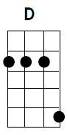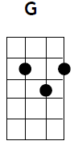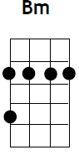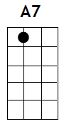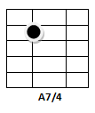
Intro:- D/// ///

D G D G
All my bags are packed, I’m ready to go, I’m standing here outside your door
D Bm A7 A7sus A7
I hate to wake you up to say goodbye
D G D G
But the dawn is breaking, it’s early morn’, taxi’s waiting, he’s blowing his horn.
D Bm A7 A7sus A7
Already I’m so lonesome I could die.

D G D G
So kiss me and smile for me, tell me that you’ll wait for me
D Bm A7 A7sus A7
Hold me like you’ll never let me go
D G D G
‘Cause I’m leavin’ on a jet plane, don’t know when I’ll be back again
D Bm A7 A7sus A7
Oh, babe… I hate to go.

D G D G
There’s so many times I’ve let you down, so many times I’ve played around
D Bm A7 A7sus A7
I tell you now… they don’t mean a thing
D G D G
Every place I go I’ll think of you, every song I sing I’ll sing for you
D Bm A7 A7sus A7
When I come back I’ll wear your wedding ring

D G D G
So kiss me and smile for me, tell me that you’ll wait for me
D Bm A7 A7sus A7
Hold me like you’ll never let me go
D G D G
‘Cause I’m leavin’ on a jet plane, don’t know when I’ll be back again
D Bm A7 A7sus A7
Oh, babe… I hate to go.

D G D G
Now the time has come to leave you, one more time, let me kiss you
D Bm A7 A7sus A7
Then close your eyes, I’ll be on my way
D G D G
Dream about the days to come, when I won’t have to leave alone
D Bm A7 A7sus A7
About the times I won’t have to say

D G D G
So kiss me and smile for me, tell me that you’ll wait for me
D Bm A7 A7sus A7
Hold me like you’ll never let me go
D G D G
‘Cause I’m leavin’ on a jet plane, don’t know when I’ll be back again
(Slowing) D G A7 D ………………
leavin’ on a jet plane,

