**Colours**

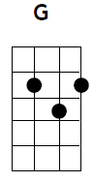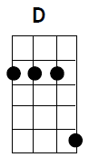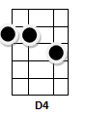

**Intro:-**D/// D/// C/// C/// G//Gsus4 G//Gsus4

[G]Yellow is the colour of my true love’s hair  
In the [C]morning when we [G]rise  
In the [C]morning when we [G]rise  
That's the [D]time, that’s the [C]time I love the [G]best G/// G/// G///  
  
[G] Blue’s the colour of the sky, aye aye  
In the [C]morning when we [G]rise  
in the [C]morning when we [G]rise  
That's the [D]time, that’s the [C]time I love the [G]best G/// G/// G///  
  
[G]Green’s the colour of the sparklin’ corn  
In the [C]morning when we [G]rise  
in the [C]morning when we [G]rise  
That's the [D]time, that’s the [C]time I love the [G]best G/// G/// G///

[G] Mellow is the feelin’ that I get  
When I [C]see her, in my[G]dreams  
When I [C]see her, in my[G]dreams  
That's the [D]time, that’s the [C]time I love the [G]best G/// G/// G///  
  
[G] Freedom is a word that I rarely use  
Without [C]thinkin’, huh [G]huh

Without [C]thinkin’, in grati[G]tude  
Of the [D]time, of the [C]time when I’ve been [G]loved.G4/// G……….