Appendix 1 to Annual Review 2022-23

Interest Group Review 2022/23 (Part 3)

Theatre Group 2

This group has now been running for six months and has ten members. We meet, over coffee, each month, to discuss the world, and thoughts for trips for the following month!
Our main activities, so far, have centred around the Royal Opera House and National Theatre screenings at Cineworld. Whilst we miss the theatre of actually being there, it is an ideal way to experience some excellent London productions. In addition, we have been to Edinburgh and the MacRobert Centre at Stirling University.
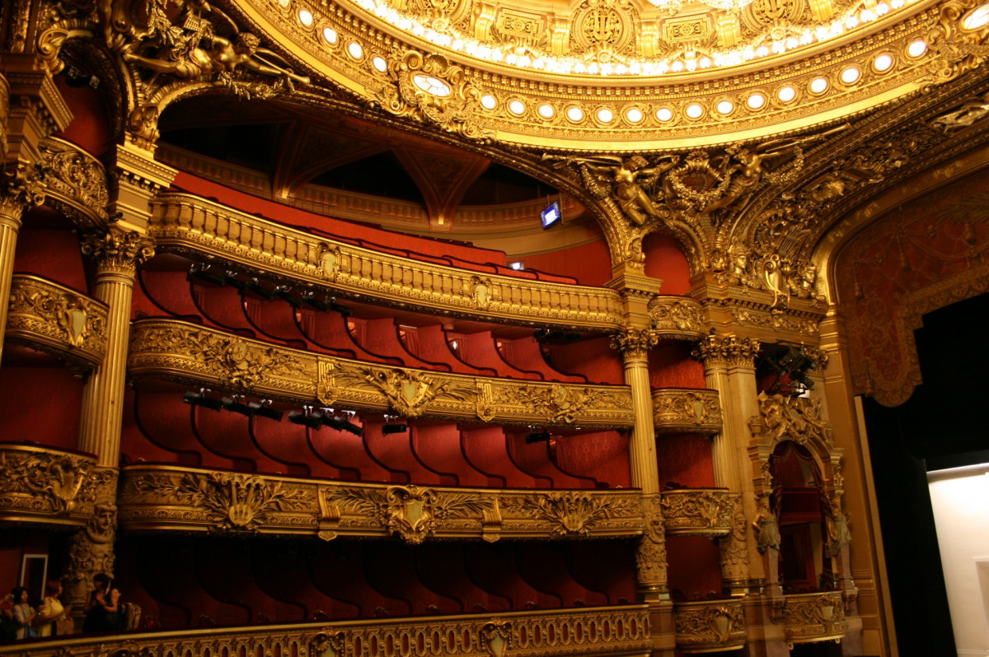

Themed Walks

The walking group meets once a month, on the second Monday of each month at ten am. The group meets throughout the year and currently has 32 members. The walks are all within 15 miles or so of Falkirk, mostly within 4 miles of the town. They are about 2.5 to 4 miles long, usually mild with moderate difficulty kept to a minimum. The walks finish with refreshments or lunch at a cafe or restaurant geographically close to the end of the walk. The walks usually consist of 8 to 15 walkers as many of the members are, either on holiday or have other commitments, or are on a break for medical reasons.

Virtual Coffee Morning.

The Group meets once a week on Thursdays at 10.30. We usually meet on Zoom but on the last Thursday of the month we meet face-to-face in a coffee shop. It’s usually a very informal event but every so often a member will talk about a particularly interesting trip or hobby sharing pictures and stories. On average 6-8 members attend but it’s a drop-in meeting which started on Zoom during lockdown and all are welcome, always!

World Events Past and Present.
This group meets on a Wednesday from 10.15 until about 11.45. The meetings take place every two weeks on Zoom, and occasionally the meeting will take place in person. Group members pick a topic of interest to all the group and everyone joins the discussion. Previous topics have included globalisation, Middle East Issues and the relationship between religion and state.
Other details about the group can be found on the website.

Learn
Laugh
Live

