**Membership Form 2023-2024**

**Renewal  New Member**

**Scottish Charity No.SC048974**

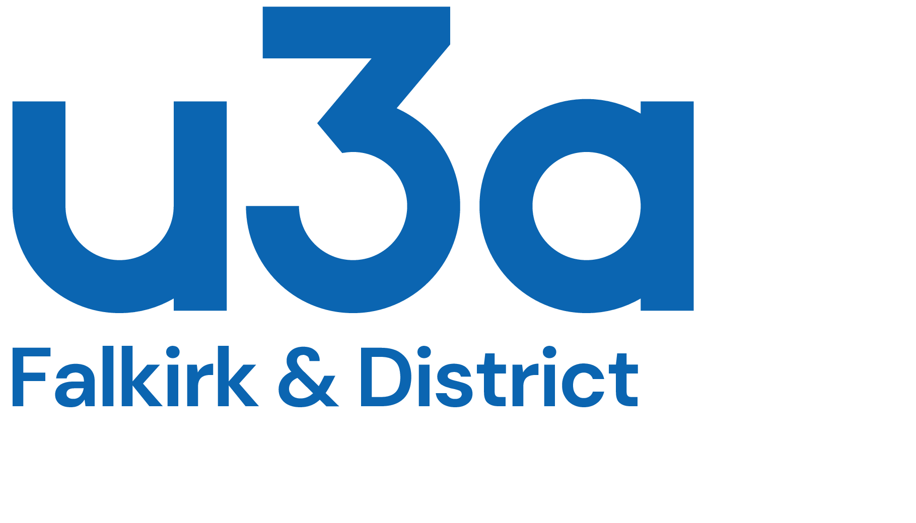

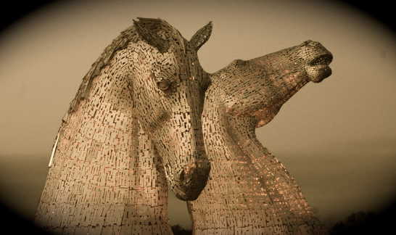

|  |  |  |  |  |
| --- | --- | --- | --- | --- |
| **Your Details** | | Title | Forename | Surname |
| Email* | | | | |
| Telephone | Home | | | |
| Mobile | | | |
| Address | | | | |
| Postcode | | | | |

*To reduce costs, the committee will communicate with you via email, where possible.

|  |  |  |  |  |  |
| --- | --- | --- | --- | --- | --- |
| **Membership fees** *Please see next page for terms and conditions of membership.*   |  |  | | --- | --- | | I enclose the annual membership fee of £20. It includes a £3.50 membership fee paid to our national organisation, the Third Age Trust, which provides a wide range of services and benefits, including liability insurance cover. We do not charge for open & group meetings.  *Annual membership runs from 1st September until 31st August.*  I am paying my membership subscription as follows (please tick one) | | |  |  | | |
| Bank transfer to ‘Falkirk & District u3a’  Sort Code 80-22-60 Account no. 12958169  Please use reference MEM-23-surname & initial  e.g.MEM-23-BLOGGSJ | Cheque payable to ‘Falkirk & District u3a’      Cash |

**Send the signed & completed Membership application form & cheque, if appropriate, to**

**The Treasurer, Falkirk & District u3a, 13 Gannel Drive, Maddiston, Falkirk ,FK2 0AL**

**or scan & email this form to peter.willett21@gmail.com**

|  |  |
| --- | --- |
| **Gift Aid** *Please read the Gift Aid declaration on next page. Tick* ***one*** *of the following boxes:*  I would like to Gift Aid my membership subscription this year & thereafter, and my name as known to the tax office is ……………………………………………………………………………………………………………… | |
| I am unable/ unwilling to Gift Aid my subscription at present | |
| **Privacy Statement**  *Please read the privacy statement on next page* *before ticking the boxes below.*  **Note if this box is NOT ticked, we cannot accept you as a member.**  I consent to my data being used for membership purposes. | |
| **The Third Age Trust magazine** - ‘Third Age Matters’- is published quarterly & is sent directly to your home address. It is included in your annual subscription.  I consent to my data being shared with the company who oversee the distribution of the Trust Magazines. | |
| I apply for membership of Falkirk & District u3a and confirm that I will abide by the terms and conditions of membership (see next page). I confirm that I have completed the form myself | |
| Signed | Dated |

**TERMS AND CONDITIONS OF MEMBERSHIP**

All members must:

* Abide by the Principles of the U3A movement.
* Always act in the best interests of the U3A and never do anything to bring the U3A into disrepute.

• Abide by the terms and conditions of the constitution.

* Treat fellow members with respect and courtesy at all times.
* Comply with and support the decisions of the elected committee.
* Advise the committee of any change in your personal details.

**GIFT AID DECLARATION**

When I Gift Aid my membership subscription, I am confirming that I have paid or will pay an amount of Income Tax and/or Capital Gains Tax for the current tax year (6 April 2021 to 5 April 2022) that is at least equal to the amount of tax that the charities that I donate to will reclaim on my gifts for the current tax year. I understand that the charity will reclaim 25p of tax on every £1 that I have given.

Note

* You can cancel this declaration at any time.
* If your circumstances change and you no longer pay sufficient income or Capital Gains tax you must notify the charity in writing.
* If you pay Income Tax at the higher or additional rate and wish to receive the additional tax relief due to you, you must include all your Gift Aid donations on your Self-Assessment Tax Return Form or ask HM Revenue and Customs to adjust your tax code.
* Please notify the charity in writing if you change your name or address.

**PRIVACY STATEMENT**

The Data Protection Act requires us to gain consent from each member to use their data in the ways shown below. Our full Data Protection Policy and Privacy Policy can be seen on our website

Please tick the box on the membership form to give us permission to use the information you have supplied in the following ways:

* To store it securely for membership purposes.
* To communicate with you as a u3a member.
* To share with group leaders for those groups in which you participate.
* To send you general information about the Third Age Trust (the national organisation to which u3as are affiliated).
* Please be advised that you can request for your data not to be used for any of these purposes at any time by contacting us.

***Please be aware that if you do not give us the required permission, we will be unable to communicate with you by phone, email or post. This includes newsletters and communications from group leaders, and therefore we will be unable to accept you as a member.***