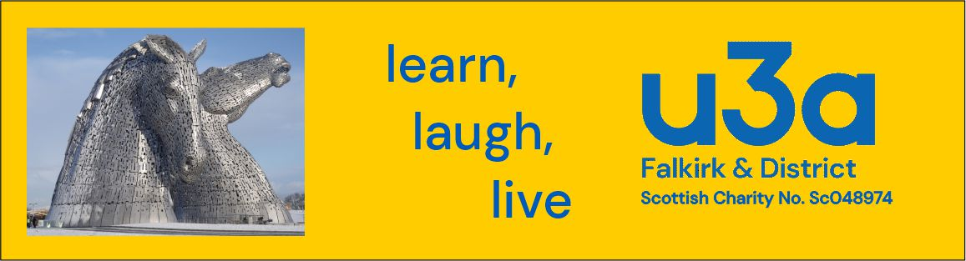
Annual Review 2022-2023

Introduction
The u3a (University of the Third Age) is a UK wide, cooperative movement of people no longer in full time work or raising a family where members promote the values of lifelong learning. Members come together to continue their educational, social and creative interests in a friendly and informal environment.
There are over 1000 u3as throughout the United Kingdom with nearly 400,000 members. Each u3a has a wide range of interest groups, chosen and run by their members.
Membership
Falkirk & District u3a membership year starts with registration at the beginning of September and meetings usually conclude with the Annual General Meeting in June when the new committee is elected. Occasional virtual and in-person coffee mornings are held over the summer months so that members can keep in touch.
A membership fee of £20 covers from September 2022 to August 2023, with £10 for those joining more than halfway through the year. A Registration Meeting was held at the beginning of September 2022 when members could pay their annual fees and sign up for Interest Groups. Members could also pay their fees online and by post.
Membership forms are available at Open Meetings and on our website. Membership numbers reduced considerably after the COVID19 pandemic but are slowly increasing from 84 and presently stand at 88.
Each household receives a quarterly u3a ‘Third Age Matters’ magazine by post which is included in their annual subscription.

Interest Groups
Interest Groups pursue a common interest and each group decides what, where and when they meet allowing members to share their knowledge, skills, interest and experience. Groups generally meet fortnightly or monthly We have had 17groups operating throughout the year. Most groups now meet in person in a public forum or in a member’s house but one or two have continued to meet on the internet using Zoom. Our largest group is the walking group.
The majority of groups do not operate during the summer months but the coffee morning group, which was set up to combat isolation during the COVID pandemic, continues throughout the year. A new Photography group is due to start shortly and a few other groups await organisers.
(See Appendix 1 Review of Interest Groups operating during 22-23 for more information)

Open Meetings & speakers
Open Meetings were held on the First Tuesday of each Month.
For most of the year, Open Meetings have been conducted as hybrid meetings, in person in St Francis Xavier Church Hall and online using Zoom.
The following speakers gave talks
October - Paul Barrowman -Self-Directed Support
November - Charlie Guy talked about historic Dead & Buried
December - A musical afternoon with ‘The Strummers’
January - The History of the Fire Brigade by Charlie Colliar
February – Danny Pace talked about his Life on the Oil Rigs
March -Archie McIntyre told us of Captain Eric ‘Winkle’ Brown CBE, Navy officer & test pilot .
April – Susan Crisp – The World’s 2nd Oldest Profession
May - Geoff Bailey – The Antonine Wall
Short films, quizzes, a mindfulness session and group leaders chat have also been included in Open Meetings.

Finance
Our financial year runs from 1st April 2022 to 31st March 2023.
We received the reclaimed Gift Aid payment from HMRC. We received a grant of £150 from The Third Age Trust, our national body, to offset any expenses incurred in our display in October 2022 in the Howgate Centre, Falkirk, at the Older Peoples Day.
The membership fee of £20 per annum was maintained in September 2022 and our financial position remains strong as shown in the attached accounts.(See Appendix 2, Annual accounts )

Information and Publicity
Contact with members is done in a variety of ways throughout the year. We send out a monthly Newsletter using Mailchimp to all members who have given us an email address.
A week before an Open Meeting, an invitation, with a short synopsis of the topic to be covered, is sent out to members using Mailchimp.
We have a website where members and those interested in joining our organisation can get a taste of what we do. Clickable link for Website - https://u3asites.org.uk/falkirk/welcome
A week before, and the week after, our monthly Open Meetings a summary of the topic to be covered by the speaker is put in the Falkirk Herald, the local weekly newspaper.
Committee members regularly attend meetings of other organisations for those who have retired in the area to increase the knowledge of others and encourage new members of Falkirk & District u3a.
We had a stall in the Howgate Shopping Centre at the Older Peoples Network exhibition in October 22. While this provided an opportunity to encourage members of the public to join our organisation and there was some interest shown in our organisation, we did not gain any new members.
We also have a presence on Facebook. The link can be found below https://www.facebook.com/groups/FalkirkandDistrictU3A

Our organisation locally and Nationally
The trustees held a face-to-face meeting in the middle of summer 2022 to help organise the coming year beginning in September 2022. Thereafter, regular monthly meetings were held by the committee on Zoom. During the year, our membership Secretary, Ron Davidson, resigned due to ill health and our thanks go to Susan Crisp who volunteered to take over and was co-opted on to the committee. All members of the committee are Trustees of the Scottish charity Sc048974.
Committee Officers and Trustees
- Chair - Louise Westall
- Vice – chair - Archie McIntyre
- Secretary - Dorothy Ferrie
- Treasurer - Peter Willett
Committee Members and Trustees
- Interest group Co-ordinator - Jennifer Kightley
- Website & IT contact – Peter Kahan
- Membership Secretary – Ron Davidson (June22 - October22)

Co-opted Committee Members and Trustees
- Membership Secretary – Susan Crisp (November 22-present)
- Publicity – John Giovanacci (February 23-present)
Members have met with the Scottish representative of The Third Age Trust and the Chairperson attends meetings of the Central Scotland network of u3as

What has been achieved this year
Throughout the year, we have become more competent in the use of the technical equipment for monthly Hybrid Open Meetings.
We have had speakers who gave interesting and informative talks on a variety of topics.
Our Privacy and GDPR (General Data Protection Regulation) Policies were update and put on our website in March
Trustees attended a variety of Scottish and UK wide meetings to further Falkirk & District u3a. These include:-
Falkirk Older People’s Network
U3a Media Scotland Club, meetings for webmasters
Quarterly meetings for Central Scotland u3a Chairs
Forums for those setting up networks/hybrid meetings
Falkirk & District CVS
Meetings with the Scottish Representative on Third Age Trust.

Looking Forward
Open Meetings will continue to be held using hybrid technology to allow those unable to attend in person, to join the meeting from their home.
Open Meetings will be enhanced, in line with the wishes of members.
Improvements will be carried out on our website to make it more appealing to potential new and existing members.
Members will be encouraged to be more participative, particularly in setting up new Interest Groups, in line with the ethos of the u3a.
Local people will be more knowledgeable about Falkirk & District u3a through improved publicity.

Thank You
Our thanks go to:-
Interest Group Organisers, many of whom have had to embrace new technology to keep in touch with members.
The volunteers, often unsung, who have helped to keep our organisation going e.g. those who have spent many hours working on developing our hybrid Open Meetings and operating the technical equipment ( George Love, Andy Crisp), Zoom organiser (Pamela Chambers), kitchen helpers (Helen Crozier, Morven Mack) and Jim and Elma Farquhar who greet everyone in the foyer at our Open Meetings.
St Francis Xavier Church Hall for the use of their hall.
Thank you to our trustees for their commitment and hard work.

