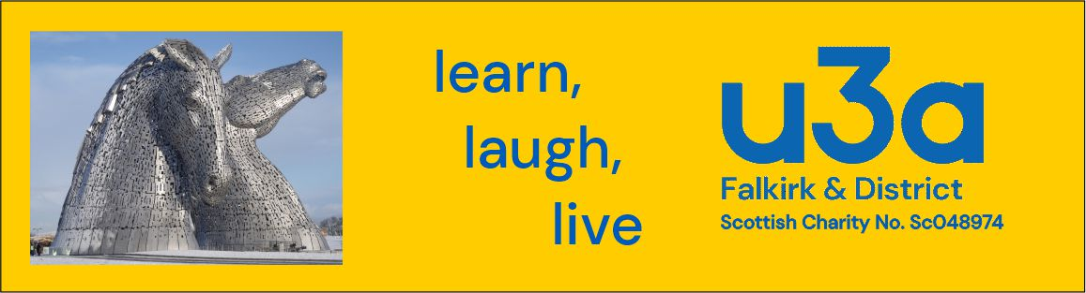

Falkirk & District u3a Privacy Policy

Falkirk & District u3a (hereafter ‘the u3a’) treats your privacy rights seriously. This privacy policy sets out how we will deal with your ‘personal information’, that is, information that could identify, or is related to the identity of an individual.

What personal information do we collect?
When you express an interest in becoming a member of the u3a you will be asked to provide certain information. This information is as follows:
- Name.
- Home address
- Email address
- Telephone number
- Subscription preferences

How do we collect this personal information?
All the information collected is obtained directly from you. This is usually at the point of your initial registration. The information will be collected via membership forms. At the point that you provide your personal information for membership purposes, we will also request that you provide consent for us to store and use your data. Your consent is required in order to ensure our compliance with data protection legislation.

How do we use your personal information?
We use your personal information:
- To provide our u3a activities and services to you
- For administration, planning and management of our u3a
- To communicate with you about your group activities
- To monitor, develop and improve the provision of our u3a activities.

We’ll send you messages by email, other digital methods, telephone or post to advise you of u3a activities.

Who do we share your personal information with?
We may disclose your personal information under the following circumstances:
- Internally - to Trustee Committee members and group organisers – as required to facilitate your participation in our u3a activities
- Externally – where we use an external membership management system and with your consent for products or services such as direct mailing of the u3a Trust magazine (Third Age Matters). Where such systems are used, the Trustee Committee has scrutinised the Terms and Conditions of each supplier and judged that their digital and physical systems and procedures are secure.
- If we have a statutory duty to disclose it for other legal and regulatory reasons

Where we need to share your information outside of the u3a we will seek your permission and inform you as to who the information will be shared with and for what purpose.

How long do we keep your personal information?
We need to keep your information so that we can provide our services to you. In most instances information about your membership will not be stored for longer than is necessary. The exceptions to this are instances where there may be legal or insurance circumstances that require information to be held for longer whilst this is investigated or resolved. Where this is the case then the member/s will be informed as to how long the information will be held for and when it is deleted.

How your information can be updated or corrected
To ensure the information we hold is accurate and up to date, members need to inform the Falkirk and District u3a as to any changes to their personal information. You can do this by contacting the membership secretary through our website or at an Open Meeting
On an annual basis you will have the opportunity to update your information, as required, via the membership renewal form. Should you wish to view the information that the u3a holds on you, you can make this request by contacting the membership secretary – as detailed above. There may be certain circumstances where we are not able to comply with this request. This would include where the information may contain references to other individuals or for legal, investigative or security reasons. Otherwise we will usually respond within 14-days of the request being made.

How do we store your personal information?
We have in place a range of security safeguards to protect your personal information against loss or theft, as well as unauthorised access, disclosure, copying, use, or modification.
Your membership information is held on a database and only accessed by Trustee Committee members and group organisers.

Availability and changes to this policy
This policy is available on Falkirk & District U3A website. This policy may change from time to time. If we make any material changes we will make members aware of this via the newsletter and the monthly members' Open meetings.
Contact
If you have any queries about this policy, or have any complaints about our privacy practices, please contact us via our website or by speaking to any Trustee at an Open Meeting.

