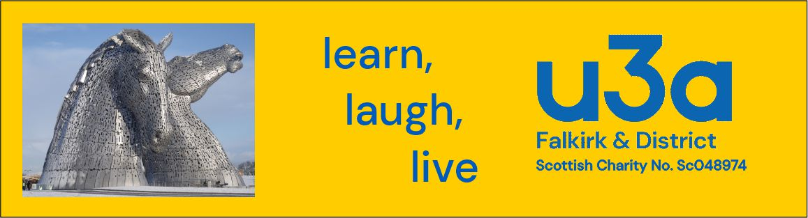

Falkirk & District u3a
Scottish charity No. SC048974

Annual General Meeting for 2022-2023 to be held on 6th June 2023 at 2.30 pm in St Francis Xavier Church Hall, Hope Street, Falkirk.

Agenda

- Confirmation of Quorum
- Chairman’s Opening Remarks
- Approval of Minutes of Previous AGM, held June 2022
- Approval of Financial Accounts for 2022-2023
- Approval of appointment of External Examiner for Financial Accounts, as required by Charity Law
- Approval of Trustees’ Review
- Election of Officers and Executive Committee Members
Chairperson
Vice Chair
Secretary
Treasurer
Other officers
- AOCB
- Close Meeting

Falkirk & District u3a
Scottish Charity No. SC048974

Minutes of the Annual General Meeting for 2021-2022
held in St Francis Xavier Church Hall, Hope Street, Falkirk on 7th June 2022 at 2.30 pm.
- Quorum: With approximately 30 members present at the start of the meeting, a quorum was confirmed.

- Chairperson’s Opening Remarks: Chairperson, Louise Westall, welcomed everyone to the meeting and thanked them for their attendance.

She reported that membership numbers had fallen due to the pandemic and now stood at 84 as compared with 145 before the pandemic. This was not surprising, but hopefully numbers would rise again in September.

Only 17 out of a total of 31 groups had remained active, and mostly via Zoom, but it was hoped that the dormant groups would re-start in September. In the meantime, Louise was pleased to report that a new Scrabble group had been set up.

Open Meetings were now hybrid meetings which meant that they not only took place in person, but also used technology so that members could access the meeting from home, if they preferred to do so.

The Committee had remained busy and had produced an Equality, Diversity and Inclusion Policy, a Code of Conduct, and a Complaints Procedure for comment by members. As no comments had been received, these documents would now be implemented. Members of the Committee had also attended meetings of the Central Belt u3a, and also the Older People’s Network.

Louise finished her report by thanking all of the other volunteers whose contributions helped with the smooth running of Falkirk & District u3a.

- Approval of Minutes: The Minutes of Previous AGM, held on 4th May 2021, were approved by the members.

- a) Treasurer’s Report and Approval of Financial Accounts 2021-22:

Treasurer, Peter Willett, presented the accounts, which were then approved by the membership.

b) Approval of appointment of External Examiner for Financial Accounts, as required by Charity Law.

Members were delighted that Innes Chalmers C.A. was continuing to offer his services as External Examiner free of charge and approved his appointment as External Examiner for 2022-23.

- Election of Officers and Executive Committee Members: The following members, each having received the required nominations, were approved by the members for election to the Executive Committee for 2022-2023:

Chairperson and Committee Member: Louise Westall
Treasurer and Committee Member: Peter Willett
Vice Chairperson and Committee Member: Archie McIntyre
Secretary and Committee Member: Dorothy Ferrie
Committee Member: Peter Kahan
Committee Member: Jennifer Kightley
Committee Member: Ron Davidson

There were no other nominations from those members present at the meeting.

- AOCB: There was nothing raised under AOCB.

- The members were thanked for their attendance and were invited to enjoy the cake that Louise had decorated to celebrate the u3a’s 40th anniversary as well as the Queen’s Platinum Jubilee. The meeting was closed at 2.50 pm.

