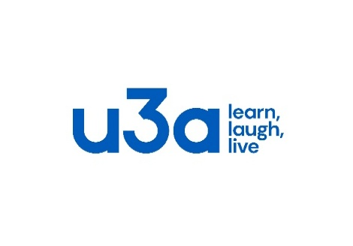
Eastleigh District u3a Membership Application
Membership no.
Your Details (Please print)
Name: Mr/Mrs/Miss/Ms | Forename: Surname:
Email: * Telephone:
Mobile:
Address:

Postcode:
*To reduce costs, the committee will communicate with you via email, where possible
Membership Fees
Membership £20.00* per person annually from 1st October 2023 to 30th September 2024.

For Associate Members who belong to another u3a and have paid the Third Age Trust subscription of £4 the fee is £16.00 annually.
Please give the name of the u3a of which you are a full member ………………………………………………………...

Please tick payment method
Cash
Cheque payable to Eastleigh District u3a
BACS Bank: Lloyds, Account name Eastleigh District u3a, Sort code 30 92 94 Account number 44192560. Reference, please quote “NEW” followed by your surname with as many digits as allowed.

*These fees include a £4.00 payment per Member for Membership Subscriptions paid to our National Organisation, the Third Age Trust, which provides a wide range of services and benefits, including liability insurance cover.

Charity Gift Aid Declaration – multiple donations
Boost your donation by 25p of Gift Aid for every £1 you donate.

Gift Aid is reclaimed by the Charity from the tax you pay for the current tax year. Your address is needed to identify you as a current UK taxpayer. (We will use the address details above.)
In order to Gift Aid your donation you must tick the box below:

I want to Gift Aid my donation of £20 and any donations I make in the future or have made in the past 4 years to:
Name of Charity – Eastleigh District u3a
I am a UK taxpayer and understand that if I pay less Income Tax and/or Capital Gains Tax than the amount of Gift Aid claimed on all my donations in that tax year it is my responsibility to pay any difference.

Signed: Dated:

Please also sign overleaf to complete your Membership Application.

Please Notify Eastleigh District u3a if you:

Want to cancel this declaration.
Change your name, email, or address.
No longer pay sufficient tax on your income and/or capital gains
If you pay Income Tax at the higher or additional rate and want to receive the additional tax relief due to you, you must include all your Gift Aid donations on your Self-Assessment tax return or ask HM Revenue and Customs to adjust your tax code.

Terms and Conditions of Membership

All members must:

- Abide by the Principles of the u3a movement.
- Always act in the best interests of the u3a and never do anything to bring the u3a into disrepute.
- Always treat fellow members with respect and courtesy.
- Comply with and support the decisions of the elected Committee
- Advise the Committee of any change in your personal details.

I hereby apply for membership of Eastleigh District u3a and confirm that I will abide by the terms and conditions as stated above. I confirm that I have completed the form myself. I will make full payment of fees due as soon as reasonably practicable. Cheques to be made payable to :- Eastleigh District u3a
Signed: Dated:

Privacy Statement
Eastleigh District u3a requires members to provide their personal details so that you can be informed about events and activities that are offered as part of your membership. In collecting your information Eastleigh District u3a will:
- Store it securely on the Beacon Online Management System which is fully compliant with current Data Protection Regulations.

- Use it to communicate with you as a member.

- Share your information with Group Leaders for those groups of which you are a member.

- Share your general information with the Third Age Trust * for distribution of the Third Age Trust magazines.

(Please see our Data Protection and Privacy Policies on our Website – Eastleigh District u3a/home or request a copy from the Secretary or Chairman)
* The Third Age Trust is the national office to which all u3a’s are affiliated.

