National Space Centre, Leicester
Saturday 12th October 2024 Code NSC

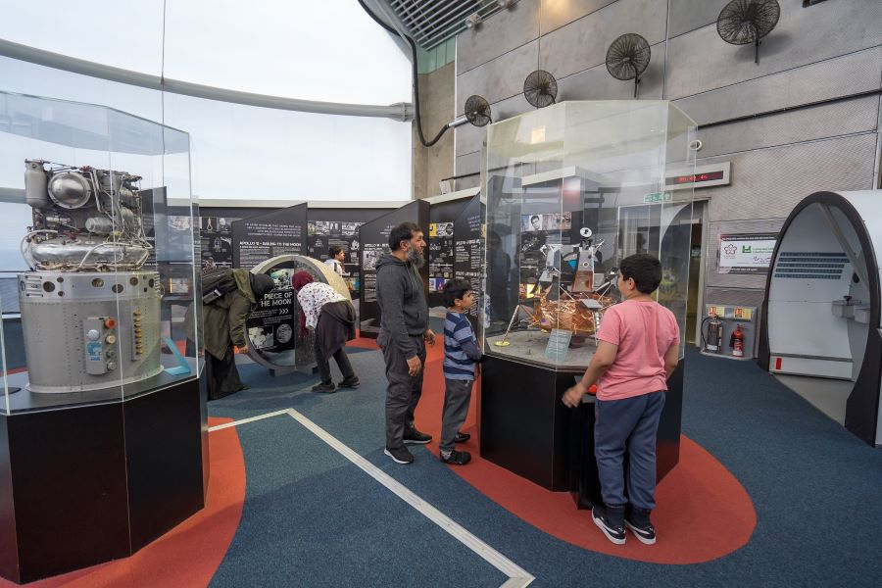
The National Space Centre is home to a world-class artefact collection that tells the past, present and future stories of space exploration and science.
However, as a science and discovery centre we also encourage you to get hands-on with science, to enjoy all the interactive elements of our galleries, and enhance your visit with 'science busking', talks and workshops thanks to our Discovery team.
As you approach the National Space Centre from any route into the City you will catch glimpses of the 42 metre high Rocket Tower.
The National Space Centre is home to the Sir Patrick Moore Planetarium, the UK’s largest full dome planetarium.
Tetrastar Spaceport is the brand-new experience at the National Space Centre. A low Earth orbit cruise is included in your day ticket (subject to availability). Take a seat on the Tharsis spacecraft and join the ever helpful ADA, as you head off on a journey to the stars.
Cost: £45 per person

Food and Drink: The Booster Café serves hot and cold drinks, nachos, jacket potatoes, hot dogs, sandwiches, salads, wraps and cakes, and has healthy, vegetarian and vegan options throughout the menu

Timings: Leave Don’s at 07.30am, Casa (Flitch House) at 07.35am and
Takeley Four Ashes at 07.50am. E.T.A. back at Don’s 6.30-7.00pm

Contact Outings Team:
Email: dunmowu3aoutings@btinternet.com
Tel: 01279 870870 or Mob: 07909-688401
For more info: www.spacecentre.co.uk

