Kiss Me Kate
Thursday 25th July 2024
Code KMK
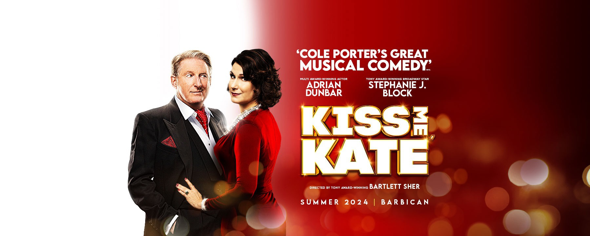

“A new production of Cole Porter’s Kiss Me, Kate, starring the multi-award-winner Adrian Dunbar and Broadway Royalty and Tony Award Winner Stephanie J. Block.
With a company of over 50 including a full-scale orchestra and featuring Cole Porter classics such as Another Op'nin', Another Show, Brush Up Your Shakespeare and Tom, Dick or Harry, Kiss Me, Kate is the perfect summer musical for 2024.
Kiss Me, Kate is the original farce and whisks you into a world of backstage chaos and romantic entanglements. With Cole Porter’s razor-sharp wit, it’s ‘The ultimate Broadway musical from the golden age’ (Financial Times) and is Broadway musical comedy meets Shakespeare meets Noises Off”.

Cost: £ 72 per person

Timings: Leave Don’s at 10.00am, Flitch House Café at 10.05, Takeley Four Ashes at 10.25am. The Performance starts at 2.30pm and lasts 2 hours and 40 minutes. Est. arrival back at Don’s approximately 7.30pm.

Food and Drink: Choose from the many cafés and restaurants nearby or eat in the Barbican Centre

Contact Outings Team: Email: dunmowu3aoutings@btinternet.com
Tel: 01279 870870 Mob: 07909-688401

For more information visit: www.barbican.org.uk

