Holkham Hall
Thursday 12th September 2024
Code HH
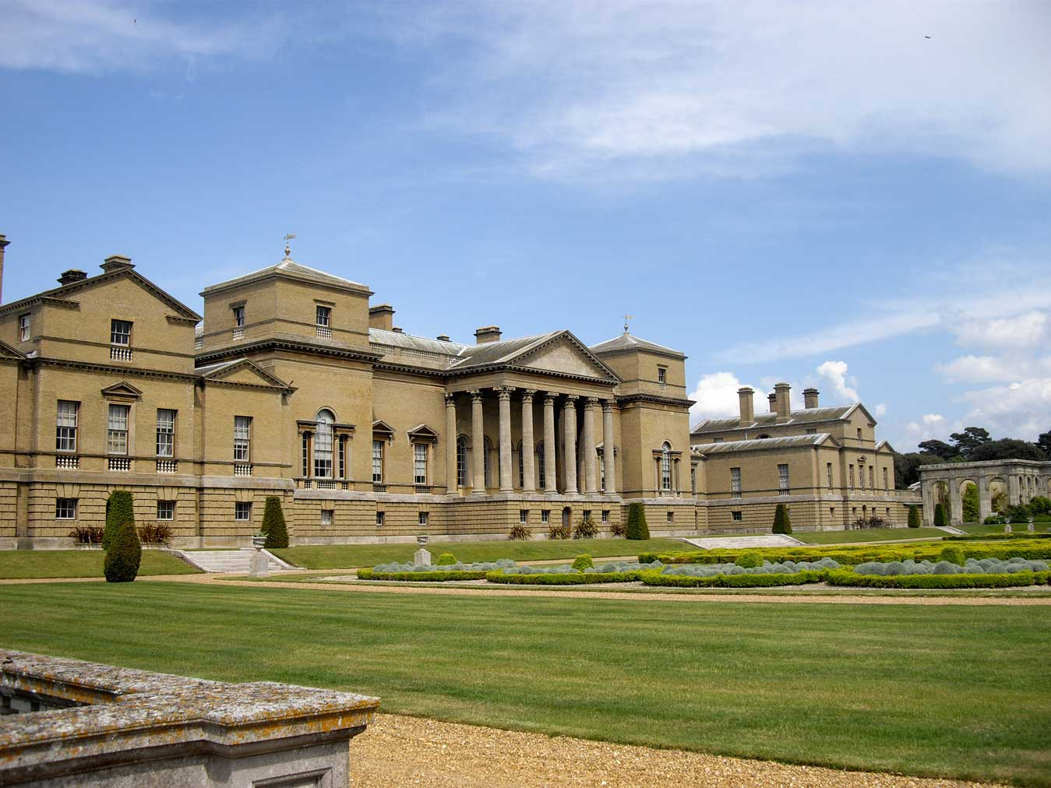

Cost: £48 per person
Nestled within 25,000 acres of rolling parkland, Holkham Hall is an 18th-century Palladian style house, based on designs by William Kent and built by Thomas Coke, 1st Earl of Leicester.
Some of the things to do whilst there:
- Take self-guided tour of Holkham Hall
- Visit Holkham Stories Experience
- Enjoy a break for lunch at the Café and a spot of shopping at the gift shop
- See the Walled Garden
- Relax by the lake in the rolling parkland

Timings: Leave Don’s at 9:00am, Casa (Flitch House) at 9:05am, Takeley Four Ashes 9:25pm. Return leaving Holkham at 4:30 pm.
E.T.A. back at Don’s 7:15pm

Food and Drink: Lunch can be bought at the Café or why not take a picnic?

Contact Outings Team: dunmowu3aoutings@btinternet.com
Or 01279 870870 Mobile 07909-688401
For more info: www.holkham.co.uk

