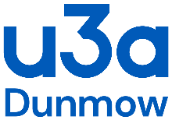

COVID-19 Risk Assessment Evaluation

Following each session, the Group leader must evaluate the assessment and methods used to prevent the spread and contamination of the Covid 19 virus.

Date | Problems highlighted | Changes made to rectify problem | Sign

Issue Date: 3 April 2021

