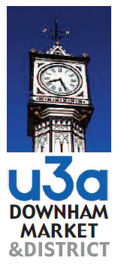
SAFEGUARDING REPORT
This report, once completed, is the Property of the Downham Market & District U3A. It contains sensitive information which the Committee of the Downham Market & District U3A undertakes to hold securely for a year in accordance with its Safeguarding Policy, a copy of which may be obtained from the Business Secretary. Information contained in this report will only be released to those persons seeking such information at the discretion of the Committee of Downham Market & District U3A and in line with the policies of that Committee.
Logging a Concern Date of this report (dd/mm/yyyy)
Account of what happened Include who was involved, what happened and when it happened (dd/mm/yyyy)

If your account includes an injury, describe it in as much detail as you can and indicate where it was on the body map
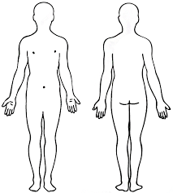
Action taken What action did you take? Who did you tell? What action was agreed?

Your name and role in the U3A (Safeguarding Officer/Assistant, Group Coordinator/Leader)

Your contact details

Upon receipt of this form the course of action to be taken will normally be decided by the Safeguarding officer. If the recipient of this form determines that immediate action (i.e. reporting to the relevant authorities) needs to occur, then feedback will be within a shorter time.
If requested the course of action will be discussed at the next meeting of the Downham Market & District U3A Committee and, a reply given to you within eight weeks of the concern being submitted.
Feedback will be given in line with the Safeguarding Policy.

