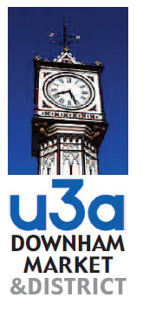
Downham Market & District U3A
Imagery Policy

- From time to time we take photographic images (moving and still) to illustrate and promote the various activities that Downham Market & District U3A undertakes.

- By ticking the box on the new member’s application or renewal application form you give us full permission to use these images and any personal information you supply to us which reasonably promotes or advertises Downham Market & District U3A.

- This may include our printed publications, advertisements, audiovisual and electronic materials, media work, display materials and any other media we may use in the future.

- An example of using this information could be:
Description of a photograph (Name) and his/her group on a recent outing.

- The images will not be used for any other purpose.

- Home and email addresses will not be given and will be collected for the purposes as stated in the Data Protection Policy, August 2021
- To facilitate the function of the Downham Market & District U3A ie the maintenance of membership lists
- To update the national database of the Third Age Trust

- Members consent may be refused, withdrawn or modified at any time by contacting the Membership Secretary and advising that you no longer give Downham Market & District U3A permission to use your image.

This statement will be reviewed every two years.

Signed

John Cowin.
Chairman Downham Market & District U3A.

1

