We are Croydon!
Six members of Croydon u3a were delighted to be involved recently in a project called ‘The 100 Faces of Croydon’ - showcasing portraits of 100 local people, who were photographed in the parts of Croydon which are particularly significant to them.

Jenny was one of those taking part and she chose to be photographed in Lloyd Park, as you can see in the photograph. The project culminated with a concert by the London Mozart Players at the Fairfield Halls, during which the 100 portraits were projected onto a large screen. The portraits will now be displayed on an online Gallery. 100 Faces of Croydon | A London Mozart Players Community-led Project

Croydon u3a was particularly pleased to take part in this project because it set out to ‘celebrate the diversity and uniqueness’ of Croydon’s community – a goal which we share. We pride ourselves on being inclusive and welcoming to everyone. There are no entry requirements for membership of Croydon u3a – and although most of our members are retired or semi-retired, we are open to anyone who has some free time in their week. We offer almost 70 Interest Groups – so that we feel confident that there is something for everybody.

Our members come from all parts of Croydon and our activities take place in different venues right across the Borough – we feel we really are representative of our wider community!
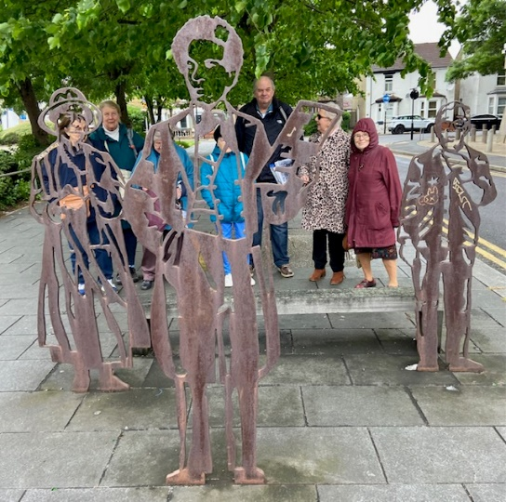
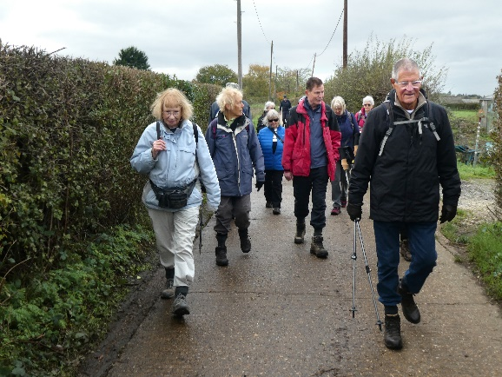

The Local History group out and about in Croydon A Walking group enjoying local green spaces

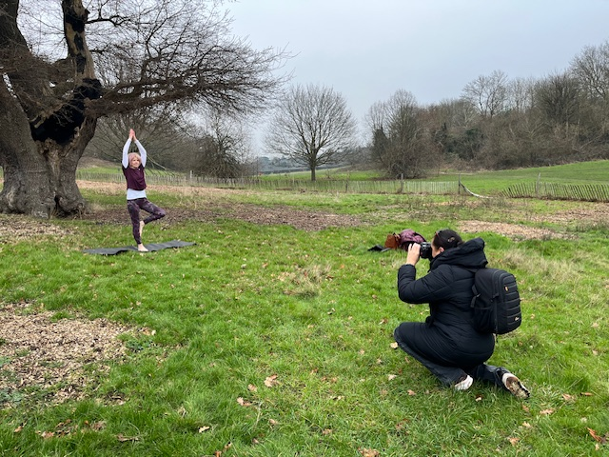
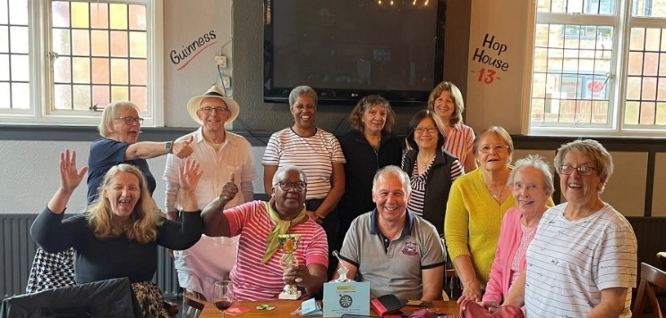
The Darts and Pub Lunch group

Photoshoot for Jenny in Lloyd Park

